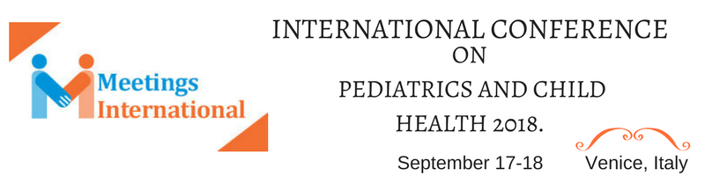

Intranasal Steroid and Asthma

Dr Rajatsubhra Mukhopadhyay
Child Health Care Arambag, Koruna Medical, India
*Address for Correspondence:
Dr Rajatsubhra Mukhopadhyay, Child Health Care Arambag, Koruna Medical, Hospital More, Arambag, Hooghly, West Bengal, India, Pin- 712601, Phone: 9732948496; E-mail: dr_rajatsubhra@yahoo.com (or) dr_rajatsubhra@sridoctor.com

Keywords: Intranasal steroid therapy, asthma, atopy, on demand intranasal
steroid therapy (ODIST),economy, under developed country

- Abstract Body (up to 250 words)
. A non randomized ,active controlled trial was done and still is open to recruitment, open label ,phase-1 type among few children over two years of age with positive history of atopy, WALRI & asthma, with intranasal steroid. Intranasal steroid was given in each side of nose with a phial then was advised to follow On Demand Steroid Therapy[ODIST]. Result was noted with their ‘ Symptoms Record Book’, PEFR, Spirometry & IgE level.
Objectives were to see its outcome. And its’ RR=1.2, OR=2. P= 0.02275 , [DF=1,CI=1.026-4.203 at95%].
This method has been named - On Demand Intranasal Steroid Therapy (ODIST). It takes almost one two months to control the allergic process. After that it can be used as ON DEMAND basis. Intranasal steroid is a safe alternative to inhalers. It is cost effective also. Easy delivery is also a cause of parents acceptance. Lesser side effects is another favorable point. ON DEMAND, INTRANASAL STEROID THERAPY (ODIST) could also be called RODIST/ ODISTR to keep the doctors name along with has made possible to lead an intermittent steroid free life.
If this system is widely acceptable, there will be great impact on economy of developing country. As WALRI & asthma are the upcoming burden to the country & intranasal steroid is cheaper & this method is making possible to use steroid intermittently.

Image:

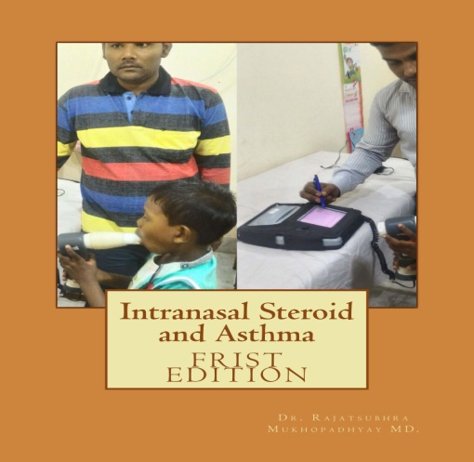

- Reference:

- Andrew H, Ronina AL, Joseph DC, Donald YM. Leung editors. Childhood asthma (Chapter 143). Kligman Stanton, St Geme, Schor Behrman - Pediatrics : Textbook of Nelson, 18th edition.
- Andrew N, Booth T (1991) The Social Impact of Asthma: Family Practice fampra oxford journals. org. J Fam Pract 8: 37-41.
- The University of Chicago Medical Center. Comer Children’s Hospital at the
University of Chicago/ 5721 S. Maryland Avenue/ Chicago, IL 60637.
- (2011) WHO :ASTHMA: Fact sheet N° 30.
- (2007) NHLBI Guidelines for the diagnosis and treatment of asthma expert panel report 3.

- NAEPP guideline (National Asthma Education and Prevent ion Programme: Washington DC NIH pub no: 02-5075.
- 20762 Mometasone Clinical_PREA Pediatric Review www.fda.gov/ downloads/Drugs/.../UCM215 6 5 9.pdf (mometasonefuroate) Nasal Spray is approved for the treatment of nasal symptoms of allergic rhinitis
- Immunol J (2002) Allergy Clin Intranasal steroids in asthma management. 2002;109:636-42
- Durham SR (2002) One airway: the link between allergic rhinitis and asthma. Advenc Stud Med 2: 861-866.
- (2011) Study of Asthma and Nasal Steroids (STAN) This study is currently recruiting par ticipants. Verified on June 2011 by American Lung Association Asthma Clinical Research Centers.
- Steroid Sparing Effect of Nasal Corticosteroid In Asthma And Rhinitis. This study has been completed. First Received on May 14, 2009. Sponsor & Information provided by: University of Dundee: ClinicalTrials. gov Identifier: NCT00903227.
- Taramarcaz P, Gibson PG (2003) Intranasal corticosteroids for asthma cont rol in people with coexisting asthma and rhinitis. Cochrane Database Syst Rev 4: CD003570.
- (2011) Asthma/Bronchialasthma; Exercise-induced asthma last reviewed.
- (2014) Exercise-induced asthma.
- Bahadori K, Doyle-Waters MM, Marra C, Lynd L, Alasaly K, et al. (2009) Economic burden of asthma: a systematic review. BMC Pulm Med 9 : 24.
- (2012) Johns hopkins health alert: “asthma and gastroesophageal reflux disease (gerd) -- what’ s the connect ion?” american academy of allergy, asthma & immunology: “asthma and gerd”, “gast roesophageal reflux disease (GERD)”.
- Bousque t J, Van Cauwenberge P, Bachert C, et al: requirements for medications commonly used in the treatment of allergic rhinitis. European Academy of Allergy and Clinical Immunology (EAACI). Allergic Rhinitis and its Impact on Asthma (ARIA). Allergy 2003; 58: 192-197.

Biography:

Dr Rajatsubhra Mukhopadhyay MD,DCH.PGPN[BOSTON]
A doctor[Pediatrician] & researcher, MBBS,DCH,MD . Coming from metropolitan I am practicing at village & nearby towns at Arambag, West Bengal, India. Along with a continuous academy, research & writings I am also trying to find out some fundamental factors of health & child health problems at rural areas[which is never possible better from metropolitan] .
The level of rural living quality is better now also for internet, mobile, road conditions etc. And I think ,my life might be an example for other doctors & public who denies to live at village.
Lastly I am trying to establish a better form of medical system ,that will be easier, cheaper & medicines will be with less side effects. Education
- RamaKrishna Mission -Joyrambati,[prebasic-class8]-
- Kamarpukur RamaKrishna Mission [Secondary],
- Bishnupur High School[HigherSecondary],
- R G Kar Medical College,[MBBS]
- Institute of Child Health-Kolkata[DCH],
- TEXILA AMERICAN UNIVERSITY[MD]
- PGPN from University of Boston

Affiliations

Indian Council of Medical Research
junior research fellow
1993 to 1993

INSTITUTE OF CHILD HEALTH ,UNIVERCITY OF CALCUTTA
PAEDIATRICIAN &RESEARCHER
1999 to 2005

Indian Medical Association
life member
2007 to Present. This is my current job.

Indain Academy of Pediatrics
life member
2009 to Present. This is my current job.

Indian Redcross Society
life member
2009 to Present. This is my current job.

Interests
Child’s Asthma and Allergy, Growth& Nutrition, Phimosis and Hirschsprung's Disease.
Projects
1.Easier way to deliver the inhalers to the newborns &infants.
2. With Intranasal steroid the long usage of inhalers could be curtailed down. ODISTR Therapy.
3. RMOP -Manual Opening of Phimosis at OPD.
4.Methods to reduce the referral to higher centers.
5. Non Surgical management of Ultra-short segment aganlionosis (Hirchsprung’s disease)
6.More easier but modified approaches to examine children at office.
7.Earlier cure of Cephal-hematoma.
8Newborns with Congenital Telipes Equiniverus Syndrome[CTEV].
9. Home based management of Very Low Birth Weight (VLBW) babies

Presenting author details
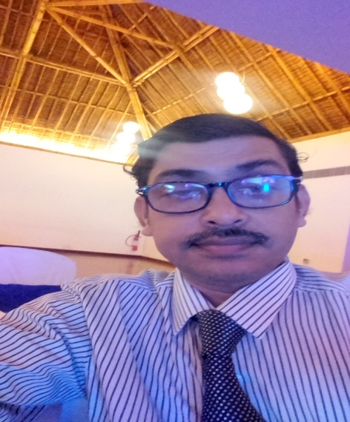
Full Name:
Dr Rajatsubhra Mukhopadhyay.
Contact number: 9732948496.
Web site:
http://www.sridoctor.com
Twitter account: https://twitter.com/DRRAJATSUBHRA
Linked In account:
https://www.linkedin.com/in/dr-rajatsubhra-mukhopadhyay-b5178828/

Session name/ number:

Category: (Oral presentation)

Passport Number:

Copyright © 2016-2018 Meetings Int PTE Ltd, All Rights Reserved.
Meetings Int.Pte Ltd

Company Registration No: 201524282R,28 MAXWELL ROAD, #03-05 RED DOT TRAFFIC, SINGAPORE (069120)
Tel: +1-302-231-6756 ; +6531080483| Toll Free no. +800-852-6126
Web: http://www.meetingsint.com/conferences/foodtechnology | E-mail foodtechnology@meetingseries.org

