Docker a compendium for Microservice Architecture
Abstract: For instance, increasing demand leaning on new technologies inversely proportional to appeal for older technologies. Thus, a newer interpretation of technologies brings minimal development work. Thereafter, advancement leads to segregate each functional module unit as a separate entity. In the virtualization as well as simulating industry environment, container-based technology becomes the most powerful hi-tech solution in recent years. Moreover, with the introduction of Docker Container based technologies emerged as a powerful and simplified solution for virtual machines. Nonetheless, compared to other visualization platform Docker provide a great level of flexibility and adaptability in conjunction with scalability to developer inclusive of administering. Subsequently, Docker provides a fast and lightweight technology solution optimized for cloud development. Thus, development utilization and deploying cost reduced as compared to the traditional virtualization platform. Therefore, of the Docker re-development and redeployment cost reduced to a great extent.
1] Introduction of Docker Software architecture differentiated into two types. First is Monolithic architecture and next Microservices architecture pattern [1]. However, in the monolithic pattern all, the application module combined into one single development unit [2]. No one able to distinguish or rather differentiated the architecture into the different small functional module [3]. Rather than, Micro-service, service-oriented architecture pattern [4]. However, the application builds in the small functional units. Moreover, the developer gets to know on which particular function model them currently working [5]. As big application divided into smaller functional modules also well-defined interface [6]. Thus, each functional module has a separate database. These modules independently deployed and operated by a small group of the developer team. Consequently, a big application divided into small independent units [7]. Furthermore, a request API comes from Mobile reaches to API Gateway. Thus, after passing the gateway goes toward specific service. For instance, account, inventory or shipping service [8]. In addition, for the desktop application web browser gives API request to the storefront. Moreover, after passing the storefront API reaches to services like Account Inventory or Shipping [9]. Thus, finally reaches to the specific database like Account database or Inventory database [10]. While Docker built on the central concept of Microservice architecture. However, Microservice architecture for the Docker provides a functional module for each independent service unit [11]. Moreover, Docker does not require any kind of operating system for running the application [12]. Furthermore, Docker has a client-server type of architecture where command line and server Docker Daemon run client [13]. Thus, Docker demon has many containers inside it supporting the Daemon as a server.
2] Literature Survey Gaurav Bhatia explained in the article "Docker a road to survey” functionality also, working of container-based technologies. No one able to distinguish or rather differentiated the architecture into the different small functional module. Rather than, Micro-service a service-oriented architecture pattern. However, the application builds in the small functional units. Moreover, the developer gets to know on which particular model them currently working. As the big application divided into smaller functional modules also well-defined interface. Thus, each functional module has a separate database. These, modules independently deployed and operated by a small group of the developer team. Consequently, a big application divided into small independent units. Moreover, Suchit Dhakate stated in his article “Distributed Cloud Monitoring Using Docker as Next Generation Container Virtualization Technology”. Thus, trends shifted from purchasing cloud infrastructure to accessing cloud-based services. Thereafter, the cloud-based service provider always assured regarding service reliability, accessibility. However, the provider spends a large amount of time and money to ensure matching service level agreement. Nonetheless, in the long term, it is not suitable as the customer load is predictable. Generally, the cloud-based services are like web-based API exposed action on the cloud portal. Gradually, testing of the entire cloud environment through North-bound API of the cloud portal
2.1] Organization The introduction of Docker container technology given in section 1. Architectonics of Docker container and it is a working principle visualization machines technologies elaborated in Section 3. Section 3.1 includes a Docker container concept starting from the base. Moreover, section 3.2 includes the details about the Docker object included things supporting Docker container lifecycle. Nonetheless, section 3.3. Contain Docker contrast to visual Machines it is a tradeoff between traditional visualization technologies v/s new age container-based technologies like Docker container. Last of all, conclusion part-containing summary of new innovative technologies like Docker. The final section gives references.
3] Docker Architecture, For instance, Docker has a client-server type of architecture where command line and server Docker Daemon run the client. Thus, Docker demon has many containers inside it supporting the Daemon as a server. Moreover, the request sent through command line known as client [19]. Thus, the incoming request is in the form of Rest API handled by the server known as Docker demon [20]. However, the demon contains container used for all types of Rest API. The request is HTTP type like getting, PUT, POST and DELETE. Thereafter, all request handled by Docker demon [21].
3.1] Docker concept as, the Docker is a container-based service. Although, software development cycle has phases like first Requirement gathering, Designing, Development and finally testing [14]. Thus, Docker will come into operation at the stage of development and testing. Reducing the development work for developer drastically. Although, Docker able to develop the application ship into container also transfer the application [15]. In addition, the Docker application uploaded into the cloud as well. Container lightweight, they are easily scalable. Docker released in the summer of 2013 afterword it become the buzzword for new-age application development for the agile project [16]. Thus, an agile project is the development of the project is small independent stages is loosely coupled to each other [17]. With the help of Docker container easy to perform the job of development, QA, analysis [18].
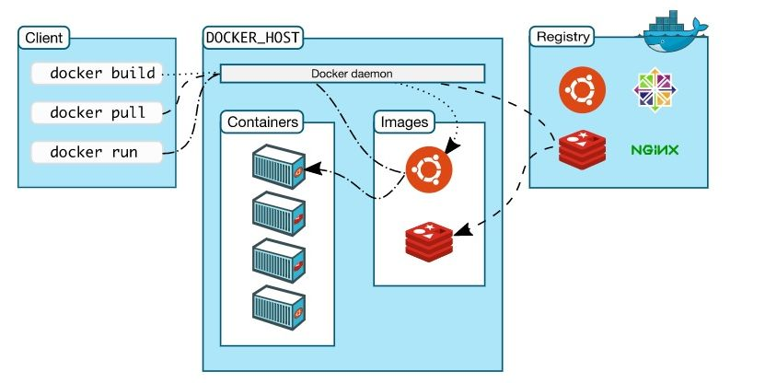 Fig -1 Represents Docker container architecture
Component of Docker architecture as shown in fig (1) which receives instructions from Docker client regarding building, running and shipping the Docker containers [22]. Docker provides the facility to run the Docker client and the Docker daemon on the same device, or the client can connect to the Docker daemon running remotely [23]. Communication between Docker client and Docker
3.2] Docker Object with Container Lifecycle to perform the application working on Docker container different objects listed below [24]. Frist is Images the images are the binary template used to define the capability of the container [25]. Images used to store and ship the application. Container images shared across the different development teams within the enterprises through a private registry or common private registry for images like Docker Hub. Furthermore, the Container is an abstracted space where all the application things run [26]. Thus, the container process the images provided by given some initial instruction to the container [27]. Container only has access to the resources defined with the images. Nevertheless, containers small as compared with virtual machines resulting in the low server density [28]. Lastly, the Network essential part of Docker container [29]. However, there are two types of network available public and private network [30]. Thus, by default, you get three types of network none bridge and host. Although, none and host part of stack network in the Docker.as well as, bridge network automatically creates gateway and IP subnet. Hence, communicate with a similar network via IP addressing [31]. Accordingly, other types of network are user-defined network usually the three types [32]. The first user-defined network is bridge type as there is no need for port forwarding for the container they communicate with each other via IP addressing [33]. Also, over relay network needed when two hosting done on two different hosts as in case of a distributed network. Thus, the next network Macvlan network as mentioned in the above two networks over relay and Bridge network giving a bridge between host and container. While Macvlan network removes the bridge that existed between network and container. Thus, Docker helps in the normalization process concerning container-based images processing concerning development, jobs on computing grid, continuous integration, and peer review, technology transfer. Accordingly, the Docker container important part. Thus, a Docker container has its lifecycle. In addition, management of the container done by the create/start/stop/remove containers, inspect containers interact and commit new images. For create and staring containers the command used is docker create image name. While to run the container it is docker run image. Thereafter, for rename and update of the container the command used like docker rename container new name, also docker update container. However, to start, stop, kill and restart command used is docker start container docker stop container, docker kill container finally docker restart container. Besides, for pause and resume commands used like docker pause container, docker unpause container. For instance, to destroy the container command give as docker rm [-f^3] container. Moreover, the container file system created in docker creates and dropped in docker em. Thus, it is president across stop/start. Thereafter, container configuration is mostly static configuration is set in create/ run docker update may change only a few parameters. While, changing other parameters require destroying and recreating the containers. Other command s are rather basic.
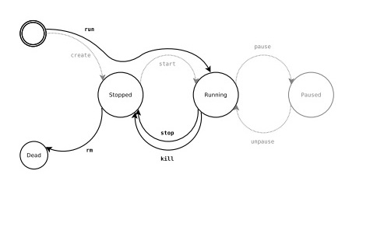
Fig-2 Represents Docker container lifecycle.
Moreover, the foreground mode is the default. Thus, stdout and strr redirected to the terminal. Docker run propagates to exit code of the main process. Briefly, containers are non-interactive. From here on the container are still exists after command exists. While -- rm the container automatically removed after exit. Moreover, for inputs and outputs Data volumes for persistent data mounted from the host file system. Named volume internal as well as volume plugins.

Accumulation and Managing Images
However, in Docker container uses the image as the most important part in the transformation of data. Thus, image constitutes of file system and criterion. For instance, Docker runs hello-world. The Docker command particular instruction given Docker program on the operating system. Moreover, the Docker run command instruction specifies that create the object of the image known as a container. At last, hello-world represent the image from a container made. Ultimately, CentOS image available in Docker Hub to run CentOS on Ubuntu machine. Consequently, executing the following commands on Ubuntu machine “sudo docker run –it centos /bin/bash”. Thus, using Sudo command to make sure it runs with root access. Moreover, centos name of the image needs to download from the Docker Hub. Also, install on Ubuntu machine. In the meanwhile, -it represents the interactive mode. While, /bin/bash executed for bash shell once CentOs executing. For deploying Docker image on the system, following commands executed. Docker image shows the entire image installed on the system. 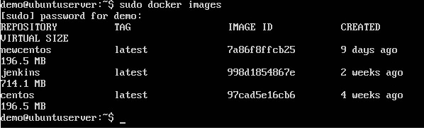
Fig- 3 Represent the Output of Docker output
A tag used for tagging the image
Image id used to identify the image.
Created the number of days since the image created.
Virtual size is the actual size of the image.
Downloading the Docker Image Thus, the downloading of the docker image carried out with the following syntax of code. “docker run image” image replaced by the image name or the image syntax associated with the image. While “docker run centos” will run the centos image, if it is not already present and run the OS container.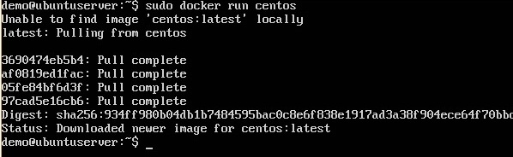
Fig- 4 Represent the Output of Docker command for centos
Thereafter, for removing the image file syntax declared as “docker rmi”. Thus, for more details command will be “docker rmi image ID”. However, the command provides the Id of the removed image from the docker.
Building an Image whenever, not able to find a suitable image on the docker hub then image needs to build on the docker hub. Thus, image build by creating the Docker file. The Docker file contains set of instruction from the inheriting image. Therefore, instruction inherited from the image used for adding new instruction or software to the updated image. Moreover, once the image created then shows data like repository name, having Tag image ID and its virtual size. Afterwards, there is alternative way of creating an image besides Docker file. That is creating bash access then customize image manually with adding a new software in the given format. Afterwards, complete the docker commit command for creating image in given executing container. In fact, after providing certain set of instruction image needs to run and validate. Thus, it is always helpful to tag image with username, image Id also version number before shifting it to Docker repository for storage.

3.3] Docker contrast to Virtual Machine
Furthermore, Virtual Machine not uses container technologies. While, container technology just user spaces for the operating system. In other word, the container process that differs from the set of process operated by the operating system. Therefore, the virtual machine shares the server hardware. Each, virtual machine based on the guest hardware. Thus, to run that set up of machine needs a hypervisor kit for Mac OS or hyperactive v kit for windows 10 premium OS. Also, needed some library files and packages to run. Then, on top of it needed the application code for the particular application to run. In contrast, Docker container itself has Docker demon act as a hypervisor. Thus, not needed to install the separate hypervisor kit for Docker. Therefore, Docker process the images with Docker container. While, Docker container is an image repository for the Docker. Therefore, have a client-server type of architecture. Consist of a client is the Docker command-line interface. Moreover, the server is the Docker demon containing different types of container. Therefore, all the container accept the request comes from the Docker command-line interface. Request in HTTP standard format. Thus, request in the form of getting, PUT, POST and DELETE.
4] Conclusion
Fourth, Docker container builds around the core concept of the Microservice architecture Meanwhile, Docker container reduces the cloud-based application development and deployment time drastically. Besides, the demand for the Docker container is less. Therefore, reduced demand for Docker container generates the high-performance output efficiency. Yet, Docker gives some fine features to provide reliability and durability as far as Microservice architect orientation considered. On the contrary, a Docker container has a security issue. Moreover, with the application of tool security issue treated in considerable amount. In the meanwhile, the purpose of research behind it to known about how Docker container technologies way ahead of the virtual machines. Meanwhile, the feature for Docker container technologies will give more advanced level as securities, scalability and flexibility issue taken into consideration.
References
[1] J. J. Joohyun Kyong, “Improving scalability of apache spark-based scale-up server through docker container-based partitioning,” Proceedings of the 6th International Conference on Software and Computer Applications, pp. 176–180, Feb. 2017.
[2] M. K. Qiumin Xu, "Docker characterization on high-performance SSDs," 2017 IEEE 31st International Conference on Advanced Information Networking and Applications (AINA), Mar. 2017.
[3] Zheng Li, "Performance Overhead Comparison between Hypervisor and Container-Based Virtualization," Mar. 2017.
[4] Yikang Liu, "Proceedings of the 2016 5th International Conference on Measurement, Instrumentation, and Automation," ICMIA 2016, Nov. 2016.
[5] X. W. Xinjie Guan, "Application-Oriented Dynamic Resource Allocation for Data Centers Using Docker Containers," IEEE Communications Letters, pp. 504–507, Dec. 2016.
[6] M. S. de B. Saiful Hoque, “Towards Container Orchestration in Fog Computing Infrastructures,” 2017 IEEE 41st Annual Computer Software and Applications Conference (COMPSAC), Jul. 2017.
[7] P. R. Jeeva Chelladhurai, “Securing Docker Containers from Denial of Service (DoS) Attacks,” 2016 IEEE International Conference on Services Computing (SCC), Jul. 2016.
[8] Nitin Naik, “Docker container-based big data processing system in multiple clouds for everyone,” 2017 IEEE International Systems Engineering Symposium (ISSE), Oct. 2017.
[9] V. M. Aleksander Slominski, “Building a Multi-tenant Cloud Service from Legacy Code with Docker Containers,” 2015 IEEE International Conference on Cloud Engineering, Mar. 2015.
[10] W. T. Wolfgang Gerlach, “Container Orchestration for Scientific Workflows,” 2015 IEEE International Conference on Cloud Engineering, Mar. 2015.
[11] M. K. Krishan Kumar, “Economically Efficient Virtualization over Cloud Using Docker Containers,” 2016 IEEE International Conference on Cloud Computing in Emerging Markets (CCEM), Oct. 2016
[12] A. Z. Rong Zhang, “Container-VM-PM Architecture: A Novel Architecture for Docker Container Placement,” International Conference on Cloud Computing, pp. 128–140, Jun. 2018.
[13] F. P. Yahya Al-Dhuraibi, “Autonomic Vertical Elasticity of Docker Containers with ELASTICDOCKER,” 2017 IEEE 10th International Conference on Cloud Computing (CLOUD), Sep. 2017.
[14] S. G. Somya Garg, “Automated Cloud Infrastructure, Continuous Integration and Continuous Delivery using Docker with Robust Container Security,” 2019 IEEE Conference on Multimedia Information Processing and Retrieval (MIPR), vol. 11 September 2017.
[15] F. P. Author(s) Yahya Al-Dhuraibi, “Autonomic Vertical Elasticity of Docker Containers with ELASTICDOCKER,” 2017 IEEE 10th International Conference on Cloud Computing (CLOUD), Jun. 2017.
[16] T. W. Lian Du, "Cider: a Rapid Docker Container Deployment System through Sharing Network Storage," 2017 IEEE 19th International Conference on High-Performance Computing and Communications; Dec. 2017.
[17] M. K. Krishan Kumar, “Sentimentalized: Docker container utility over Cloud,” 2017 Ninth International Conference on Advances in Pattern Recognition (ICAPR), Dec. 2017.
[18] V. P. Vishaka Balasubramanian Sekar, “AWS EC2 vs. Joyent’s Triton: A Comparison of Docker Container-hosting Platforms,” Proceedings of the 8th Workshop on Scientific Cloud Computing Pages 33-36, Jun. 2017.
[19] B. W. Hao Zeng, “Measurement and Evaluation for Docker Container Networking,” 2017 International Conference on Cyber-Enabled Distributed Computing and Knowledge Discovery (CyberC), Oct. 2017.
[20] D. V. David Jaramillo, “Leveraging microservices architecture by using Docker technology,” SoutheastCon 2016, Apr. 2016.
[21] J. M. B. Amar A Mohhale, “Experimenting with docker: Linux container and base OS attack surfaces,” 2016 International Conference on Information Society (i-Society), Oct. 2016.
[22] Z. Y. Janaki Bhimani, “Docker Container Scheduler for I/O Intensive Applications Running on NVMe SSDs,” IEEE Transactions on Multi-Scale Computing Systems (Volume: 4, Issue: 3, July-Sept. 1 2018), Feb. 2018.
[23] J. K. P. A R Manu, “Docker container security via heuristics-based multilateral security-conceptual and pragmatic study,” 2016 International Conference on Circuit, Power and Computing Technologies (ICCPCT), Mar. 2016.
[24] S. Y. Lele Ma, “Efficient service handoff across edge servers via docker container migration,” SEC ’17 Proceedings of the Second ACM/IEEE Symposium on Edge Computing, vol. October 12-14, 2017.
[25] J. A. Ryan Mabry, “Maritime autonomy in a box: Building a quickly-deployable autonomy solution using the Docker container environment,” OCEANS 2016 MTS / IEEE Monterey, Sep. 2016.
[26] C. O. David Elliott, “A Cloud-Agnostic Container Orchestrator for Improving Interoperability,” 2018 IEEE 11th International Conference on Cloud Computing (CLOUD), Jul. 2018.
[27] R. O. S. Zhanibek Kozhirbayev, “A performance comparison of container-based technologies for the Cloud,” Future Generation System, vol. 68, pp. 175–182, Mar. 2017.
[28] X. Z. Xiaolin Geng, "A Novel Architecture and Inter-process Communication Scheme to Adapt Chromium Based on Docker Container," Procedia Computer Science, vol. 107, pp. 691–696, 2017.
[29] C. H. Y. DT-Tri Nguyen, “An Index Scheme for Similarity Search on Cloud Computing using Map Reduce over Docker Container,” Proceedings of the 10th International Conference on Ubiquitous Information Management and Communication, Jan. 2016.
[30] A. G. Suchit Dhakate, “Distributed Cloud Monitoring Using Docker as Next Generation Container Virtualization Technology,” IEEE INDICON, vol. 2015.
[31] A. C. Gaurav Bhatia, “THE ROAD TO DOCKER: A SURVEY,” International Journal of Advanced Research in Computer Science, vol. 8, no. 8, pp. 1–6, Oct. 2017.
[32] “https: //www.tutorialspoint.com/docker/docker_images.htm.”
[33] Christopher M. Judd, “file:///C:/Users/CIML/Downloads/572027-rc221-docker%20 (1).pdf,” Getting Started with Docker. .

