TheSocialMedwork Abstract

Title: Accelerating global access to health innovations

Keywords: Medicines access, Named patient regulation, Global health access, Patient centricity
- Abstract Body (up to 250 words)
Healthcare access is a worldwide challenge. Every day, patients from all over the world are denied access to elsewhere approved health innovations for arbitrary reasons.

I have also been there myself. I experienced personal hardships friends who passed away before ever accessing the medicines they needed.

I was determined to find a way to undo the injustices of medicines access on a global scale and to accelerate this process to patients all over the world.

The creation of TheSocialMedwork is a timely and critical one, with only 11 years separating us from the 2030 health targets of the United Nations. It is our responsibility and duty to eradicate this challenge as soon as possible.

Our aim is to keep pushing for a change in the access to healthcare landscape every single day. We have now safely delivered over 5,500 latest innovative medicines to over 75 countries, years before the official availability in these countries.

Under the Named Patient import basis, TheSocialMedwork is safely and legally delivering medicines to all over the world.

TheSocialMedwork’s end goal is global health access for everyone regardless of their financial situation. This is why we are working towards crowd funding, blockchain transparency, pricing algorithms and conditional reimbursement pilots.

In the future we aim to further work together with pharma companies, patient organisations and healthcare professionals to provide patients with the latest and most innovative treatments at their fingertips the second they become approved around the world.

Let’s make this world work for everyone!

- Image:

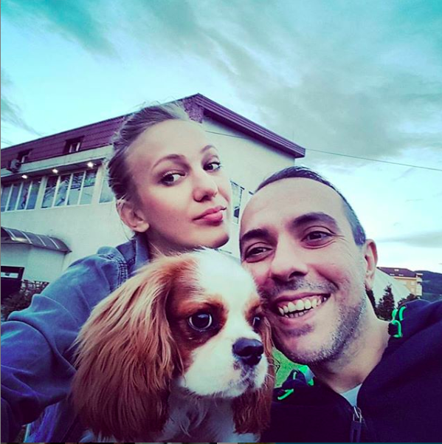
This is Zoran, he’s one of our clients who made it his life’s mission to raise awareness of ALS in his native Bosnia after his diagnosis. We feel so honored to be able to help individuals like Zoran every day.

- Biography:
As a social innovator, Sjaak has always aimed to create a more equal and fair healthcare system that give everyone, everywhere the access they need. After a successful career in advertising, he set out to dedicate his time towards social good. He founded TheSocialMedwork in 2014 with the sole mission to help patients all over the world to get access to the newest treatments not approved in their home countries.

Presenting author details

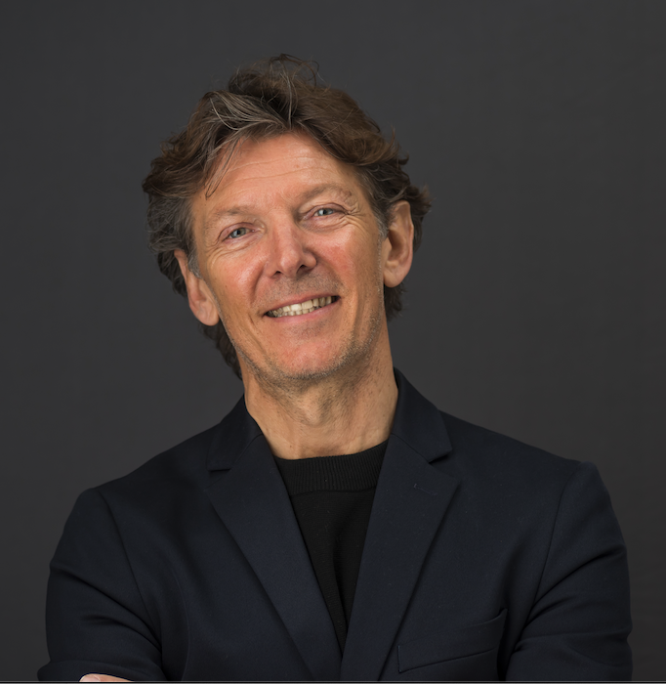
Full Name: Sjaak Vink
Contact number: 0612700777
Twitter account: @sjaakvink
Linked In account: https://www.linkedin.com/in/sjaak-vink-59752a/
Session name/ number:
Category: Oral presentation with PowerPoint
Passport Number:

