Effect of Egyptian and Libyan Bee Honeys Phenolic Compounds on Squamous Cell Carcinoma Cell Line Hep-2

Abd Elhamid ES¹, El-Gihani GA², El-Malahy MH³, El-Sayed AF⁴
¹Department of Oral Histopathology, Faculty of Oral and Dental Medicine, Misr International University, Cairo, Egypt
²Department of Oral Pathology, Faculty of Dentistry, Ben Ghazi University, Ben Ghazi, Lybia
³Department of Oral Pathology, Faculty of Dentistry, Ain Shams University, Cairo, Egypt
⁴Research Center, VACSERA, Cairo, Egypt

Keywords: Bee Honey Phenolic Compounds, Hep-2 cell line,

- Abstract Body
Background: Honey has been used as food and a traditional medicament since ancient times. However, recently many scientists have been concentrating on the anti-oxidant, anti-proliferative, anti-inflammatory and other properties of honey. This work is conducted to investigate the potential anticancer effect of various types of natural bee honey obtained from different Arabic regions on Hep-2 carcinoma cell line in comparison with 5-fluorouracil (5-FU). Methods: Anti-cancer activities of all samples were determined against the Hep-2 cell line using cytotoxicity assay, cytological analysis, DNA fragmentation assay and flow cytometry. Results: All honey samples obtained from different Arabic botanical showed anti-proliferative and apoptotic inducing activities when tested against Hp-2 cells in a time-dependent manner. Conclusions: Different types of natural bee honey are cytotoxic and showed anti-proliferative activity to Hep-2 cell line. Total phenolic content (TPC) on the analysed honeys had impact on their anti-cancerous activity. Eucalyptus honey which has the highest TPC also showed the best apoptotic effect on Hep-2 cells.

- Image
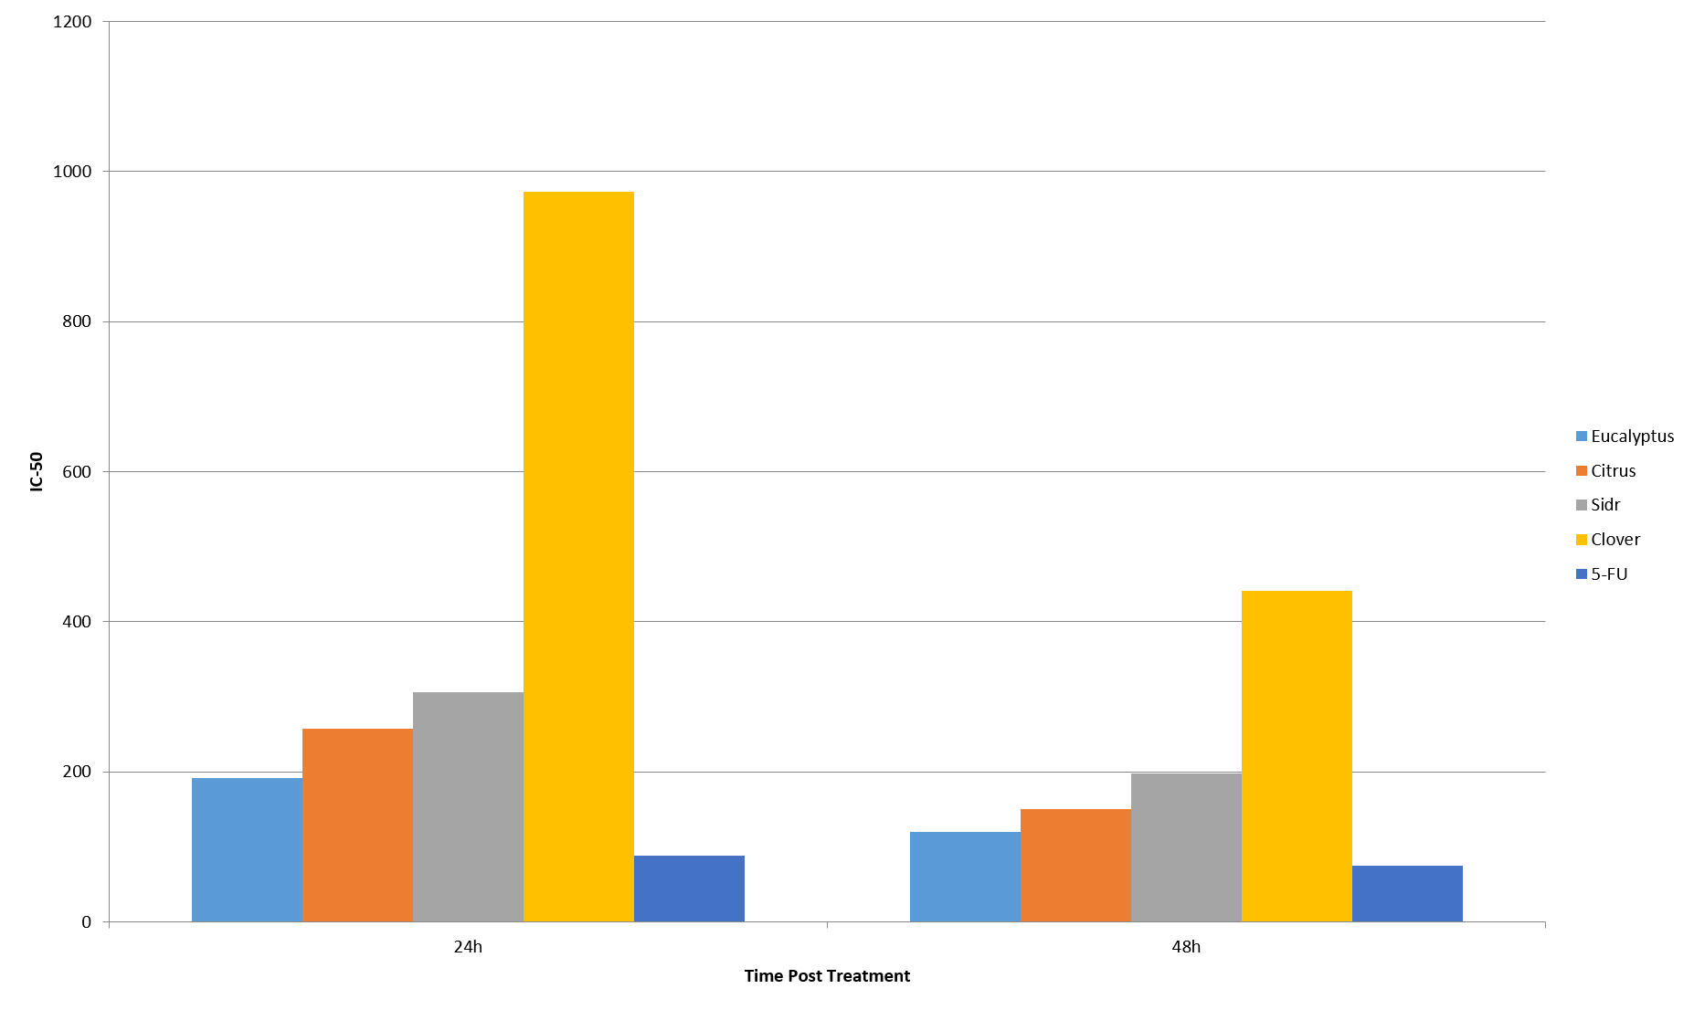

- Reference:
- Forouzanfar M, Afshin A, Alexander L, Anderson H, Bhutta Z, Biryukov S, Brauer M, Burnett R, Cercy K, Charlson F, et al. (2016) Risk Factors Collaborators. Global, regional, and national comparative risk assessment of 79 behavioural, environmental and occupational, and metabolic risks or clusters of risks, 1990-2015: a systematic analysis for the Global Burden of Disease Study. Lancet. 388(10053), pp.1659-1724.
- Aggarwal B and Shishodia S. (2006) Molecular targets of dietary agents for prevention and therapy of cancer. Biochem Pharmacol.71(10), pp.1397–1421.
- Chari R. (2008) Targeted cancer therapy: conferring specificity to cytotoxic drugs. Accounts of Chem Res. 41(1), pp.98–107.
- Goldman B. (2003) Combinations of targeted therapies take aim at multiple pathways. J Nat Cancer Institute.95(22), pp.1656–7.
- Hatakeyama H andHarashima H. (2014) Cancer multidrug resistance: mechanisms involved and strategies for circumvention using a drug delivery system. Arch Pharm Res. 37(1), pp4-15.
- Sherlock O, Dolan A, Athman R, Power A, Gethin G, Cowman S, Humphreys H. (2010) Comparison of the antimicrobial activity of Ulmo honey from Chile and Manuka honey against methicillin-resistant Staphylococcus aureus, Escherichia coli and Pseudomonas aeruginosa. BMC Compl Alternative Med. 10(47), pp1-5.
- Tomasin R, de Andrade R, Gomes-Marcondes M. (2015) Oral administration of Aloe vera and honey improves the host body composition and modulates proteolysis through reduction of tumor progression and oxidative stress in rats. J Med Food.18(10), pp1128-35.
- Ozcan M andOlmez C. (2014) Some qualitative properties of different monofloral honeys. Food Chem.163, pp212-8.
- Abubakar M, Abdullah W, Sulaiman S, and Suen A. (2012) A review of molecular mechanisms of the anti-leukemic effects of phenolic compounds in honey. Int J Mol Sci.13(11), pp15054–73.
- Jaganathan S and Mandal M. (2009) Honey constituents and their apoptotic effect in colon cancer cells. JApiPr and ApiMed Sci.1(2), pp29–36.
- Yao L, Jiang Y, Singanusong R, Datta N, Raymont K. (2004) Phenolic acids and abscisic acid in Australian Eucalyptus honeys and their potential for floral authentication. Food Chem. 86, pp169–77.
- Yaoa L, Jiang Y, Singanusong R, Datta N, Raymont K. (2005) Phenolic acids in Australian Melaleuca, Guioa, Lophostemon, Banksia and Helianthus honeys and their potential for floral authentication. Food Res. Int. 38, pp651–8.
- Andrade P, Ferreres F, Gil M, Tomás-Barberán F. (1997) Determination of phenolic compounds in honeys with different floral origin by capillary zone electrophoresis. Food Chem. 60(5), pp79–84.
- Goupy P, Hugues M, Biovin P, and Amiot M. (1999) Antioxidant composition and activity of barley (Hordeumvulgare) and malt extracts of isolated phenolic compounds. J. Sci. Food Agric. 79, pp1625-34.
- Mark. A: (2007) The nuclear area factor (NAF): A measure of cell apoptosis using microscopy and image analysis. Modern Res and Educ Topics in Microscopy.3, pp378-84.
- Wlodkowic D, SkommerJ, and Darzynkiewicz Z. (2009) Flow cytometry-based apoptosis detection. Methods Mol Biol. 55(9), pp2-5
- Aggarwal B, Danda D, Gupta S, Gehlot P. (2009) Models for prevention and treatment of cancer: Problems vs promises. Biochem Pharmacol. 78, pp1083–94.
- Prakash O, Kumar A, Kumar P. (2013) Anticancer Potential of Plants and Natural Products: A Review. 1(6), pp.104-15.
- [19] Bogdanov S, Martin, P. (2002) Honey authenticity: A review. Mitt.Lebensm.Hyg. 93, pp.232–54.
- Manthey J, Guthrie N. (2002) Antiproliferative activities of citrus flavonoids against six human cancer cell lines. Agric Food Chem. 50, pp.5837-43.
- Alzubier A and Okechukwu P. (2011) Investigation of anti-inflammatory, antipyretic and analgesic effect of Yemeni Sidr honey. World Acad of Sci, Engineer and Technol. 5(11), pp.8-20.
- Badria F, Fathy H, Fatehe A, Elimam D, Ghazy M. (2017) Evaluate the cytotoxic activity of honey, propolis, and bee venom from different localities in Egypt against liver, breast, and colorectal cancer. Journal of Apitherapy. 203(7), pp.53-9.
- Roshan N, Rippers T, Locher C, Hammer K. (2017) Antibacterial activity and chemical characteristics of several Western Australian honeys compared to manuka honey and pasture honey. Arch Microbiol. 199(2), pp.347-55.
- Fauzi A, Norazmi M, Yaacob N. (2011) Tualang honey induces apoptosis and disrupts the mitochondrial membrane potential of human breast and cervical cancer cell lines. Food Chem. Toxicol. 49, pp.871–8.
- Hsu M, Elder D, Herlyn M. (1991) Cancer Cell Lines Part 1. In: Masters, J R, Palsson B, editors. Human Cell Culture Volume 1. Dordrecht: Kluwer Academic, pp. 259–74.
- Ahmed S, Othman N. (2013) Honey as a potential natural anticancer agent: a review of its mechanisms. Evid Based Complement Alternat Med. 20, pp.82-90.
- Chua L, Rahaman N, Adnan N, Eddie T. (2013) Antioxidant activity of three honey samples in relation with their biochemical components. J Anal Methods Chem, 31(3), pp.87-98
- Wen C, Hussein S, Abdullah S, Karim N, Makpol S, Yusof Y. (2012) Gelam and Nenas honeys inhibit proliferation of HT 29 colon cancer cells by inducing DNA damage and apoptosis while suppressing inflammation. Asian Pac. J. Cancer Prev. 13(1), pp.1605–10.
- Hussein S, MohdYusof K, Makpol S, MohdYusof Y. (2011) Antioxidant capacities and total phenolic contents increase with gamma irradiation in two types of Malaysian honey. Molecules.16, pp.6378-95.
- Ghashm A, Othman N, Khattak M, Ismail N, Saini R. (2010) Antiproliferative effect of Tualang honey on oral squamous cell carcinoma and osteosarcoma cell lines. BMC Compl Alternative Med. 10, pp.49-55.
- Samarghandian S, Afshari J, Davoodi S. (2011) Honey induces apoptosis in renal cell carcinoma. Pharmacogn Mag. 7(25), pp.46-52
- Tomasin R. and Cintra Gomes-Marcondes M. (2011) Oral administration of Aloevera and honey reduces walker tumour growth by decreasing cell proliferation and increasing apoptosis in tumour tissue. Phytotherapy Research. 25(4), pp.619– 23.
- Moskwa J, Borawska M, Markiewicz-Zukowska R, Puscion-Jakubik A, Naliwajko S, Socha K, Soroczynska J. (2014) Polish natural bee honeys are anti-proliferative and anti-metastatic agents in human glioblastoma multiforme U87MG Cell Line. 9(3), pp.533-41.
- Zhivotosky B, Orrenius S. (2001) Assessment of apoptosis and necrosis by DNA fragmentation and morphological criteria. Curr Protoc Cell Biol. 18(3), pp.10-12.
- Morales P, Haza A. (2013) Antiproliferative and apoptotic effects of Spanish honeys. Pharmacogn. Mag. 9, pp.231–7.
- Jaganathan S, Mandal M. (2009) Antiproliferative effects of honey and of its polyphenols: a review. J Biomed Biotechnol.34, pp.1–13.
- Galijatovic A, Otake Y, Walle U, Walle T. (2001) Induction of UDP glucuronosyltransferase UGT1A1 by the flavonoid chrys in Caco-2-cells– potential role in carcinogen bioinactivation. Pharm Res. 18(3), pp.374–9.
- Biography:
Ehab Abd Elhamid has completed his PhD at the age of 33 years from Ain Shams University and Postdoctoral Studies from School of Dentistry, Ain Shams University, Egypt. He is the Director of Medical Research Center, Misr International University. He has published more than 25 papers in either local or international journals and has been serving as an executive director of Quality Assurance and Accreditation Project at Ministry of Higher Education, Egypt.

- Presenting author details

 | Full Name: Ehab Saeed Abd Elhamid  Contact number: 00201001520698  ORCID ID: https://orcid.org/0000-0001-9749-9861  Linked In account: Ihab Ibrahim  Session name/ number:  Category: (Oral Presentation)  Passport Number: S00019443

