Molecular detection of Anaplasma spp. in blood and milk from dairy cattle in Southern Luzon Island in the Philippines
Angelito P de la Cruz, UPCVM, UPLB, Philippines Remil L Galay, DVM PhD, UPCVM, UPLB, Philippines Flor Marie Immanuelle R. Pilapil-Amante, DVM MS, UPCVM, UPLB, Philippines

Abstract
Statement of the Problem: Polymerase chain reaction (PCR) is currently the best choice in terms of sensitivity and specificity in the detection of the presence of Anaplasma spp. in infected animals commonly being detected in blood. There is no known study in the detection of its presence in milk of infected animals until the study of Zhang et al., (2016) which reported it in milk of sheep and goats. This study was conducted to determine whether the blood parasite Anaplasma species can also be detected in the bovine milk. Methodology & Theoretical Orientation: Blood and milk were collected from a total of 98 lactating dairy cattle across the five provinces of Southern Luzon Island in the Philippines. DNA extraction, molecular detection of actin and Anaplasma spp. were done followed by genetic sequencing. Findings: A detection rate of Anaplasma spp. in 98.97% (97/98) of the blood samples and 6.12% (6/98) of the milk samples by nPCR were obtained. Genetic sequence analysis of the positive bands from the milk revealed 99% similarity with reported Anaplasma marginale isolates. Conclusion & Significance: The milk detection rate may be low but may be a huge public health concern for those consuming the milk raw warranting further investigation. To the authors’ knowledge, this is the first study done in the Philippines to detect Anaplasma in dairy cattle milk.

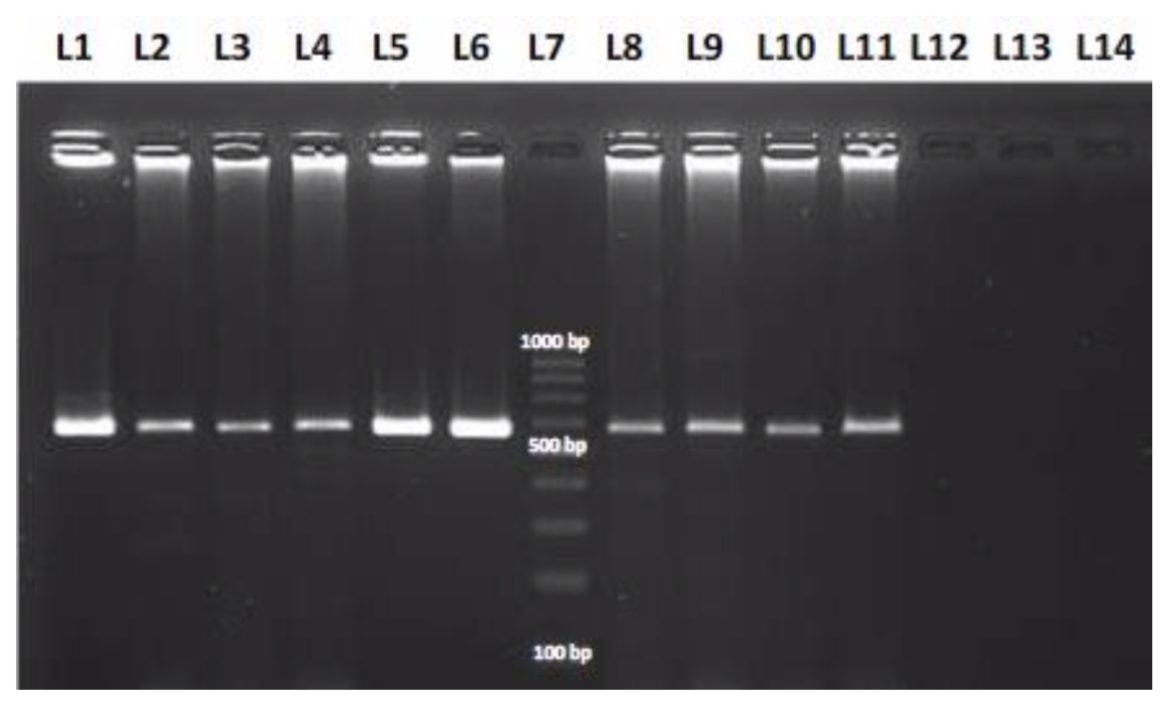
Image

Figure 1. Photograph of representative samples of nPCR products in a 2% agarose gel after electrophoresis. L1-L6 are blood samples showing positive bands for Anaplasma spp at 513 bp. L8-L13 are their milk samples counterparts. L7 is a 100-bp MW marker. L8-L11 are milk samples showing positive bands for Anaplasma spp at 513 bp. L12-L13 are milk samples negative for Anaplasma spp. L14 is a negative control.
Recent Publications
- Aquino AJB, Divina BP, Bombio AM, and Pilapil FMIR (2018) Detection of Anaplasma marginale infection in a dairy cattle farm by stained blood smear examination and nested polymerase chain reaction. Philippine Journal of Veterinary and Animal Sciences 2018 44(1): 68-75.
- Davis BJK, Li CX and Nachman KE (2014) A literature review of the risks and benefits of consuming raw and pasteurized cow’s milk. John Hopkins Public Health Magazine pp. 1- 20.
- Ochirkhuu N, Konnai S, Mingala CN, Okagawa T, Villanueva M, Pilapil FMIR, Murata S, and Ohashi K (2015) Molecular epidemiological survey and genetic analysis of vector-borne infections in Luzon Island, the Philippines. Elsevier Veterinary Parasitology 212(3- 4): 161-167.
- Ybañez AP, Mingala CN, and Ybañez RHD (2017) Historical review and insights on the livestock tick-borne disease research of a developing country: the Philippine scenario. Parasitology International 67(2): 262-266.
- Zhang Y, Lv Y, Cui Y, Wang J, Cao S, Jian F, Wang R, Zhang L, and Ning C (2016) First molecular evidence for the presence of Anaplasma DNA in milk from sheep and goats in China. Springer Parasitology Research 115: 2789-2795.

Biography
Flor Marie Immanuelle R. Pilapil-Amante is an assistant professor of the Department of Veterinary Clinical Sciences, College of Veterinary Medicine, University of the Philippines Los Baños, Philippines. She is also a large animal practitioner specialising on ruminants and veterinary public health. Her other work focuses on cattle welfare, antimicrobial resistance and ethnoveterinary medicine.
Email: frpilapil@up.edu.ph

Notes/Comments:

