Bioimmunotherapy with rm GM-CSF and enkephalin fragment peptide (Tyr-Gly-Gly) in L. donovani-infected BALB/c mice.
Ganesh Yadagiri and Prof. Prati Pal Singh*
Centre of Infectious Diseases, Department of Pharmacology and Toxicology, National Institute of Pharmaceutical Education and Research, S. A. S. Nagar, Punjab-160 062.
yadagiriganesh@gmail.com, drppsingh2016@gmail.com

Abstract
Visceral leishmaniasis (VL) is as neglected tropical protozoan parasitic disease with 20000-30000 death toll. The emergence of drug resistant parasites, serious adverse effects of current anti-leishmanials, and absence of effective vector control measures and vaccine(s) against VL poses a serious problem to VL treatment and control. In such a scenario, bioimmunotherapy of VL appears to be a promising alternative approach. Here, we have reported the bioimmunotherapeutic effect of recombinant mouse granulocyte-macrophage colony-stimulating factor (rm GM-CSF) and a synthetic enkephalin fragmented peptide Tyr-Gly-Gly (TGG) in L. donovani-infected BALB/c mice. rm GM-CSF (23 kDa) is an immunoregulatory glycoprotein cytokine, regulates the activation status of the mature macrophages and plays an important role in host defence. Met-enkephalin and its derivatives (TGG and Tyr-Gly) modulates Th1 and Th2 cytokines in vitro. Co-treatment with rm GM-CSF (10 µg/kg) and TGG (2 mg/kg ×3 per day, intraperitoneally (i.p.)) supressed the liver (86.14%) and spleen (89.1%) parasite burden in L. donovani-infected mice compared to monotherapy with rm GM-CSF/TGG treatment alone. In in-vitro, co-treatment with rm GM-CSF (3.2 ng/ml) and TGG (10⁻⁹ M) has shown maximum inhibition of intra-cellular amastigote growth than individual treatments of rm GM-CSF and TGG. In both in-vitro and in-vivo the combined bioimmunothearapeutic effect of rm GM-CSF and TGG was annulled by the treatment of anti rm GM-CSF antibody and naloxone, a non-selective opioid receptor blocker. Total circulating leukocytes and pool-size peritoneal macrophages (PM) were significantly (P< 0.001) increased in rm GM-CSF (10 µg/kg) and TGG (2 mg/kg) co-treated L. donovani-infected BALB/c mice compared to negative control. The splenocytes from protected mice and rm GM-CSF (3.2 ng/ml) and TGG (10⁻⁹ M) co-treated L. donovani-infected PM, significantly (P< 0.001) enhanced the nitrite levels in the culture supernatants. Bone marrow (BM) cellularity was increased and BM infection was completely cleared in protected mice. It is thus concluding that co-treatment with rm GM-CSF and TGG can protect the VL infected mice and thus warrants further evaluation in primates and human VL.
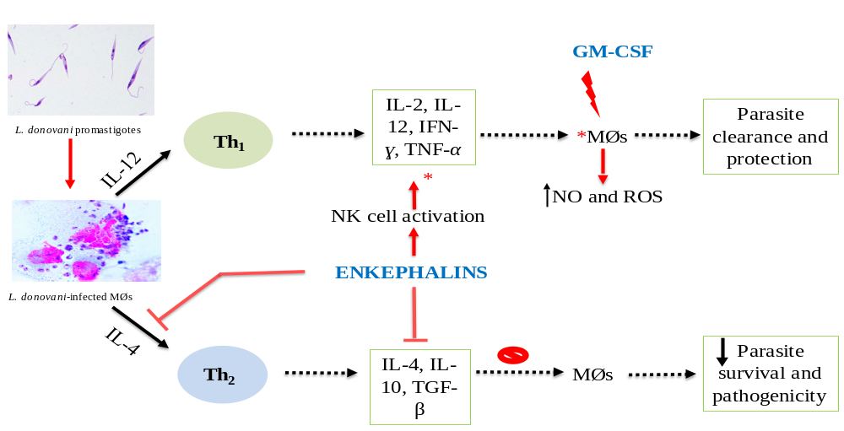
Figure 1: Immunological effects of rm GM-CSF and TGG in host-parasite interactions.

REFERENES:
- Bi, K. et al. (2018) Current visceral leishmaniasis research: a research review to inspire future study. Biomed Res. Int. 2018, 1–13
- Yadagiri, G. and Singh, P.P. (2018) Chemotherapy and experimental models of visceral leishmaniasis. In: Singh P. (eds) Infectious Diseases and Your Health. Springer, Singapore. 63-97.
- Singh, O.P. and Sundar, S. (2014) Immunotherapy and targeted therapies in treatment of visceral leishmaniasis: Current status and future prospects. Front. Immunol. 5, 1–9
- Kaur, A. et al. (2004) Bioimmunotherapy of rodent malaria: Co-treatment with recombinant mouse granulocyte-macrophage colony-stimulating factor and an enkephalin fragment peptide Tyr-Gly-Gly. Acta Trop. 91, 27–41
- Piva, M. et al. (2006) In vitro modulation of cytokine expression by enkephalin-derived peptides. Neuroimmunomodulation 12, 339–347

Contact:
Ganesh Yadagiri, Ph.D Scholar,
yadagiriganesh@gmail.com,
Mobile: 7696364419,
Centre of infectious disease, Department of Pharmacology and Toxicology, National Institute of Pharmaceutical Education and Research (NIPER), Mohali, India.

