AERODYNAMICS OF THE EMPTY NOSE SYNDROME AND NASAL SEPTUM PERFORATION
Dmitrii A Shcherbakov, MD, Russian eye and plastic surgery center, Russia
Nikita I Cheremnyh, PhD, Russian eye and plastic surgery center, Russia

Abstract
Statement of the Problem: Surgical treatment of the empty nose syndrome is a complex, general medical problem. Researchers have reported that after performing CFD modeling in group 1, it was found that air is distributed mainly in the lower nasal passage, the speed varies 5.5 ± 1.5 m/s. Pressure indicators reach from + 5 ± 2 Pa, which shows a reduced "suction" force of the nose. The air temperature practically does not change, varying 26.8 ± 0.3 Celsius. Humidity decreases to 88 ± 4.3%. In group 2, it was found that the speed pattern varies from 20 ± 4 m/s. The presence of perforation creates a shunt between the both nasal cavities, which negatively affects the air heating and pressure. The air temperature throughout the nasal cavity during perforation varies 30.4 ± 0.5 Celsius, while in the perforation area it decreases to 25.6 ± 0.2. The pressure indicators slightly deteriorate, varying from -35 ± 5 Pa throughout the nasal cavity and to -50 ± 5 Pa in the nasopharynx. The relative humidity index decreases and amounts to 97 ± 0.34%. Methodology & Theoretical Orientation: Two groups were formed for the study. Group 1 - patients with empty nose syndrome after resection of the lower nasal turbinates (32 people), group 2 - patients with perforation of the nasal septum (31 people) – fig. 1. Modeling of the air flow in the nasal cavity was carried out using the ANSYS. Conclusion & Significance: Using the results obtained, the tactics of surgery in Group 1 is the thickening of the nasal septum and augmentation of the lower nasal concha in order to narrow the lower nasal passage so that air can rush into the upper sections. In group 2, the tactic is surgical closure of the nasal septum perforation with the ethmoid artery mucosal flap.

Image
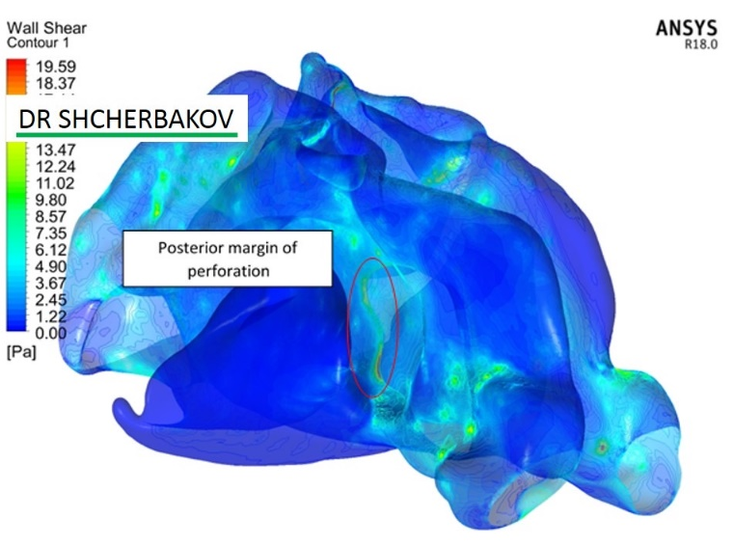
Fig.1. The wall shear stress on the posterior margin of the nasal septum perforation – the main factor of the perforation enlargement and recurrent nasal bleeding
Recent Publications (minimum 5)
- Farzal Z, Del Signore AG, Zanation AM, Ebert et al. A computational fluid dynamics analysis of the effects of size and shape of anterior nasal septal perforations. Rhinology. 2019;57(2):153-159.
- Shcherbakov DA, Kryukov AI, Madayev TS, Kokareva VV. [The role of computational aerodynamics of the nasal cavity in diagnostics of septal deviation]. Rossiyskaya Otorinolaringologiya. 2019;18;4(101):82-88.
- Shcherbakov DA, Kryukov AI, Krasnozhen VN, Garskova YuA, Saushin II. [CFD-simulation of the air flows in the maxillary sinus]. Vestnik Otorinolaringologii. 2017;82(4):32-34.
- Shcherbakov DA, Kokareva V.V., Cheremnykh N.I. Computational Aerodynamics in Nasal Septal Perforation / International Journal of Biomedicine 10(1) (2020) 82-85.
- Pless D, Keck T, Wiesmiller KM, Lamche R et al. Numerical simulation of airflow patterns and air temperature distribution during inspiration in a nose model with septal perforation. Am J Rhinol. 2004;18(6):357-62.

Biography
Dmitry Shcherbakov has his own experience in the diagnosis and surgical treatment of patients with the empty nose syndrome (ENS). Based on the CFD-modeling method, he inspired new mechanisms in the pathogenesis of ENS. At the Russian Center for Ophthalmic and Plastic Surgery, he is the founder and head of the Department of Otorhinolaryngology and the laboratory for modeling aerodynamics "AirFlow".
Email: dmst@bk.ru

Notes/Comments

