KneeNet: A Keypoint-Based Deep Learning Model for Automated Joint Space Width Estimation in Knee Osteoarthritis
Chia-Hui Lin¹⁻², Kun-Hui Chen^{2-4, *}
- Department of Computer Science and Engineering, National Chung Hsing University, Taichung 402, Taiwan.
- Department of Orthopedic Surgery, Taichung Veterans General Hospital, Taichung 407, Taiwan.
- Department of Post-Baccalaureate Medicine, College of Medicine, National Chung Hsing University, Taichung 402, Taiwan
- Department of Computer Science and Information Engineering, Providence University, Taichung 433, Taiwan.
* Corresponding Author: Kun-Hui Chen (e-mail: khc@vghtc.gov.tw).
Introduction: Knee osteoarthritis (OA) is one of the most prevalent degenerative joint diseases, causing chronic pain, stiffness, and functional impairment, particularly among older adults. Accurate quantification of joint space width (JSW) on knee radiographs is essential for early diagnosis and longitudinal monitoring of OA progression. However, manual measurement remains inconsistent and highly dependent on physician expertise, which limits reproducibility and efficiency.
Methods: To address these limitations, we developed KneeNet, a keypoint-based deep learning model designed to estimate medial and lateral JSW through the prediction of four anatomically defined landmarks on standard knee radiographs. KneeNet introduces a Directional Axis-weighted Euclidean (DAE) loss function, which places stronger emphasis on vertical precision for alignment with bone contours. Furthermore, the model incorporates a visual warning system based on heatmap overlays, allowing clinicians to immediately verify predictions. These interpretability features enhance clinical trust and provide safeguards against misinterpretation.
Results: KneeNet was evaluated by a large-scale clinical dataset of 4,184 radiographs collected at Taichung Veterans General Hospital. On the public dataset, the model achieved a vertical localization error of 0.21 mm and JSW error of 0.21 mm. The intraclass correlation coefficient exceeded 0.96, indicating strong agreement between KneeNet and experienced orthopedic surgeons.
Clinical Integration: By integrating into hospital workflows through PACS and HIS systems, KneeNet enables fully automated processing of radiographs, returning both quantitative results and visual overlays in real time. This streamlined process reduces manual workload and enhances diagnostic reproducibility. Importantly, the heatmap-based warning mechanism ensures that clinicians can rapidly identify model predictions, reinforcing the system’s safety in clinical practice.
Conclusion: In conclusion, KneeNet demonstrates that a keypoint-based deep learning model, combined with a directionally weighted loss function and a visual verification mechanism, can deliver clinically reliable, interpretable, and reproducible JSW measurements. Its seamless integration into existing radiology infrastructure highlights its potential as a practical tool for real-time OA diagnosis and monitoring in everyday clinical care.
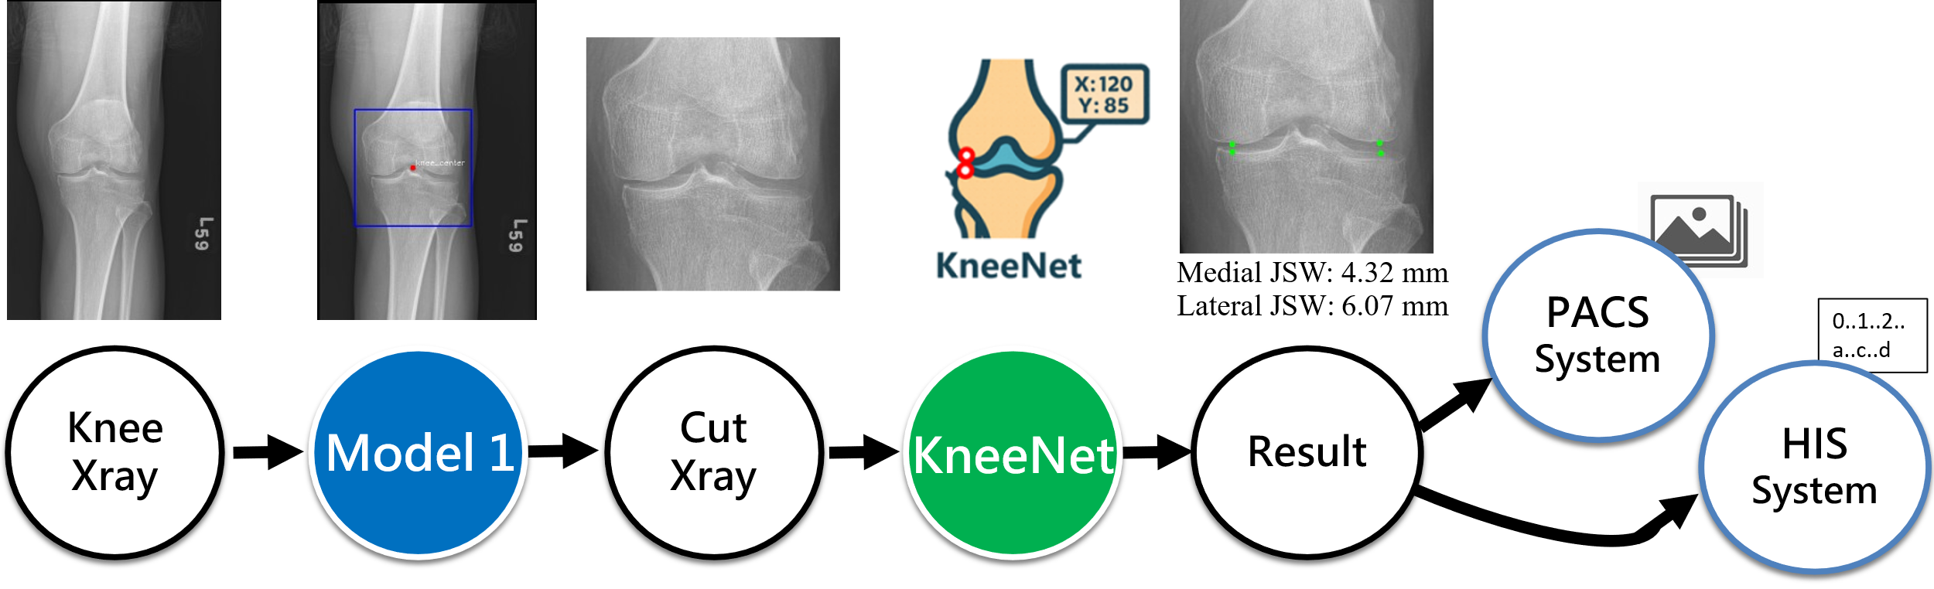
Clinical Workflow of KneeNet Integration.

