WALKING ON WATER – HOW JOINTS WORK AND OSTEOARTHRITIS
Background
Joints experience massive forces but subchondral circulation was never studied during activity.
Intraosseous pressure (IOP) poorly understood.
Bone fat is semi-liquid at body temperature.
Subchondral adipocytes, capillaries and trabeculae are delicate and flexible yet tolerate huge loads.
T2 MRI scans show subchondral vascular marks, lost in osteoarthritis (OA) Fig1.
Anatomy and histology support hydraulic pressure load-bearing.
Objectives
To demonstrate:
IOP varies and is not a constant for the whole bone but reflects systemic blood pressure.
Individual IOPs have a proportionate pulse volume (PV).
Subtracting proximal arterial occlusion (IOPa) from proximal venous occlusion (IOPv), gives needle tip perfusion ‘bandwidth’.
Subchondral IOP is increased by loading, far above perfusion pressures.
Steroid manipulation of intraosseous fat volume alters perfusion.
Sub-cortical choke valves contain raised hydraulic pressure during load transfer.
MRI scans have water bright marks, lost in early osteoarthritis Fig2.
OA is a vasculo-mechanical disease.
Methods
IOP perfusion and loading studies in vitro with a perfused calf foot model (x188), in vivo in the rabbit (x42) and in man (x7), with and without vascular occlusion.
Steroid-treated model (x12) with IOP and angiograms compared to untreated control.
Sixty pairs of upper tibial MRI scan vascular marks compared with Kellgren-Lawrence (K-L) plain x-ray score.
Histology - calf, rabbit and man, normal and OA
Results
IOP is proportional to BP p<0.0005
IOP is proportional to pulse volume p<0.001, correlation r²=0.9089
IOP rises with proximal venous occlusion p<0.012
IOP falls with proximal arterial occlusion p<0.0001
Subchondral IOP rise with one body weight is 53% p<0.0002
Steroid model loses bone fat giving secondary hyperdynamic flow on IOP, micro-angiograms confirm.
Loss in vascular MRI marks with increasing K-L grade of OA p<0.002.
Histology demonstrates same MRI vessels in subchondral plane and sub-cortical choke valves.

Conclusions
Combinations of IOP measurement with proximal vascular occlusion and loading allow exploration of subchondral weight-bearing physiology. Intraosseous fat volume manipulation with steroids affects IOP. Specialised bone lipids and vascular anatomy allow hydraulic pressure load transmission. A loss in MRI subchondral vascularity is associated with increasing OA. This new field of subchondral physiology holds the key to an understanding of osteoarthritis and other bone pathology and the hope of better treatment.

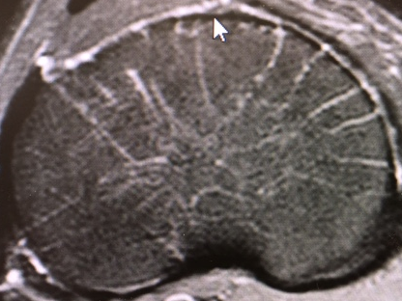
Fig1 Water-bright vascular marks MRI

Fig2 Marks lost with increased OA

