Endoplasmic reticulum stress-mediated inflammatory signaling pathways within the osteolytic periosteum and interface membrane in particle-induced osteolysis
Guoyin Liu, Jianmin Chen.
Department of Orthopaedics, Jinling Hospital of Nanjing Medical University, Nanjing, 210000, China.
Abstract
Aseptic loosening secondary to periprosthetic inflammatory osteolysis results from the biological response to wear particles and is a leading cause of arthroplasty failure. The origin of this inflammatory response remains unclear. We aim to validate the definite link between endoplasmic reticulum (ER) stress and particle-induced inflammatory signaling pathways in periprosthetic osteolysis. We examine the histopathologic changes of osteolysis and the expression of specific biomarkers for ER-stress-mediated inflammatory signaling pathways (IRE1α, GRP78/Bip, c-Fos, NF-κB, ROS and Ca²⁺). Moreover, pro-inflammatory cytokines (TNF-α, IL-1β and IL-6) and osteoclastogenic molecules (VEGF, OPG, RANKL and M-CSF) were assessed in clinical interface membranes and murine periosteum tissues. We found wear particles to be capable of inducing ER stress in macrophages within clinical osteolytic interface membranes and murine osteolytic periosteum tissues and to be associated with the inflammatory response and osteoclastogenesis. Blocking ER stress with sodium 4-phenylbutyrate (4-PBA) results in a dramatic amelioration of particle-induced osteolysis and a significant reduction of ER-stress intensity. Simultaneously, this ER-stress blocker also lessens inflammatory cell infiltration, diminishes the capability of osteoclastogenesis and reduces the inflammatory response by lowering IRE1α, GRP78/Bip, c-Fos, NF-κB, ROS and Ca²⁺ levels. Thus, ER stress plays an important role in particle-induced inflammatory osteolysis and osteoclastogenic reactions. The pharmacological targeting of ER-stress-mediated inflammatory signaling pathways might be an appealing approach for alleviating or preventing particle-induced osteolysis in at-risk patients.
Key words: Endoplasmic reticulum stress; Osteolysis; Aseptic loosening; Wear
Particles.

Biography
Guoyin Liu has completed his Master's degree from Medical School of Nanjing University, and is currently a PhD candidate in Nanjing Medical University. He is the doctor-in-charge and associate professor at the Department of Orthopaedics, Jinling Hospital of Nanjing Medical University. He worked mainly on the role of intracellular and extracellular GRP78/Bip in particles-induced periprosthetic osteolysis and rheumatoid arthritis; the clinical application of extracorporeal shock wave therapy, corticosteroid injection, and needle-knife therapy in the treatment of chronic plantar fasciitis; and the application of lamina osteotomy and replantation with miniplate fixation (restorative laminoplasty) in intraspinal occupying lesions. He had been invited as a speaker to the “World Congress on Virology & Infectious Diseases” during November 20-22, 2017 in Miami, FL, USA, and as a speaker to the International Conference on Biomarker Research in Clinical Medicine scheduled for February 19-21, 2018 in Paris, France (BRCM 2018). He was a member of the Standing Committee of the China Medicine Education Association (CMEA), and a managing director of National Association of Health Industry and Enterprise Management (NAHIEM). He was an editorial board member for Journal of《Orthopaedic Surgery and Research》, 《Innate Immunity》, 《Frontiers in Bioscience-Landmark》, 《Current Molecular Medicine》and《Current Pharmaceutical Design》. He was also an editorial board member for Tianjin Medical Journal, Chinese General Practice , China Medical Herald，New Medicine, Drugs & Clinic, Chinese Traditional and Herbal Drugs, Anhui Medical and Pharmaceutical Journal, Anhui Medical Journal, Translational Medicine Journal, Journal of Medical Research, Health Medicine Research and Practice, Hebei Medicine, Hainan Medical Journal, Zhejiang Clinical Medical Journal, China Modern Medicine, China Modern Doctor, and Henan Medical Research. He have obtained several project: The National Natural Science Foundation of China (NSFC)(82102547), The Natural Science Foundation of Jiangsu Province (BK20181113), The Science and Technology Foundation of Nanjing City (201803059), Youth Science Foundation Project of Jingdu Hospital (20170302), Technological Innovation Foundation of Nanjing Military Region (15ZD020), The Science and Technology Foundation of Nanjing City (201503007) ,Clinical Scientific Project of Wu Jieping Medical Foundation (320-2745-16-115), Technological Innovation Foundation of Nanjing Military Region (14MS046).

About Research Topic
The cell fate and growth in interface membrane, influenced by wear particles, were activated in response to ER stress; in addition, prolonged and enduring ER stress was thought to be essential to the pathogenesis of inflammatory diseases. However, previous work has provided only a limited viewpoint regarding the influence of ER stress on inflammatory osteolysis and reports describing the straight effect of ER stress on particle-induced inflammation and osteoclastogenesis were scarce. Thus, we hypothesized that particle-induced inflammatory signaling pathways within the osteolytic interface membrane in periprosthetic osteolysis are mediated by ER stress and that the inhibition of the ER-stress response in osteolytic tissue macrophages, which could further cause changes in particle-induced inflammation and osteoclastogenesis, is undoubtedly a good therapeutic option. Therefore, in our study, we determined the potential effect of ER stress on wear particle-induced osteolysis, osteoclastogenesis and macrophage inflammation within osteolytic tissues in an effort to identify the mechanism of the inflammatory response caused by wear particles.

Endoplasmic reticulum stress-mediated inflammatory signaling pathways is as follows:

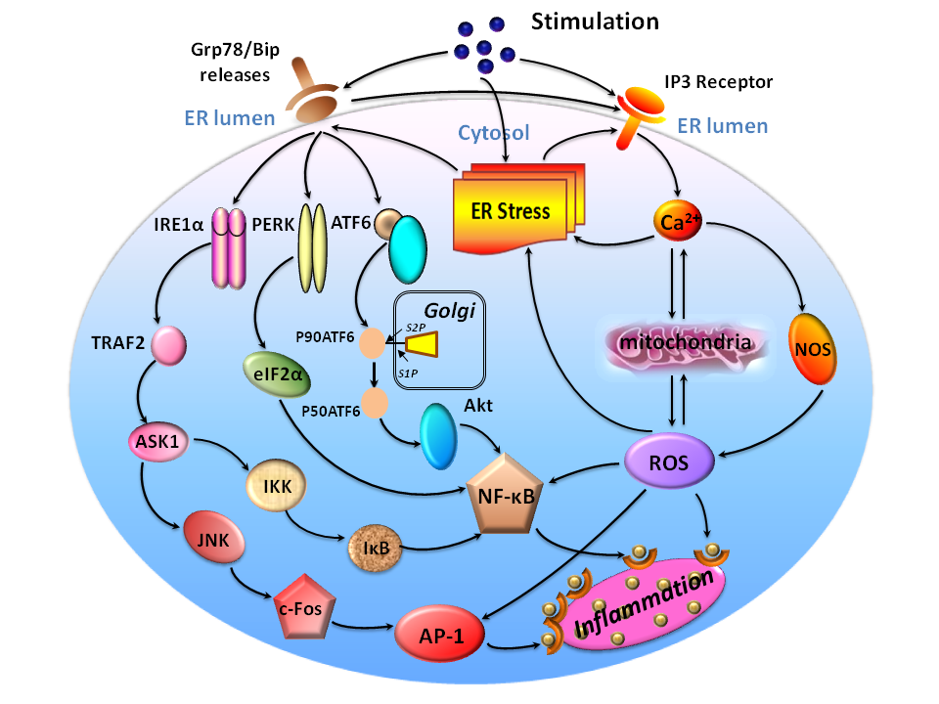
ER-stress-mediated inflammatory signaling pathways proposed in particle-induced periprosthesis osteolysis. Wear particles phagocytosed by macrophages might induce ER stress and several potential avenues might link ER stress and inflammatory signaling. Normally, the ER chaperone Grp78/BiP binds the N-termini of ER-stress sensors IRE1α, PERK and ATF6, preventing their activation. In response to particle-induced ER stress, Ca2+ is released from ER and Grp78/BiP preferentially binds to unfolded or misfolded proteins, thus driving the equilibrium of Grp78/ BiP binding away from IRE1α, PERK and ATF6. Upregulation of these genes triggers ER stress and thereby activates their downstream mediators of inflammation and leads to the release of NF-κB, AP-1 and ROS. These molecules move to the nucleus and switch on the expression of a variety of genes involved in inflammation, such as TNF-α, IL-1β and IL-6, leading to inflammatory responses

About Institution:
Jinling Hospital of Nanjing Medical University, also named as General Hospital of Eastern Theater Command, located in Nanjing, China, is a tertiary hospital.

References:
[1] Liu G, Guo T, Zhang Y, Liu N, Chen J, Chen J, et al. Apoptotic pathways of macrophages within osteolytic interface membrane in periprosthestic osteolysis after total hip replacement. APMIS 2017 2017-06-01;125(6):565-578.
[2] Liu G, Liu N, Xu Y, Ti Y, Chen J, Chen J, et al. Endoplasmic reticulum stress-mediated inflammatory signaling pathways within the osteolytic periosteum and interface membrane in particle-induced osteolysis. CELL TISSUE RES 2016 2016-02-01;363(2):427-447.
[3] Wang Z, Liu N, Liu K, Zhou G, Gan J, Wang Z, et al. Autophagy mediated CoCrMo particle-induced peri-implant osteolysis by promoting osteoblast apoptosis. AUTOPHAGY 2015 2015-01-20;11(12):2358-2369.
[4] Wang Z, Liu N, Shi T, Zhou G, Wang Z, Gan J, et al. ER Stress Mediates TiAl6V4 Particle-Induced Peri-Implant Osteolysis by Promoting RANKL Expression in Fibroblasts. PLOS ONE 2015 2015-01-20;10(9):e137774.
[5] Wang R, Wang Z, Ma Y, Liu G, Shi H, Chen J, et al. Particle-induced osteolysis mediated by endoplasmic reticulum stress in prosthesis loosening. BIOMATERIALS 2013 2013-04-01;34(11):2611-2623
[6] Wang Z, Huang Z, Gan J, Liu N, Zhou G, Shi T, et al. The fibroblast expression of RANKL in CoCrMo-particle-induced osteolysis is mediated by ER stress and XBP1s. ACTA BIOMATER 2015 2015-09-01;24:352-360
[7] Liu L, Zhou M, Zhu R, et al. Hydrogen sulfide protects against particle-induced inflammatory response and osteolysis via SIRT1 pathway in prosthesis loosening[J]. FASEB J,2020,34(3):3743-3754.
[8] Zou B, Zhang Y, Li T, et al. A mutation of cysteine 46 in IKK-beta promotes mPGES-1 and caveolin-1 expression to exacerbate osteoclast differentiation and osteolysis[J]. Biochem Pharmacol,2020,172:113762.
[9] Hu J, Li X, Chen Y, et al. The protective effect of WKYMVm peptide on inflammatory osteolysis through regulating NF-kappaB and CD9/gp130/STAT3 signalling pathway[J]. J Cell Mol Med,2020,24(2):1893-1905.
[10] Enogieru A B, Omoruyi S I, Hiss D C, et al. GRP78/BIP/HSPA5 as a Therapeutic Target in Models of Parkinson's Disease: A Mini Review[J]. Adv Pharmacol Sci,2019,2019:2706783.
[11] Girona J, Rodriguez-Borjabad C, Ibarretxe D, et al. The Circulating GRP78/BiP Is a Marker of Metabolic Diseases and Atherosclerosis: Bringing Endoplasmic Reticulum Stress into the Clinical Scenario[J]. J Clin Med,2019,8(11).
[12] Ghaderi S, Ahmadian S, Soheili Z S, et al. AAV delivery of GRP78/BiP promotes adaptation of human RPE cell to ER stress[J]. J Cell Biochem,2018,119(2):1355-1367.
[13] Ruggiero C, Doghman-Bouguerra M, Ronco C, et al. The GRP78/BiP inhibitor HA15 synergizes with mitotane action against adrenocortical carcinoma cells through convergent activation of ER stress pathways[J]. Mol Cell Endocrinol,2018,474:57-64.
[14] Cubillos-Ruiz J R, Bettigole S E, Glimcher L H. Tumorigenic and Immunosuppressive Effects of Endoplasmic Reticulum Stress in Cancer[J]. Cell,2017,168(4):692-706.
[15] Ghosh R, Wang L, Wang E S, et al. Allosteric inhibition of the IRE1alpha RNase preserves cell viability and function during endoplasmic reticulum stress[J]. Cell,2014,158(3):534-548.
[16] Hotamisligil G S. Endoplasmic reticulum stress and the inflammatory basis of metabolic disease[J]. Cell,2010,140(6):900-917.
[17] Pfaffenbach K T, Lee A S. The critical role of GRP78 in physiologic and pathologic stress[J]. Curr Opin Cell Biol,2011,23(2):150-156.
[18] Salganik M, Sergeyev V G, Shinde V, et al. The loss of glucose-regulated protein 78 (GRP78) during normal aging or from siRNA knockdown augments human alpha-synuclein (alpha-syn) toxicity to rat nigral neurons[J]. Neurobiol Aging,2015,36(6):2213-2223.
[19] Ruggiero C, Doghman-Bouguerra M, Ronco C, et al. The GRP78/BiP inhibitor HA15 synergizes with mitotane action against adrenocortical carcinoma cells through convergent activation of ER stress pathways[J]. Mol Cell Endocrinol,2018,474:57-64.
[20] Ghaderi S, Ahmadian S, Soheili Z S, et al. AAV delivery of GRP78/BiP promotes adaptation of human RPE cell to ER stress[J]. J Cell Biochem,2018,119(2):1355-1367.
[21] Lev A, Lulla A R, Wagner J, et al. Anti-pancreatic cancer activity of ONC212 involves the unfolded protein response (UPR) and is reduced by IGF1-R and GRP78/BIP[J]. Oncotarget,2017,8(47):81776-81793.
[22] Park K W, Eun K G, Morales R, et al. The Endoplasmic Reticulum Chaperone GRP78/BiP Modulates Prion Propagation in vitro and in vivo[J]. Sci Rep,2017,7:44723.
[23]Zaiss M M, Hall C, Mcgowan N, et al. Binding Immunoglobulin Protein (BIP) Inhibits TNF-alpha-Induced Osteoclast Differentiation and Systemic Bone Loss in an Erosive Arthritis Model[J]. ACR Open Rheumatol,2019,1(6):382-393.

