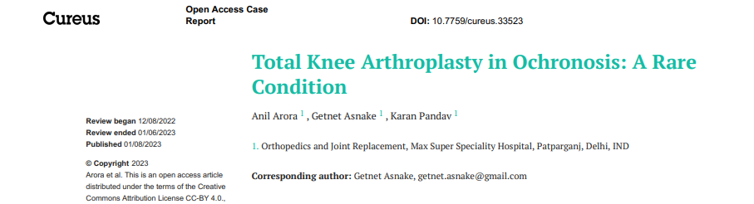


Abstract

Ochronosis is a rare metabolic disorder characterized by homogentisic acid deposition in the large joints and spine, resulting in progressive degeneration. We present two cases of ochronotic arthritis of the knee subjected to cemented total knee arthroplasty (TKA). These cases were diagnosed intraoperatively and later confirmed with a histopathologic examination. Orthopedic surgeons should be aware of the condition as the intraoperative finding of darkened cartilage might surprise them. After a five-year TKA follow-up, both of our cases showed better mobility and function.

Biography

Dr Getnet Asnake is an Orthopedic surgeon and a researcher at Feya General Hospital, Shashemene , Ethiopia. Currently he is a fellow in Hip and Knee Arthroplasty at Max Super Speciality Hospital,Delhi, India. Recently he has published an article on“Total Knee Arthroplasty in Ochronosis: a Rare Condition”. He has also published other publications in the field of Arthroplasty like “Stress fractures of the femoral neck following Total knee Arthroplasty” and “Total Knee Arthroplasty in Patients with Prior Quiescent Distal Femur Osteomyelitis”.

About Research Topic
Ochronosis is a rare metabolic disorder with a prevalence of one in 250,000-1,000,000 births. This metabolic disorder occurs in the catabolic pathway of tyrosine and is caused by a deficiency of the hepatic enzyme homogentisate oxidase, leading to the accumulation of homogentisic acid in connective tissues . The deposition of homogentisic acid leads to dark pigmentation, inflammation, and, later on, the degeneration of the tissue.The deposition is seen on articular cartilage, bones, tendons, ears, sclera, skin, and aortic valves . The accumulation of homogentisic acid in the bigger joints over the years results in articular cartilage degeneration and ochronotic arthritis. Commonly affected joints include the spine, hip, knee, shoulder, and sacroiliac. Total knee arthroplasty (TKA) is indicated for patients with advanced ochronotic arthropathy of the knee.

About Institution:
Max Super Speciality Hospital, Patparganj is 400+ bed Healthcare facility and a unit of Balaji Medical Diagnostic Research Centre, providing services in medical disciplines of Cardiac Sciences, Oncology, Neurosciences, Obstetrics and Gynaecology, Orthopaedics, Urology and Kidney Transplants, Minimal Access, Metabolic, and Bariatric Surgery, among others. Equipped with 116 ICU beds and 14 HDU beds,
Max Super Speciality Hospital Patparganj brings together patient-centric care and the latest innovations in medical technology. With over 510 medical experts and leading doctors, and a nursing staff of over 770 nurses, each and every individual of the Max Patparganj family is committed towards providing the highest standard of
medical care in the world. Armed with state-of-the-art technology, 11 high-end modular Operation Theaters, and a commitment to provide patient-centric care, we make sure that every patient who
walks through the doors of Max Healthcare and gets a holistic healing environment that they deserve. With over 28 clinical specialities, Max Super Speciality Hospital, Patparganj offers the advantage of integrated medical care in a multidisciplinary setting provided by a faculty of highly qualiﬁed doctors,
nurses, &amp; healthcare professionals. Comprehensive specialist services are provided with advanced
medical technology, making it a regional hub for complex procedures such as neurovascular interventional procedures, targeted cancer treatments, heart surgeries, orthopaedic surgeries, and
fertility treatments. Max Super Speciality Hospital, Patparganj is an established leader among healthcare
providers with multiple awards and industry accreditations to its name for world-class infrastructure,
advanced technology, and health and safety standards.

