

Abstract Template

Title: A unique case of latissimus dorsi tendon avulsion injury in an athlete cycling anabolic steroids and successful delayed repair utilizing an intracortical button technique1

WATERS G¹, D’ALESSANDRO P¹²³, MCGRATH B⁴, LEITH J⁵

¹ Fiona Stanley Fremantle Hospitals Group; Perth, Western Australia

² School of Surgery, University of Western Australia, Western Australia

³ Orthopaedic Research Foundation of Western Australia, Western Australia

⁴ Hunter Sports and Joint Replacement; New South Wales, Australia

⁵ Department of Orthopaedics, University of British Columbia, Canada

Keywords: latissimus dorsi, surgical repair, avulsion, anabolic steroids, athlete

- Abstract Body (up to 250 words)
Latissimus Dorsi is a large pectoral girdle muscle and powerful arm adductor (1, 2). Avulsion injuries of its tendinous insertion into the humerus are incredibly rare. Surgical repair has rarely been reported, literature showing fewer than 15 cases, most with tendon augmentation (1, 3-8). This unique and complex case of a delayed Latissimus Dorsi avulsion injury in a power-lifting athlete cycling anabolic steroids. Using an intracortical button technique, we proposed that this robust repair would enable restoration of full function, strength and cosmetic defects.
28-year-old competitive powerlifter cycling anabolic androgenic steroids and testosterone presented 15 weeks post injury. Clinical examination revealed obvious asymmetry, tenderness and posterior axillary fold defect. Profound weakness of resisted arm adduction. MRI revealed absent Latissimus Dorsi insertion, tendon stump in axilla.
Surgical repair was undertaken via dual axillary approach. Retracted tendon mobilised and two titanium buttons with integrated Fibrewire Sutures (Arthrex Inc) created a modified Krakow suture, a novel technique. A dual fixation point at its anatomical insertion was created using an intracortical button. We described a successful delayed repair of this chronic injury without the need for tendon augmentation. Dual approach assists with tendon mobilization and preparation, along with restoration of anatomy and strong fixation at bicipital groove. Clinical and radiological evidence of recovery without pain, correction of cosmetic defects and full return to competitive powerlifting.
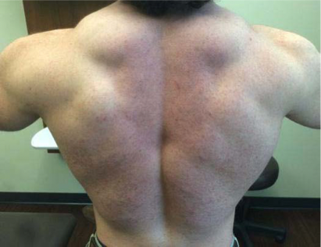
This robust intracortical button technique produces a successful Latissimus Dorsi tendon avulsion repair with incredible results leading to restoration of full function, even in the most challenging competitive athletes.

Image:

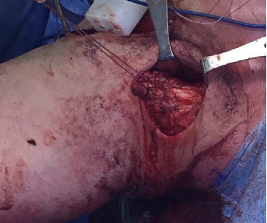
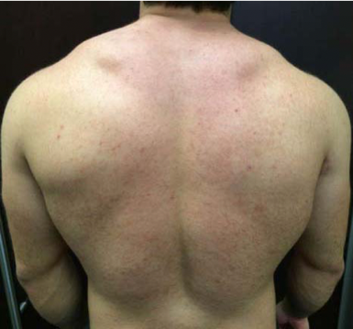

Reference:
- Çelebi M, Ergen E, Üstüner E. Acute Traumatic Tear of Latissimus Dorsi Muscle in an Elite Track Athlete. Clin Pract. 2013; 3: 37-38.
- Moore K, Dalley AF, Agur AMR. Clinically Oriented Anatomy. 6 ed. Philadelphia: Lippincott Williams & Wilkins; 2006; 1134.
- Hiemstra L, Butterwick, D, Cooke, M, Walker, RE. Surgical Management of Latissimus Dorsi Rupture in a Steer Wrestler. Clinical Journal of Sport Medicine. 2007;17(4):316-8.
- Schickendantz M, Kaar SG, Meister K, Lund P, Beverley L. Latissimus dorsi and teres major tears in professional baseball pitchers: a case series. American Journal of Sports Medicine. 2009;37(10):2016-20.
- Nagda S, Cohen SB, Noonan TJ, Raasch WG, Ciccotti MG, Yocum LA. Management and outcomes of latissimus dorsi and teres major injuries in professional baseball pitchers. American Journal of Sports Medicine. 2011;39(10):2181-6.
- Park J, Lhee, SH, Keum, JS. Rupture of latissimus dorsi muscle in a tennis player. Orthopedics. 2008;31(10).
- Butterwick D, Mohtadi NG, Meeuwisse WH, Frizzell JB. Rupture of latissimus dorsi in an athlete. Clinical Journal of Sport Medicine. 2003;13(3):189-91.
- Hapa O, Wijdicks, CA, LaPrade, RF, Braman, JP. Out of the ring and into a sling: acute latissimus dorsi avulsion in a professional wrestler: a case report and review of the literature. Knee Surgery, Sports Traumatology, Arthroscopy. 2008;16:1146-50.
Citation: Waters G, D’Alessandro P, McGrath B, Leith J (2018) A Unique Case of Latissimus Dorsi Tendon Avulsion Injury in an Athlete Cycling Anabolic Steroids and Successful Delayed Repair Utilizing an Intracortical Button Technique. Ann Sports Med Res 5(1): 1127.

Biography:
Georgina is an Orthopaedic Registrar at Fiona Stanley Hospital in Perth, Australia. She completed her post-graduate Bachelor of Medicine and Surgery at the University of Western Australia in 2014. Mr Peter D’Alessandro is an Orthopaedic Consultant at the Fiona Stanley and Fremantle Hospital Group, specializing in shoulder and knee reconstruction, hip arthroscopy, surgery for athletes. He completed his Fellowship of the Royal Australasian College of Surgeons and the Australian Orthopaedic Association in 2013.

Presenting author details
Full Name: Georgina Waters
Contact number: +61 439958663
Category: Oral presentation
Passport Number: PA8036074

Copyright © 2016-2018 Meetings Int PTE Ltd, All Rights Reserved.
Meetings Int.Pte Ltd

Company Registration No: 201524282R,28 MAXWELL ROAD, #03-05 RED DOT TRAFFIC, SINGAPORE (069120)
Tel: +6531080483| Toll Free no. +800-852-6126
Web: https://www.meetingsint.com/conferences/orthopedics | E-mail: orthopedics@annualmeetings.net

