

Title: Ganglion cyst of Hoffa’s fat pad of knee-a rare cause of anterior knee pain and swelling
Rakesh Goyal¹, Rajat Chopra², Shivendra Singh³, Puneet Kamra⁴

¹ Senior resident, Department of orthopedics (Lok Nayak Hospital and Maulana Azad Medical College, New Delhi, India)
² Senior Consultant, Department of Orthopaedics (Sir Ganga Ram Hospital, New Delhi)
³ Senior Resident, Department of Orthopaedics (GSVM Kanpur, U.P.)
⁴ DNB Resident, Department of Orthopaedics (Sir Ganga Ram Hospital, New Delhi)

Keywords: ganglion cyst, knee, Hoffa’s fat pad, open excision

- Abstract Body
Ganglion cysts around knee joint are uncommon and that from Hoffa’s fat pad are even rarer. We present a case of 30 year old male patient with complaint of pain and swelling in left knee joint. Radiograph did not show any bony abnormality. MRI showed large tubulocystic lesion within Hoffa’s fat pad which showed low signal intensity on T1-weighted images and high signal intensity on T2-STIR images. Open excision of the lesion was done. Histopathology of the specimen confirmed the diagnosis of the ganglion cyst. In follow-up, patient had asymptomatic left knee with full range of motion and did not show any sign of recurrence. Ganglion cysts from fat pad though very rare but should be considered in differential diagnosis to have an early diagnosis and management. Symptomatic ganglion cyst should be excised by open procedure or arthroscopically depending upon the size and extent of the lesion.

Image:
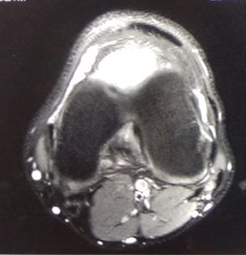
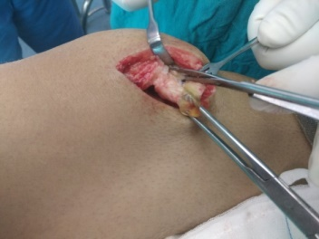

- References:
1.Nikolopoulos I, Krinas G, Kipriadis D, Ilias A, Giannakopoulos A, Kalos S. Large infrapatellar ganglionic cyst of the knee fat pad: a case report and review of the literature. Journal of Medical Case Reports. 2011;5:351. doi:10.1186/1752-1947-5-351.
2. Yilmaz E., Karakurt L., Ozercan I., Ozdemir H. A ganglion cyst that developed from the infrapatellar fat pad of the knee. Arthroscopy. 2004;20(7):e65–e68. doi: 10.1016/S0749-8063(04)00608-5
3. Kang CN, Kim DW, Kim DJ, Kim SJ. Intra-articular ganglion cysts of the knee. Arthroscopy 1999;15:373-378.
4. Zantop T, Rusch A, Hassenpflug J, Petersen W. Intra-articular ganglion cysts of the cruciate ligaments: Case report and review of the literature. Arch Orthop Trauma Surg 2003;123:195-198

- Biography:
Rakesh Goyal has completed his Master of surgery in field of orthopedics from Gujarat University, India. He has worked as senior resident in Sir GangaRam Hospital, New Delhi. He is currently working as senior resident in department of orthopedics in Lok Nayak Hospital and Maulana Azad Medical College, New Delhi, India.

Presenting author details



Full name: Dr. Rakesh Goyal
Contact number: +919727736016
Linked In account: linkedin.com/in/rakesh-goyal-2b305a65

Session name: Track 1: Orthopedics & Orthopedic Surgery
Category: Oral presentation
Passport number: Z3622735

Copyright © 2016-2018 Meetings Int PTE Ltd, All Rights Reserved.
Meetings Int.Pte Ltd

Company Registration No: 201524282R,28 MAXWELL ROAD, #03-05 RED DOT TRAFFIC, SINGAPORE (069120)
Tel: +6531080483| Toll Free no. +800-852-6126
Web: https://www.meetingsint.com/conferences/orthopedics | E-mail: orthopedics@annualmeetings.net

