

Title: A rare case of traumatic posterior dislocation of hip in a 7 year old child following trivial trauma

Rakesh Goyal^{1,} Deepak Gupta²

¹ Senior resident, Department of orthopedics (Lok Nayak Hospital and Maulana Azad Medical College, New Delhi, India)
² Senior resident, Department of orthopedics (Lok Nayak Hospital and Maulana Azad Medical College, New Delhi, India)

Keywords: hip dislocation, children, trivial trauma

- Abstract Body
Traumatic hip dislocation is relatively rare in children .It accounts for 5 % of total hip dislocations in all age groups. We reported a case of hip dislocation in 7 year old child following trivial trauma. Diagnosis was confirmed clinically and radiologically. Reduction was done after four hours of injury under general anesthesia and fluoroscopic guidance .Post reduction radiograph and Computed tomographic scans showed joint congruency. Post reduction abduction bar was given and child kept non weight bearing initially and allowed weight bearing gradually as tolerated. At 10 weeks post reduction, patient has full range of motion at right hip joint and able to walk with full weight bearing. Reduction should be done as soon as possible to avoid complications like avascular necrosis.

Image:
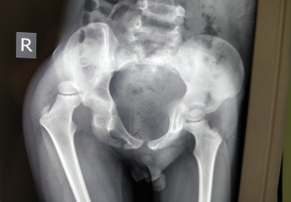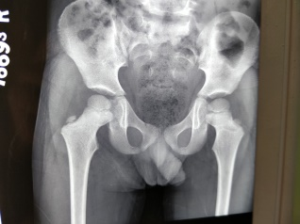

- Reference:

1. H. Rieger, D. Pennig, W. Klein, and J. Grunert, “Traumatic dislocation of the hip in young children,” Archives of Orthopaedic and Trauma Surgery, vol. 110, no. 2, pp. 114–117, 1991.
2. Furuya H, Shimamura Y, Kaneko K, Sakuramoto H, Hirata K, Arai Y : Traumatic dislocation of the hip in a child caused by trivial force for age. Case Rep Orthop. 2014; 2014:467246.
3. Herrera-Soto, J. A. and C. T. Price (2009). "Traumatic hip dislocations in children and adolescents: pitfalls and complications." J Am Acad Orthop Surg17 (1): 15-21.

4. Gilberto Francisco Brandão, Luiz Renato Drumond Américo, Cláudio Beling Gonçalves Soares, Rodrigo Galinari Costa Faria, Luiz Eduardo Moreira TeixeiraRev Bras Ortop. 2010 Mar-Apr; 45(2): 196–199. Published online 2015 Nov 16. doi: 10.1016/S2255-4971(15)30293-7
5. Navin Balasubramanian, N Ganesh Babu, and P Sindhuja, “Traumatic Hip Dislocation in A Child Younger Than 3 Years- A rare Case Report And Review of Literature.,” Journal of orthopaedic case reports, vol. 5, no. 2, pp. 69–71
6. Kutty S, Thornes B, Curtin WA, Gilmore MF. Traumatic posterior dislocation of hip in children. Pediatr Emerg Care 2001; 17:32-5
7. C. F. Moseley, “Fractures and dislocations of the hip,” Instructional Course Lectures, vol. 41, pp. 397–401, 1992.
8. Mehlman CT, Hubbard GW Crawford AH, Roy DR, Wall EJ. Traumatic hip dislocation in children. Clin Orthop. 2000; (376): 68-79.

Biography:
Rakesh Goyal has completed his Master of surgery in field of orthopedics from Gujarat University, India. He has worked as senior resident in Sir GangaRam Hospital, New Delhi. He is currently working as senior resident in department of orthopedics in Lok Nayak Hospital and Maulana Azad Medical College, New Delhi, India.

Presenting author details



Full name: Dr. Rakesh Goyal
Contact number: +919727736016
Linked In account: linkedin.com/in/rakesh-goyal-2b305a65

Session name: Track 1: Orthopedics & Orthopedic Surgery
Category: Oral presentation
Passport number: Z3622735

Copyright © 2016-2018 Meetings Int PTE Ltd, All Rights Reserved.
Meetings Int.Pte Ltd

Company Registration No: 201524282R,28 MAXWELL ROAD, #03-05 RED DOT TRAFFIC, SINGAPORE (069120)
Tel: +6531080483| Toll Free no. +800-852-6126
Web: https://www.meetingsint.com/conferences/orthopedics | E-mail: orthopedics@annualmeetings.net

