

Title: Risk Factors Associated with Major Lower Extremity Amputations after
Osseous Diabetic Charcot Reconstruction

¹Tammer Elmarsafi, DPM, MBBCh; ²Paul S. Cooper, MD; ¹John S. Steinberg, DPM;
¹Karen K. Evans, MD, ¹Paul J. Kim, DPM, MS; and ¹Christopher E. Attinger, MD.

1 Department of Plastic Surgery, MedStar Georgetown University Hospital, 3800 Reservoir Rd NW, Washington DC, 20007.
² Department of Orthopedic Surgery, MedStar Georgetown University Hospital, 3800 Reservoir Rd NW, Washington DC, 20007.

Keywords: Major Amputation, Charcot, Diabetes, Neuropathy, Non-union, Peripheral Arterial Disease, Reconstruction, Ulcer

- Abstract Body
Patients with Diabetic Charcot Neuroarthropathy are at high risk for ulcerations and major lower extremity amputations. Osseous reconstruction is an important component in ulcer healing and prevention, however despite such efforts, major lower extremity amputations remain a serious post-reconstruction concern. The aim of this study was to identify risk factors for major lower extremity amputation in patients who underwent osseous Charcot reconstruction. A retrospective review was performed on 331 patients with the diagnosis of Charcot Neuroarthropathy in the foot and ankle treated over a 16-year period. Two hundred eighty five patients were included after exclusion of those without Diabetes. Demographic data, anatomical wound location, surgical interventions, wound healing status, and the level of eventual amputation were recorded. Multivariate logistic regression and Fischer Test were used for analysis. All patients had Diabetes, neuropathy, Charcot Neuroarthropathy, and required osseous reconstruction. Risk factors and their respective odds ratios are as follows: Postoperative non-union [OR 8.5 (95% CI 2.2-33.5), 0.0023]; development of new site of Charcot [OR 8.2 (95% CI 1.1-62.9), 0.0440]; Peripheral arterial disease [OR 4.3 ( 95% CI 1.7-11.0), 0.0020]; renal disease [OR 3.7 (95% CI 1.6-8.8), 0.0025]; postoperative delayed healing [OR 2.6 (95% CI 1.1-6.5), 0.0371]; postoperative osteomyelitis [OR 2.4 (95% CI 1.0-5.9), 0.0473]; elevated HbA1c; [OR 1.2 (95% CI 1.0-1.4), 0.0053]. Independent risk factors found to be statistically significant for major lower extremity amputation in Diabetic Charcot Neuroarthropathy in the setting of osseous reconstruction must be mitigated for long term prevention of major amputations.

Image:
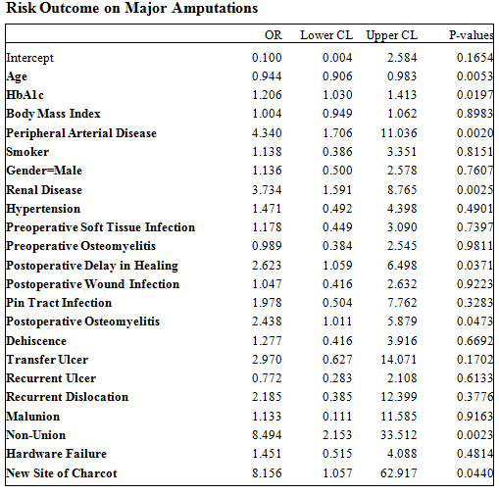
- Reference:

- Sohn, M. W., Stuck, R. M., Pinzur, M., Lee, T. A., & Budiman-Mak, E. (2010). Lower-extremity amputation risk after Charcot arthropathy and diabetic foot ulcer. Diabetes Care, 33(1), 98-100.

- Schon, L. C., Easley, M. E., & Weinfeld, S. B. (1998). Charcot neuroarthropathy of the foot and ankle. Clinical orthopaedics and related research, 349, 116-131.

- Wukich, D. K., Raspovic, K. M., & Suder, N. C. (2016). Prevalence of peripheral arterial disease in patients with diabetic Charcot neuroarthropathy. The Journal of Foot and Ankle Surgery, 55(4), 727-731.

Biography:
Dr. Tammer Elmarsafi has completed his MBBCh from Cairo, Egypt, and his DPM degree from Washington, DC USA. He completed a fellowship in Diabetic Limb Salvage at MedStar Georgetown University Hospital and is currently an Attending Surgeon at a level one academic trauma center in Washington, DC. He has multiple publications related to Limb Salvage.

Presenting author details


Tammer Elmarsafi, DPM MBBCh
Office Line” 1-202-877-6640 Mobile 1-631-332-8142
Email: Tammer.Elmarsafi@gunet.georgetown.edu
Alt Email: telmarsafi.medstar@gmail.com
Oral Abstract Presentation

Copyright © 2016-2018 Meetings Int PTE Ltd, All Rights Reserved.
Meetings Int.Pte Ltd

Company Registration No: 201524282R,28 MAXWELL ROAD, #03-05 RED DOT TRAFFIC, SINGAPORE (069120)
Tel: +1-302-231-6756 ; +6531080483| Toll Free no. +800-852-6126
Web: https://www.meetingsint.com/conferences/orthopedics | E-mail orthopedics@meetingsintl.net

