Calcaneal Lengthening for the Pes Planovalgus Foot
Deformity in Children with Cerebral Palsy
Aly Mohamed Aboelenien , MD,* Vincent Mosca, MD,† Mohamed Lotfy Fahmy, FRCS,* Hasan Magdy Barbary, MD,* Sherif Galal, MD,*

From *Department of Orthopaedic Surgery, Al- Razy hospital Kuwait
,Department of Orthopedic surgery Washington University,Seattle hospital,USA
,Department of Orthopedic surgery Al-Razy hospital Kuwait,
Department of Orthopaedic Surgery, Cairo University Abu El-Reesh Hospital, Egypt
and †Department of Orthopaedic Surgery, Cairo University Abu El-Reesh Hospital, Egypt.
Study conducted at AL- Razy Orthopaedic hospital, Kuwait

Abstract: The objective of this study was to evaluate the operative management of pes planovalgus deformity in ambulatory cerebral palsy (CP) children by calcaneal lengthening osteotomy described by Evans. Fifteen children (10 girls and 5 boys) with average age 11 years 6 months (range, 8 years 4 months to 14 years 6 months) with 22 feet with pes planovalgus (PPV) deformity were included in this study. Clinical evaluation was made according to Dogan's scale and graded as perfect, good, fair and poor. Preoperative and postoperative radiological assessment of anteroposterior talo-first metatarsal angle (AP-T1MT), anteroposterior talo-calcaneal angle (AP-TC), laterl Talo-first metatarsal angle (Lat. T1MT), lateral Talo-calcaneal angle (Lat. TC), and lateral Calcaneal pitch angle (Lat. CP) had been done for all feet. All feet were corrected with modification of the calcaneal lengthening osteotomy described by Evans. Clinical results were perfect in 18 feet (82%), good in 2 feet (9%) and fair in 2 feet (9%). Radiological results showed improvement in 20 feet, while 2 feet showed no improvement. The improvement was significant in Lat. T1MT (P ‹ 0.001), AP-T1MT (P < 0.05)., AP-TC and Lat. CP (P < 0.001, < 0.001 respectively) whereas it was insignificant in Lat. TC (P > 0.05).The results of the present study showed that the procedure reliably relieves pain in PPV foot in CP children and proved effective in addressing all components of the deformity in both hindfoot and forefoot clinically and radiographically.
Key words: Pes planovalgus – Calcaneal osteotomy - Evans.
REFERENCES
- Kerr Graham H, Selber P.: Musculoskeletal aspects of cerebral palsy. J Bone Joint Surg Br 2003; 85:157-166.
- Rosenbaum P, Paneth N, Leviton A, Goldstein M, Bax M, Damiano D, Dan B and Jacobsson B: A report: The definition and classification of cerebral palsy. April 2006.Dev Med Child Neurol Suppl 2007, 109:8-14
- Gage J.: The treatment of gait problems in cerebral palsy. London: MacKeith Press,2004.
- Cooper PS, Nowak MD and Shaer J.: Calcaneocuboid joint pressures with lateral column lengthening (Evans) procedure. Foot Ankle Int. 1997; 18:199-205.
- Zorer G, Bagatur AE, Dogan A and Unlu T. Dennyson-Fulford: Subtalar extra-articular arthrodesis in the treatment of paralytic pes planovalgus and its value in the alignment of the foot. [Article in Turkish] Acta Orthop Traumato Turc 2003; 37:162-9.
- Evans D.: Calcaneo-valgus deformity. J Bone Joint Surg [Br] 1975; 57:270-8.
- Andreacchio A, Orellana CA, Miller F and Bowen TR.: Lateral column lengthening as treatment for planovalgus foot deformity in ambulatory children with spastic cerebral palsy. J Pediatr Orthop 2000; 20:501-5.
- Yoo WJ, Chung CY, Choi IH, Cho TJ and Kim DH.: Calcaneal lengthening for the planovalgus foot deformity in children with cerebral palsy. J Pediatr Orthop 2005; 25:781-5.
- Mosca, VS: Calcaneal lengthening for valgus deformity of the hindfoot.
Results in children who had severe, symptomatic flatfoot and skewfoot.
J. Bone Joint Surg. Am. 77:500 – 512, 1995
- Noritake, K; Yoshihashi, Y; Miyata, T: Calcaneal lengthening for planovalgus foot deformity in children with spastic cerebral palsy. J. Pediatr. Orthop. B 14:274 – 279, 2005.
- Philips, GE: A review of elongation of os calcis for flat feet. J. Bone Joint Surg. Br. 65:15 – 18,1983.
- Armstrong C.; and Carruthers C.C.: Evans elongation of lateral column of the foot for valgus deformity. In Proceedings of the Canadian Orthopaedic Association. J. Bone Joint Surg. 57-B (4): 530, 1975.
- Tohen, A; Carmona, J; Chow, L; Rosas, J: Extra-articular subtalar arthrodesis. A review of 286 operations. J Bone Joint Surg Br 51:45 – 52, 1969.
- Anderson, A.F. and Fowler, S.B.: Anterior calcaneal osteotomy for symptomatic juvenile pes planus. Foot and Ankle International Mar-Apr; 4(5): 274-283, 1984
- Zeifang, F; Breusch, SJ; D¨oderlein, L: Evans calcaneal lengthening procedure for spastic flexible flatfoot in 32 patients (46 feet) with a follow up of 3 to 9 years.. Foot Ankle Int. 27:500 – 7, 2006.
- Davitt J.S.; MacWilliams B.A.; and Armstrong P.F.: Plantar pressure and radiographic changes after distal calcaneal lengthening in children and adolescents. J Pediatr Orthop; 21: 70 - 75, 2001.
- Dogan A.; Albayrak M.; Akman Y.E.; and Zorer G.: The results of calcaneal lengthening osteotomy for the treatment of flexible pes planovalgus and evaluation of alignment of the foot. Acta Orthop Traumatol Turc 40(5): 356-366, 2006.
- Mosca, VS: Letter to the JPO editors re: article by Andreacchio et alentitled “lateral columnlengthening as treatment for planovalgus foot deformity in ambulatory children with spastic cerebral palsy” (J.Pediatr. Orthop. 20:501 – 505, 2000.). J. Pediatr. Orthop. 26:412, 2006

Biography:
Aly has completed his PhD, doctarte degree(MD)at the age of 35 years from Cairo University and Postdoctoral Studies from School of Medicine, cairo University, egypt. He is pediatric orthopedic consultant in many institution in egypt. He had clinical training in pediatric ortho. Surgery at necker enfants malades hospital paris,france and also at seattle children hospital,washengton,USA.

Presenting author details

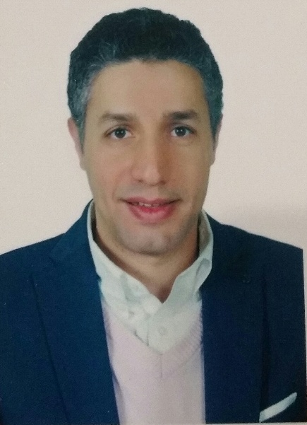

Full Name: Aly Mohamed Abouelenein
Contact number: 00201000100396
Linked In account: dr Aly Abouelenein
Session name/ number: pediatric orthopedic
Category: (Oral presentation)

