

Abstract Template

Title: Peri-operative Antibiotic Prophylaxis in Total Joint Arthroplasty: A Systematic Review & Meta-Analysis
Ahmed Siddiqi, DO, MBA¹, Salvador Forte, DO¹, John J. McPhilemy, DO, FAOAO¹, Antonia F. Chen, MD, MBA², Neil P. Sheth³
1Department of Orthopedic Surgery, Philadelphia College of Osteopathic Medicine, Philadelphia, PA, USA
2Department of Orthopedic Surgery, Brigham & Women’s Hospital, Boston, MA, USA
2Department of Orthopedic Surgery, University of Pennsylvania, Philadelphia, PA, USA

Keywords: total joints, PJI, SSI, perioperative antibiotics

- Abstract Body (up to 250 words)

The 2017 CDC guidelines for prevention of surgical site infection (SSI) recommended against continuation of postoperative antibiotics after total joint arthroplasty (TJA), which are disconcerting since the revised guidelines are only based on 6 orthopedic studies, of which 83% (5/6 studies) were published from 1987-1991. The purpose of this study was to conduct a systematic review of the literature regarding the efficacy and duration of peri-operative antibiotic prophylaxis (PAP) in TJA. PubMed, EMBASE, and Ovid MEDLINE were screened for “surgical antimicrobial prophylaxis orthopedics” in accordance to PRISMA guidelines from 1945-2018. 695-studies were screened, and 40-studies were evaluated. Studies examining perioperative antibiotics with subsequent SSI/PJI rates in TJA were included. 29-randomized controlled trials, 3-prospective cohort and 8-retrospective cohort studies with 55,828 TJA patients were included in this review. The studies that included 24-hour PAP (n=22) had SSI rates of 0.3-7.2%, and 3-reported no infections. Studies with PAP>24-hours (n=14) had SSI rates of 0.6-3.3%. Studies with a single pre-operative dose of PAP (n=12) had SSI rates of 0.8-5.6%, and 6-reported no infections. Only six-studies compared a single pre-operative dose to 24-hour PAP, 3 of which compared different antibiotics. 68% of studies (27/40) were before the year 2000. All included studies were underpowered and heterogenous regarding type of antibiotic used and duration. The literature relative to PAP in TJA is conflicting, scarce, of debatable strength, and based on patient populations with higher than contemporary SSI rates. Every study had different definition criteria of SSI/PJI. The findings of this study demonstrate the need for level-1 studies with adequate power to evaluate the safety of shortened PAP duration after TJA and its effect on SSI/PJI prior to widespread implementation.

Image:
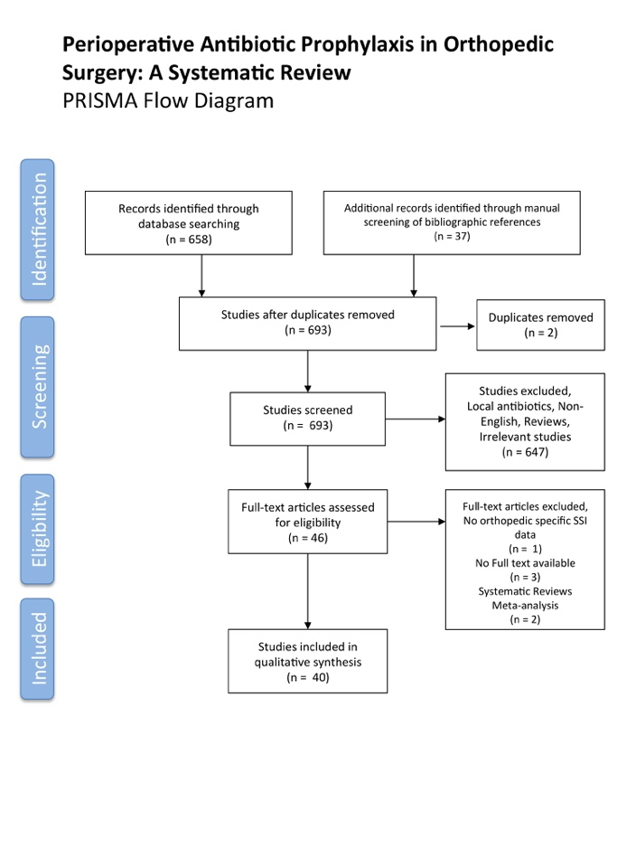

Biography:
Ahmed Siddiqi, DO, MBA has completed his medical degree at the age of 24 years from Touro College of Osteopathic Medicine and completing his orthopedic surgery residency in Philadelphia, PA, USA. He will be completing an adult reconstruction total joints fellowship at Cleveland Clinic Foundation in Cleveland, OH in 2019-2020. He has had 11 publications over the past one year and have served on several orthopedic board societies. He is the recent winner of the 2018 John Charnley Hip Society Award.

Presenting author details

Full Name: Ahmed Siddiqi Contact number: 718 869 0048
Session name/ number:
Category: Oral Presentation , Arthroplasty and Associated Infections

Copyright © 2016-2018 Meetings Int PTE Ltd, All Rights Reserved.
Meetings Int.Pte Ltd

Company Registration No: 201524282R,28 MAXWELL ROAD, #03-05 RED DOT TRAFFIC, SINGAPORE (069120)
Tel: +1-302-231-6756 ; +6531080483| Toll Free no. +800-852-6126
Web: https://www.meetingsint.com/conferences/orthopedics | E-mail orthopedics@meetingsintl.net

