Title: Our results in correction of congenital club hand deformity, using a modified Sarey centralization technique.
Dr. Abdulrahim Aljayar MD, Dr. Monim Shakeer MS, Dr Mutaz Aljayar MBBCh.

Keywords: Congenital Club hand, Centralisation, Relapse.

Abstract
Congenital radial club hand is a spectrum of complex pre-axial upper limb defect,
Characterized by radial deviation and flexion of the hand, hypoplasia, or aplasia of the radius and thumb, shortened forearm and generalized underdevelopment of the involved extremity.
Despite the recognized relapse rates, centralization of the hand on the distal ulna remains the core idea of treatment, and the huge diversity of techniques ranging from the conservative stretching, splinting and functional rehabilitation, to the complex microsurgical interventions, reflects the challenge of management.
Here is our prospective assessment of 11 hands with congenital radial club hand deficiency, in 9 patients, reporting our local exposure, and satisfying results of correction by fitting the distal end of the ulna in to a created carpal notch, (modified Sayer⃰ technique).
Where we achieved a mean angulation correction of 85.4 degrees, and left with only 12.7 degrees, mean residual angulation, after an average follow up period of 39.8 months, (range: 28 to 52 months).

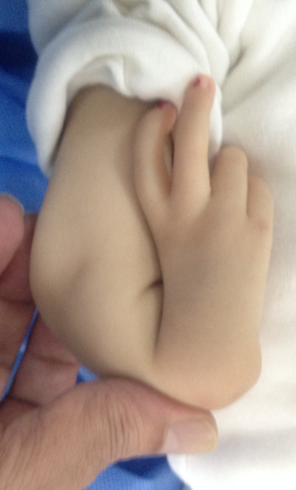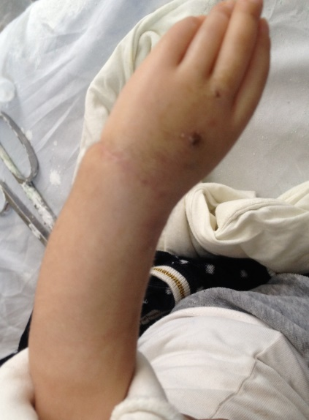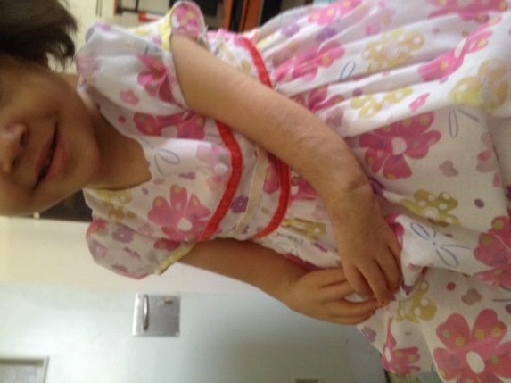

Reference:
1- Ekblom A.G., Laurell T., Arner M. Epidemiology of congenital upper limb anomalies in 562 children born in 1997 to 2007: a total population study from Stockholm, Sweden. J. Hand Surgery [Am]. 2010; 35, N 11. P. 1742-1754.
2- Shariatzadeh, H., Jafari, D., Taheri, H. and Mazhar, F.N. Recurrence rate after radial club hand surgery in long term follow up. Journal of Research in Medical Sciences, 2009; 14, P. 179-186.
3- Flatt AE. The Care of Congenital Hand Anomalies, 2d ed. St Louis: Quality Medical Publishing.1994; P. 366-410.
4- M D’Arcangelo M, Gupta A, Schecker LR. Radial club hand. In: Gupta A, Ray SP, Schecker LR, editors. The growing hand. Diagnosis and management of the upper extremity in children. London: Mosby, 2000; P. 147-68.
5- Riordan DC. Congenital absence of the radius. Can. J. Surgery.1958; 1. (4): P. 301-308.
6- Lourie GM, Lins RE. Radial longitudinal deficiency. A review and update. Hand Clin.1998; 14. (1): 85-99.
7- Bayne L.G., Klug M.S. Long-term review of the surgical treatment of radial deficiencies. J. Hand Surgery [Am].1987; 12, (2): P. 169-179.
8 - Hosny Gamal A., Ahmed Abdel-Salam A. Management of congenital radial club hand by gradual correction // Гений ортопедии. 2016; 4. С. 17-21.
9- Avdeichik N.V., Govorov A.V., Golyana S.I., Safonov A.V. Occurrence of Radial Club Hand in Children with Different Syndromes. Pediatric Traumatology, Orthopaedics and Reconstructive Surgery.2015; 3, Issue 4.
10- MA James, M BednarDeformities of the wrist and forearm DP Green, MD Pederson, RN Hotchkiss, SW Wolf (Eds.), Green's operative hand surgery. 5th ed, Elsevier Churchill Livingstone, Philadelphia.2005; P. 1469-1479.
11- Goldfarb C.A., Wall L., Manske P.R. Radial longitudinal deficiency, the incidence of associated medical and musculoskeletal conditions. J. Hand Surgery [Am].2006; 31. (7): P. 1176-1182.
12- Maschke S.D., Seitz W., Lawton J. Radial longitudinal deficiency. J. Am. Acad. Orthopedics Surgery.2007; 15, (1): P. 41-52.
13- Lamb DW. The treatment of radial club hand, absent radius, aplasia of the radius, hypoplasia of the radius, and radial paraxial hemimelia. Hand Clin.1972; (4): P. 22-30.
14- Urban MA, Osterman AL. Management of radial dysplasia. Hand Clin.1990; (6): P. 589-605.
15- Sayer RH. A contribution to the study of club hand. Trans Am Orthopedics Association 1983; (6): P. 208-216.
16- Watson H.K., Beebe R.D., Cruz N.I. A centralization procedure for radial club hand. J. Hand Surgery [Am].1984; 9, (4): P. 541-547.
17- Manske PR, McCarroll HR Jr, Swanson K. Centralization of the radial club hand, an ulnar surgical approach. J. Hand Surgery [Am].1981; 6, (5): P. 423-433.
18- Buck-Gramcko D. Radialization as a new treatment for radial club hand. J. Hand Surgery [Am].1985; 10, (2): P. 964-968.
19- Albee FH. Formation of radius congenitally absent: condition seven years after implantation of bone graft. Ann Surgery.1968; (87): 105-110.
20- Pickford M.A., Scheker L.R. Distraction lengthening of the ulna in radial club hand using the Ilizarov technique. J. Hand Surgery [Br].1998. 23, (2): P. 186-191.
21- SK Vilkki. Vascularized metatarsophalangeal joint transfer for radial hypoplasia Semin Plast Surgery.2008; 22, (3): P. 195-212.
22- de Jong, J.P., Moran, S.L. and Vilkki, S.K. (2012) Changing paradigms in the treatment of radial club hand: Microvascular joint transfer for correction of radial deviation and preservation of long-term growth. Clinics in Orthopedic Surgery, 4, 36-44.http://dx.doi.org/10.4055/cios.2012; 4.1.36.
23- H. Kawabata, T. Shibata, T. Masatomi, N. Yasui. Residual deformity in congenital radial club hands after previous centralisation of the wrist. Ulnar lengthening and correction by the Ilizarov method. J. Bone Joint Surgery [Br].1998; 80, (5): P. 762-765.
24- Kumar, M.K. and Sumar, S.K. Radial club hand: A Neglected case. Journal of Clinical and Diagnostic Research, 2011; (5): P. 1458-1460

Dr. Abdulrahim Aljayar: completed his MBBch.at the age of 26 years from Benghazi University and Postdoctoral Studies from School of Medicine, Budapest. MD. Orthopedics, Consultant Hand Surgeon, Al-jala Trauma Hospital. Assistant professor at Benghazi University, Benghazi/Libya.


Abdulrahim Aljayar: 0925324067
Twitter account: @Daljayar:
Oral presentation
Passport Number: K5L24PLK

