

Abstract

Title: Robotic equipment in upper limb amputations

O. FADILI

Keywords: bionic, hand, robotic, amputation, upper, limb, 3d print, surgery

- Abstract Body
The human hand is a very important member in our daily life, it is necessary in any activity.

However, loss as a result of trauma, accident or other cause can have a detrimental effect on the individual's personal, social, psychological and economic life.

Therefore, the establishment of a robotic device to restore the important functions in the simulation of the functions of a biological standard is of interest.

We have the honor to present a robotic device, which served to the patients, who lost upper limb, to have a bionic hand under the vocal or myo-electrical command, and which can reproduce the movements elementals of a biological hand.

During the design and manufacture of the equipment, we tried to respect the biomechanical rules of the physiological principle. We will present the different stages of realization and manufacture of this robotic device, as well as a demonstration.

The manufacture of the equipment passes through the main stages:
1. 3D modeling: it is the geometric design of all the pieces on a computer, but also to export these pieces in the form of a file accessible at any time.
2. 3D printing: it consists of converting a virtual computer file into a real object, via a 3D printer. All the printed parts are brought together to form all the equipment.
3. Motorization and implementation of the electronic circuit: we installed servo-engines (one responsible for the pronation / supination of the forearm and 5 for the mobilization of the fingers). These servo motors are connected to an electronic card with a programmable microprocessor.

Amputation is a big problem; this bionic hand is an ultimate solution for these patients and allow them to recover their hand functions.

Image:

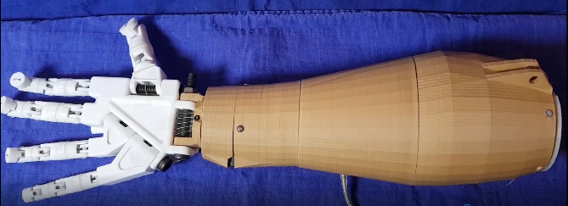

Presenting author details


FADILI Omar
drfadiliomar@outlook.fr
+212648182666
Category: (Oral presentation/ Poster presentation)

