

The treatment method and results of percutaneous pinning and dynamic external fixator application for unstable distal radius fractures
Adnan Kara¹, Erden Erturer², Burak Sener³, Faik Seckin⁴, Senol Akman⁴, Irfan Ozturk⁵
¹Department of Orthopedics and Traumatology, Faculty of Medicine, Istanbul Medipol University, Istanbul, Turkey.
²Department of Orthopedics and Traumatology, Faculty of Medicine, Istinye University, Istanbul, Turkey.
³Department of Orthopedics and Traumatology, Faculty of Medicine, Uskudar University, Istanbul, Turkey.
⁴Department of Orthopedics and Traumatology, Faculty of Medicine, Bilim University, Istanbul, Turkey.
⁵Department of Orthopedics and Traumatology, Faculty of Medicine, Istanbul University, Istanbul, Turkey.

Keywords: Distal radius fracture, unstable fracture, dynamic fixator

- Abstract
Objective: The aim of this study is to present results of patients with unstable distal radius fracture treated with closed reduction and percutaneous fixation followed by application of Pennig dynamic wrist fixator (Orthofix, Srl, Italy) allowing early wrist motion.
Materials and Method: This study includes 25 patients diagnosed with distal radius fracture and treated with closed reduction and percutaneous fixation followed by application of dynamic wrist fixator. The number of male and female patients were 15 (%60) and 10 (%40), respectively. The mean age of patients was 47.32 (20-76). The mean period between initial trauma and operation was 8.52 (1-23) days. Mean follow-up was 20.3 (8-60) months. All patients were allowed active shoulder, elbow and finger exercises immediately after surgery. External fixator was dynamized at the end of 3rd week and removed at the mean of 6,8 (5–8) weeks.
Results: Radiologic evaluation was performed according to criteria described by Sarmiento and modified by Lidström. Results revealed excellent in 12 (%46.15) patients, good in 11 (%42.30) patients, and fair in 3 (%11.55) patients. No patient had poor result. Functional scores were assessed according to Gartland-Werley classification and modified by Sarmiento. Results revealed excellent in 14 (%56 patients), good in 8 (%32) patients and moderate in 3 (%12) patients.
Conclusion: Use of Pennig dynamic wrist fixator in the treatment of unstable distal radius fractures has advantages such as; ease of use, minimal surgical trauma, allowing early rehabilitation, and early return to daily activities as well as increased anatomical and functional results.

Image:

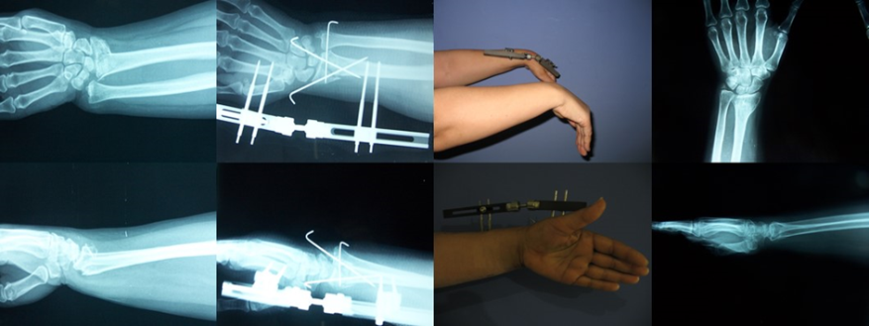
- Reference:

1 Kapoor H, Agarwal A, Dhaon BK. Displaced intra-articular fractures of distal radius: a comparative evaluation of results following closed reduction, external fixation and open reduction with internal fixation. Injury 2000; 31(2): 75-9.
2. Klein W, Dee W, Rieger H, Neumann H, Joosten U. Results of transarticular fixator application in distal radius fractures. Injury 2000; 31 Suppl: 71-7.
3. Werber KD, Raeder F, Brauer RBWeiss S. External fixation of distal radial fractures: four compared with five pins: a randomized prospective study. J Bone Joint Surg Am 2003; 85-A(4): 660-6.
4. Markiewitz AD, Gellman H. Five-pin external fixation and early range of motion for distal radius fractures. Orthop Clin North Am 2001; 32(2): 329-35.
5. Ring D: Intra articular fractures of the distal radius. J Hand Surg Am 2002; 2(2): 60-77.

Biography:
I was graduated from Istanbul Sisli Etfal Training and Research Hospital Orthopaedics and Traumatology Clinic in 2008 as a specialist in Orthopaedics and Traumatology. Between 2008 and 2014 i worked in Sisli Etfal Training and Research Hospital Orthopaedics and Traumatology Clinic. In 2014 started working in Istanbul Medipol University

Presenting author details
Orthopaedic Surgeon, Asst. Prof. Dr
https://www.researchgate.net/profile/Adnan_Kara
Full Name: Adnan Kara
Contact number: +905053951475
Twitter account: @bordobahce
Linked In account: www.linkedin.com/in/adnan-kara-10a73a61
Session name/ number: Orthopedic Surgery
Category: Oral presentation
Passport Number: S 02765417




Image: AO: C2, Frykman: F8,functional and radiographic results of 53-year old female patient with radius distal fracture.

Copyright © 2016-2018 Meetings Int PTE Ltd, All Rights Reserved.
Meetings Int.Pte Ltd

Company Registration No: 201524282R,28 MAXWELL ROAD, #03-05 RED DOT TRAFFIC, SINGAPORE (069120)
Tel: +1-302-231-6756 ; +6531080483| Toll Free no. +800-852-6126
Web: https://www.meetingsint.com/conferences/orthopedics | E-mail orthopedics@meetingsintl.net

