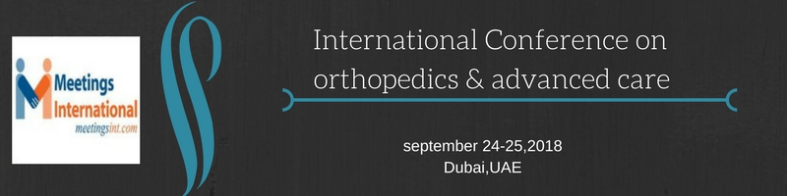

Recent developments in upper limb prosthetic technology and their clinical impact

Day S1
1National Centre for Prosthetics and Orthotics, Department of Biomedical Engineering, University of Strathclyde, Glasgow, UK.

Keywords: Upper limb prosthetics, OMT, TMR, multi-articulating

- Abstract
Traditional upper limb prostheses have low acceptance rates with patients often feeling frustrated by their lack of functionality and usability of the device. Efforts have been made in the past two decades to develop prosthetic hands capable of more realistic movements, such as those used in everyday activities of daily living. More recently, research teams have been investigating ways of improving control of these devices, through methods such as targeted muscle re-innervation, pattern recognition, and implantable electrodes.
This presentation will explore the clinical impact of prescribing multi-articulating prosthetic hands over traditional terminal devices, considering factors such as acceptance, function, usability and compensatory movements. In addition, we will present clinical findings from teams working towards embodiment of the prosthetic hand.

Biography:
Sarah Day has extensive prosthetic experience having held clinical, academic and managerial posts in a variety of international settings over a 20 year period including UK, Ireland, Australia, South-East Asia and the Middle East. She is a registered Prosthetist Orthotist and is currently employed as a tenured Teaching Fellow at the National Centre for Prosthetics and Orthotics, University of Strathclyde.
Mrs Day’s teaching and research interests are focused around upper limb prosthetics, burden of disability, and emerging technologies. She has received over $1.4 million in research funding from organisations such as EPSRC and the Google Foundation, and has presented her research findings at international symposiums and within peer-reviewed journals.

Presenting author details
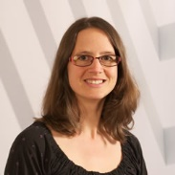
Full Name: Sarah Day
Contact number: +44 141 548 4034
Twitter account: sarahdaypo
Linked In account: www.linkedin.com/in/sarah-day-59105733
Session name/ number:
Category: Oral presentation
Passport Number: Will be supplied upon acceptance

Copyright © 2016-2018 Meetings Int PTE Ltd, All Rights Reserved.
Meetings Int.Pte Ltd

Company Registration No: 201524282R,28 MAXWELL ROAD, #03-05 RED DOT TRAFFIC, SINGAPORE (069120)
Tel: +1-302-231-6756 ; +6531080483| Toll Free no. +800-852-6126
Web: https://www.meetingsint.com/conferences/orthopedics | E-mail orthopedics@meetingsintl.net

