

Title: Scope And Emerging Applications Of Nanotechnology In Orthopedics

Keywords: Nanotechnology, Nanomedicine, Orthopedics.

Purpose

The purpose of this article is to highlight scope and emerging applications of nanotechnology in the field of orthopedic surgery.

Abstract

The earliest evidence of Nanotechnology was found in the microstructure of Wootz Steel, pioneering steel alloy matrix developed in Southern India, dating back to 600BC. However, the foundation of the central concepts of Nanotechnology was laid down in the mid-1980s. Nanotechnology is still a relative newcomer to the forefront of orthopedic research, diagnostics, and treatment. Nanotechnology involves manipulation of matter measuring 1–100 nm at the molecular level and has several advantages in the field of medicine i.e. nanomedicine since most of the biological molecules exist and function at a nanoscale.

Nanotechnology has the perspective to improve the whole healthcare process for the patient; starting from diagnosis to the surgical treatments. Since the bone and many its constituents are nano-compounds Orthopedics is an attractive area for the application of nanotechnology. Here are some of the major orthopedic applications of nanotechnology:

1) Effective drug delivery systems with the help of nanoparticles for antibiotics and chemotherapeutics.
2) Application of nanoparticles as implant coating materials in order to control and improve the implant success rate.
3) Development of Nano-structured polymer scaffolds for bone regeneration.
4) Diagnostic applications in the field of musculoskeletal infections.

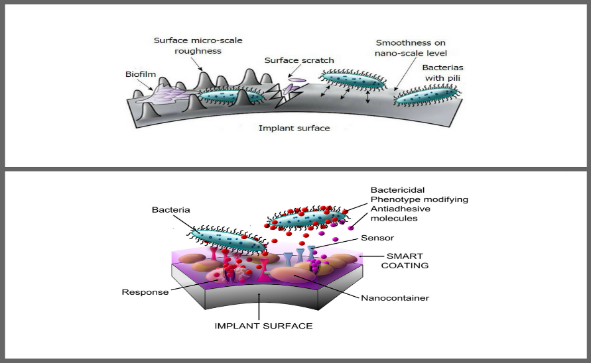
Reference:

1.https://www.ncbi.nlm.nih.gov/pubmed/27821998?dopt=Abstract
2.https://www.ncbi.nlm.nih.gov/pubmed/17224843
3.http://www.fluidinova.com/hydroxyapatite-properties-uses-and-applications
4.https://online.boneandjoint.org.uk/doi/abs/10.1302/0301-620X.96B5.33606
5.https://www.researchgate.net/publication/263320061_Applications_of_Carbon_Nanomaterials_in_Bone_Tissue_Engineering
6.https://www.hindawi.com/journals/isrn/2014/939378/
7.http://journals.plos.org/plosone/article?id=10.1371/journal.pone.0195261
8.https://www.ncbi.nlm.nih.gov/pmc/articles/PMC2800311/
9.https://www.ncbi.nlm.nih.gov/pubmed/11549164

Biography:
Vibhor Verma has completed his Bachelor degree at the age of 23 years from Punjab Technical University, India. He is the currently working as an Digital Marketing Expert at NEXwhaT Consultancy, an integrated marketing firm. He has published more than 22 blog articles related to orthopedics for reputed clients.

Author Details:

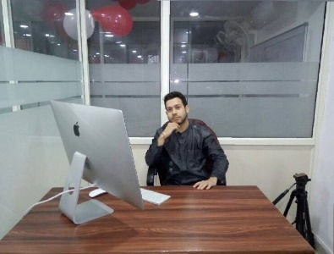

Full Name: Vibhor Verma
Contact Number: +918195998987
Twitter Account: @vermavibhor0071
Linked In Account: https://www.linkedin.com/in/vibhor-verma-4b1886116/
Category: Abstract

Copyright © 2016-2018 Meetings Int PTE Ltd, All Rights Reserved.
Meetings Int.Pte Ltd

Company Registration No: 201524282R,28 MAXWELL ROAD, #03-05 RED DOT TRAFFIC, SINGAPORE (069120)
Tel: +1-302-231-6756 ; +6531080483| Toll Free no. +800-852-6126
Web: https://www.meetingsint.com/conferences/orthopedics | E-mail orthopedics@meetingsintl.net

