
TITLE: THE EFECTIVENESS OF CUSTOMISED ORTHOPAEDIC SHOE FOR THE ULCERATION IN PATIENT WITH DIABETES.
Name: Muhammad Shafiq
Centre for the Rehabilitation of the paralysed(CRP)

Back ground: Customised Orthopadic shoe is intended to be used in cases of both typical and atypical/complex foot with ulcer . It is designed to offer space and weight free arae of the foot and ankle while offering greater comfort for the beneficiaries.
Objectives: The clinician finds out regarding how the effectiveness is of the customised Orthopaedic shoe for a complex ulcer client. Clinician set the objectives which the followings are to know the existing situation of the ulcer client, the expectation of the client with weight free ulceration area and to know the effect of the shoe with modefication, space and comfort in ulcer area for theprevent amputtion to prvide cutomised design and manufacture for the suitable and comfortable shoe of a client.
Methods: The clinician used the method directly make the shoe for the client, The process has been started from assessment, casting, modification, rectification, manufacturing, fitting and finally process has been finished through the evaluation and follow up.
Results: Clinician showed the result are nice free space in ulcer area, stop bleeding achieved by weight less walking, provide comfort achieved by making supplement with padding in pressure point area and also the soft material on the first layer of supplement makes it more comfort.
Recommendation and conclusion: The clinician recommended some points for using the customised orthotic shoe required more time to prevent further deformity of the ankle (ankle abnormal movement/valgus) on the both foot
Key word: Orthotic shoe, ulcer, diabetic, Casting, Modification, Rectification, Manufacturing and Fitting

Appendix

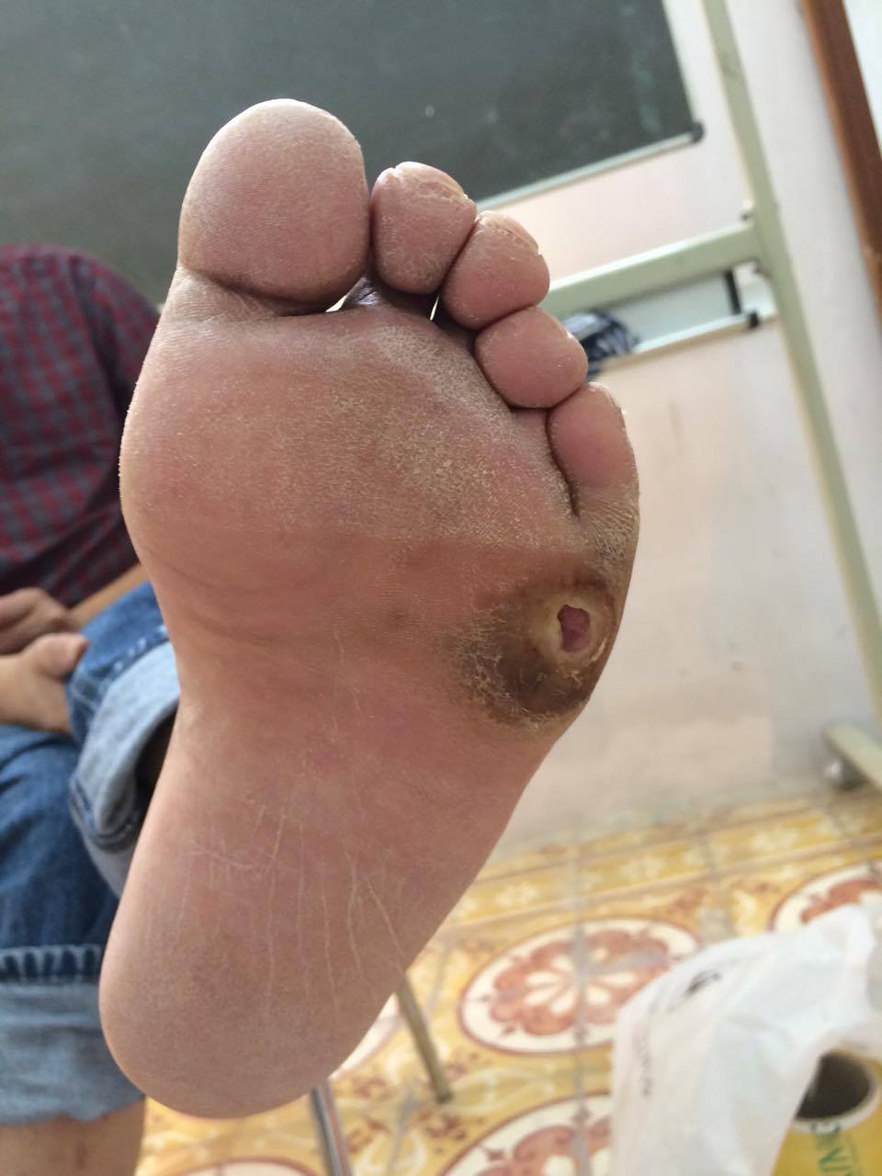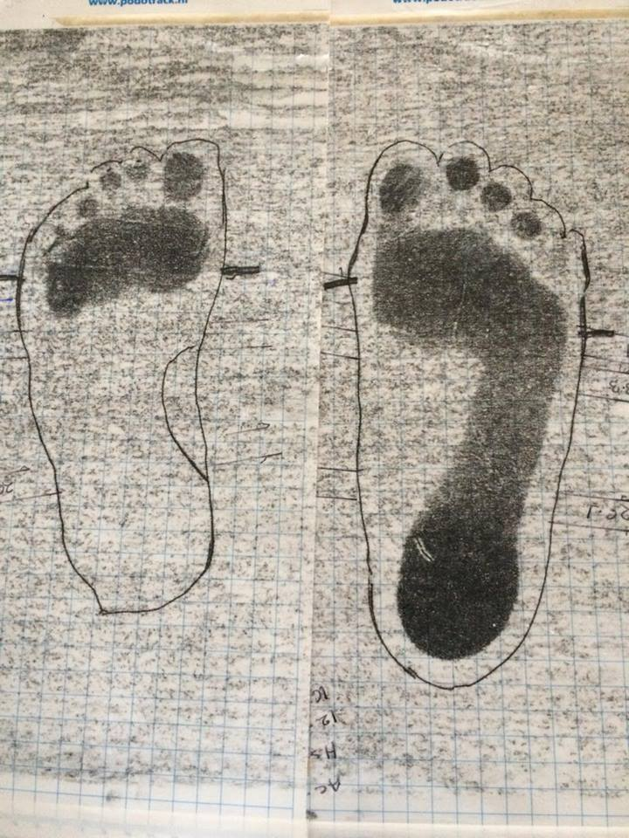

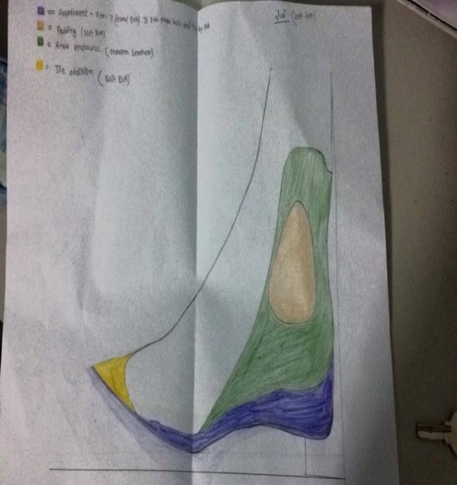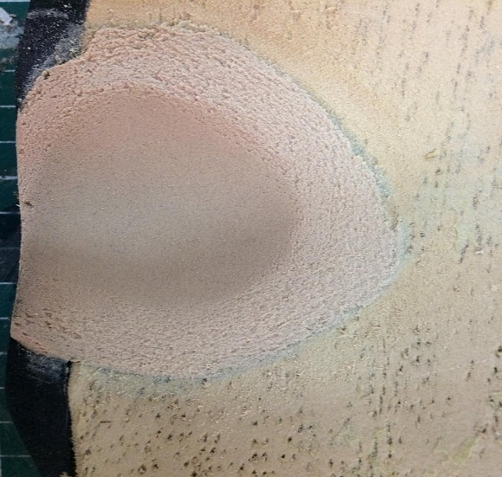

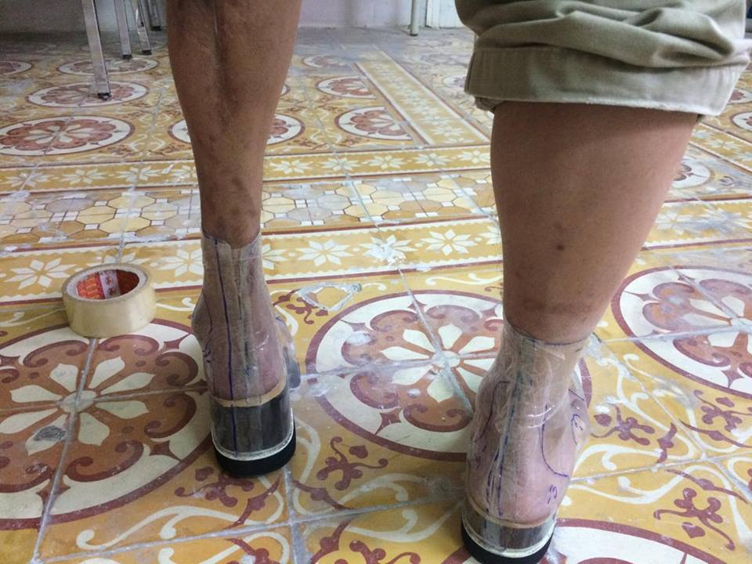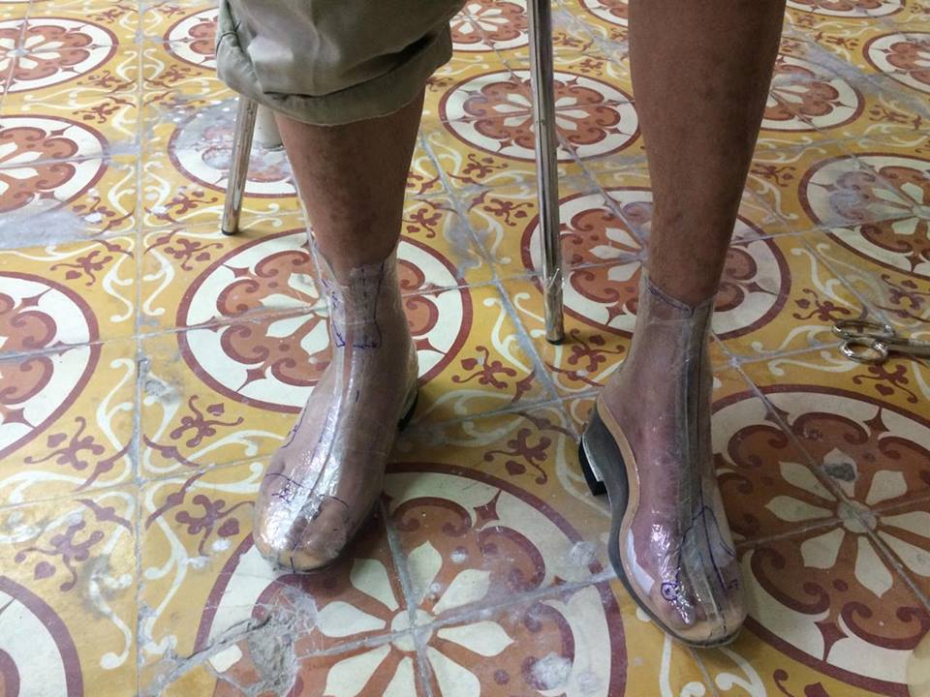

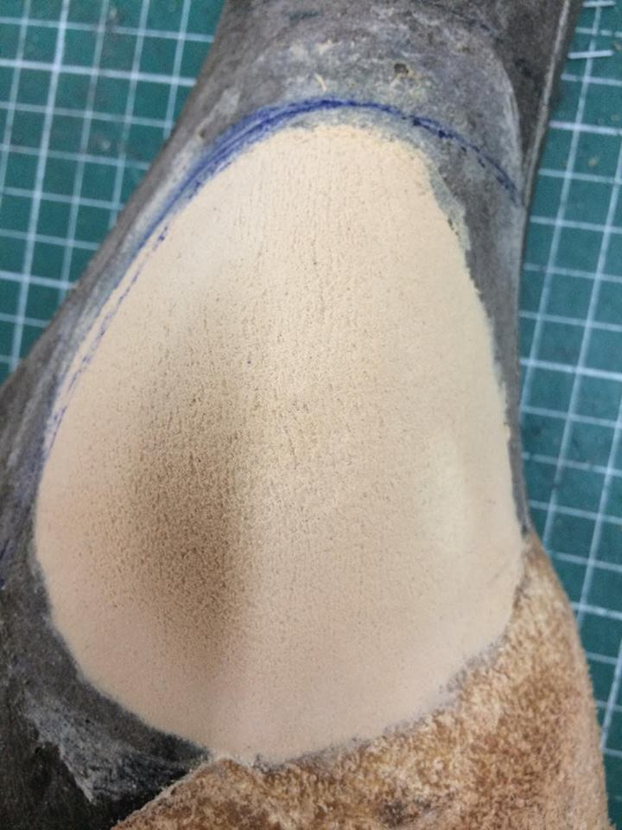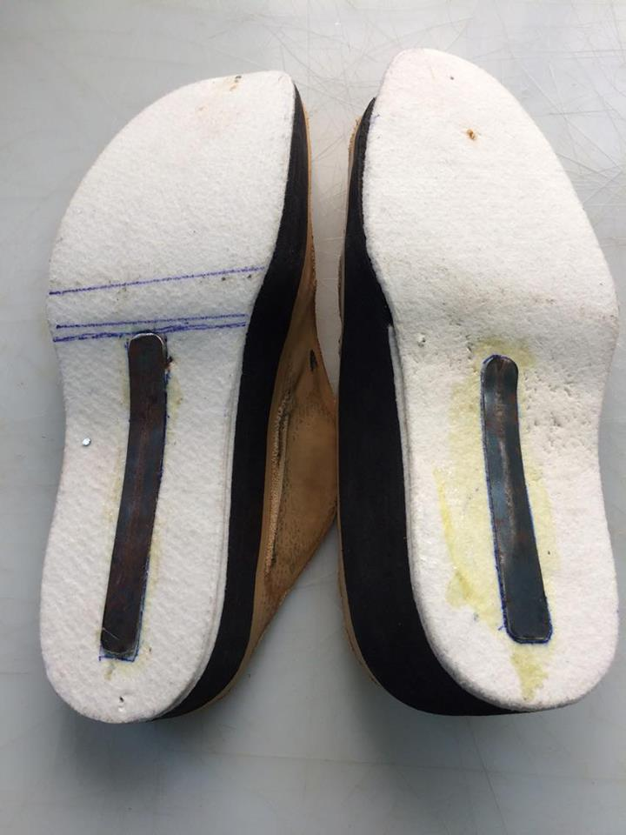

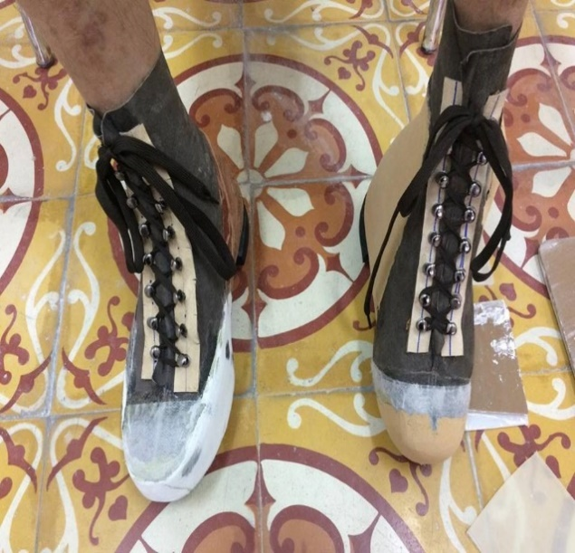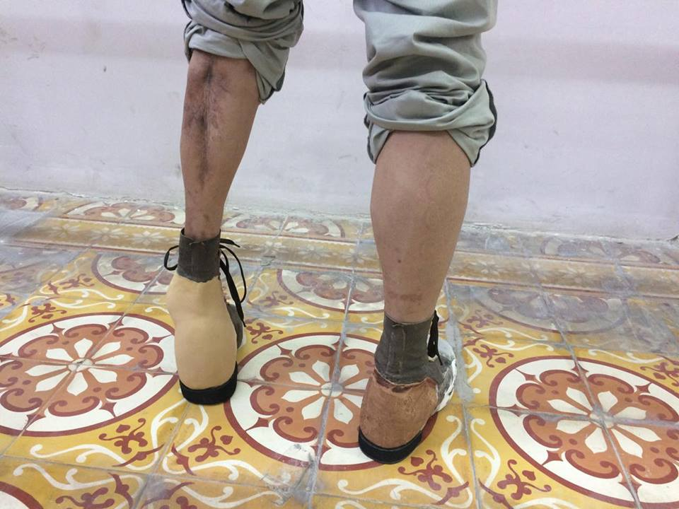

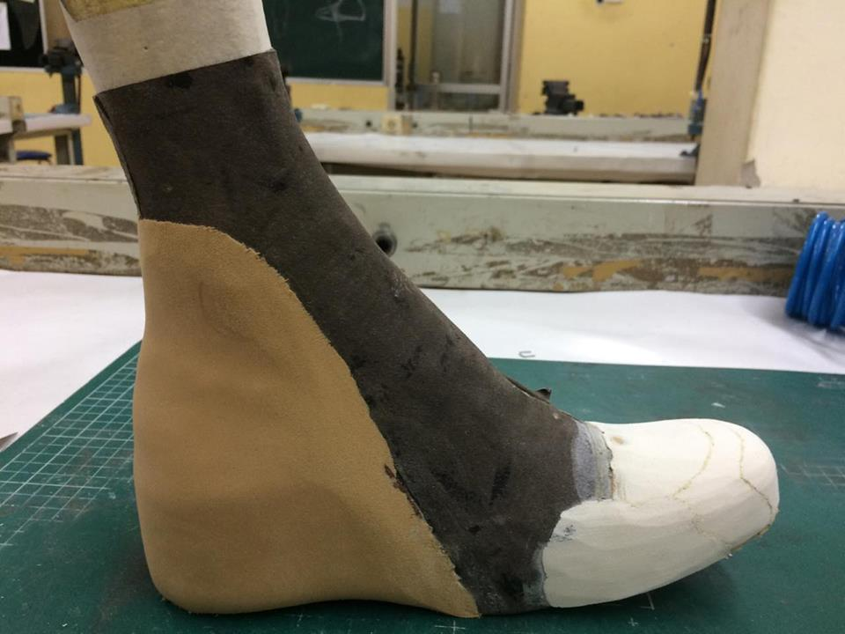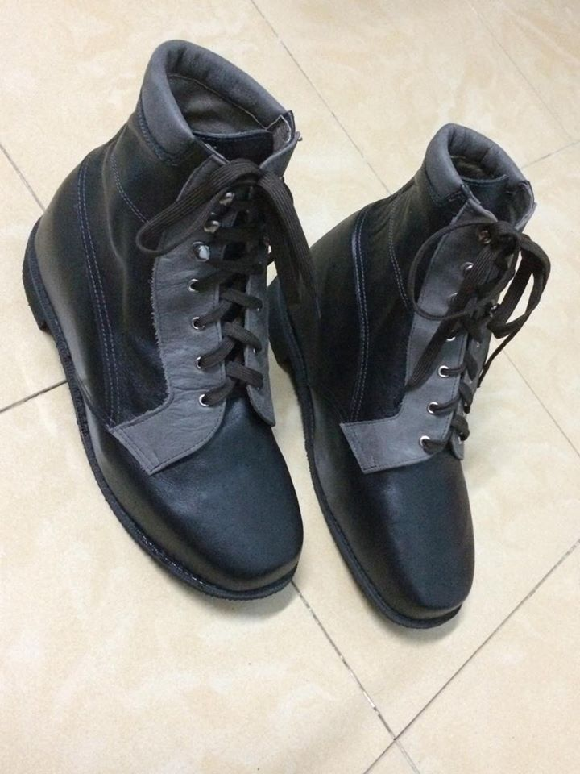
GLOSSARY
Ulcer- Sore/ abscess
Hypertension- High blood pressure
Obesity- Fatness/ heaviness
Offload- Unburden
Recommendation- Advice
Manufacturing - to build up something

Full Name:
OST- Orthopaedic shoe
DM- Diabetes Mellitus
MTP- Meta-terso phalangeal
EVA- Ethylene Vinyl Acetate
WHO- World Health Organization
IC- Initial Contact
LD- Loading Response
MS- Mid stance

