Abstract
Title:
To provide the specialist Orthotics & Prosthetics Device and Orthopedic shoe for the better walk&keep smiling in life.
- Abstract Body:
Orthotics is a specialty within the medical field concerned with the design, manufacture and application of orthoses. An orthosis (plural: orthoses) is "an externally applied device used to modify the structural and functional characteristics of the neuromuscular and skeletal system". An orthotist is the primary medical clinician responsible for the prescription, manufacture and management of orthoses. An orthosis may be used to:
- Control, guide, limit and/or immobilize an extremity, joint or body segment for a particular reason
- Restrict movement in a given direction
- Assist movement generally
- Reduce weight bearing forces for a particular purpose
- Aid rehabilitation from fractures after the removal of a cast
- Otherwise correct the shape and/or function of the body, to provide easier movement capability or reduce pain
Orthotics combines knowledge of anatomy and physiology, pathophysiology, biomechanics and engineering. Patients who benefit from an orthosis may have a condition such as spina bifida or cerebral palsy, or have experienced a spinal cord injury or stroke. Equally, orthoses are sometimes used prophylactically or to optimise performance in sport.

In medicine, a prosthesis is an artificial device that replaces a missing body part( Upper extremity & Lower extremity), which may be lost through trauma, disease, or congenital conditions. Prosthetics are intended to restore the normal functions of the missing body part.Prosthetic amputee rehabilitation is primarily coordinated by a prosthetist and an inter-disciplinary team of health care professionals including psychiatrists, surgeons, physical therapists, and occupational therapists.

The foot is an anatomical structure found in many vertebrates which bears weight and allows locomotion where contains a lot of complex mechanisms with bones, joints, muscles, tendons ,ligaments which connect together and work simultaneously. A diabetic foot is a foot that exhibits any pathology that results directly from diabetes mellitus. Presence of several characteristic diabetic foot pathologies such as infection, diabetic foot wounds, ulcer and neuropathic osteoarthropathy is called diabetic foot syndrome. For these it can affect more than small mechanism.
The Orthopedic shoes are biomechanically engineered with unique features that are not found in any other shoe and it could be solve this situation. With also improve the mobility, enhance comfort from heel to toe and get ultimate protection for diabetic feet and also provide to give a cosmetic and comfortable satisfaction for the client.

Images:
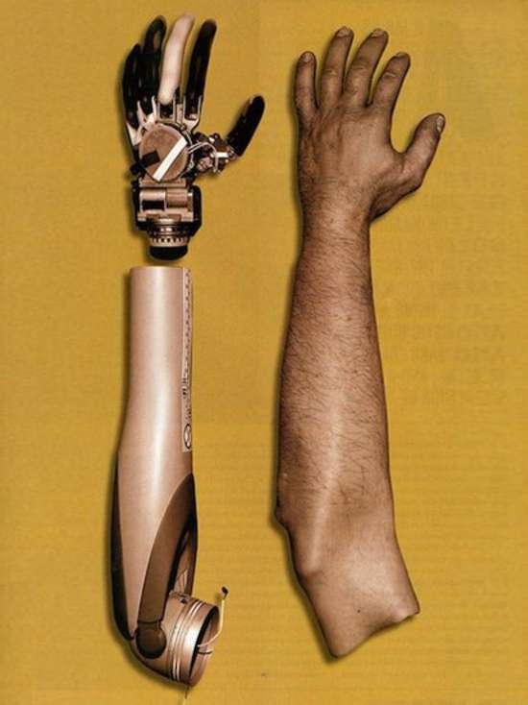
Orthosis: Prosthesis:
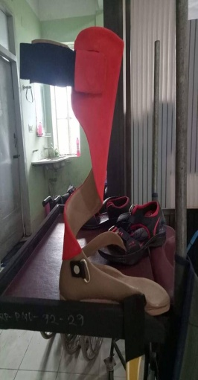
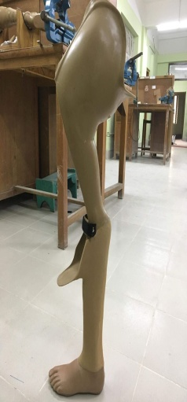
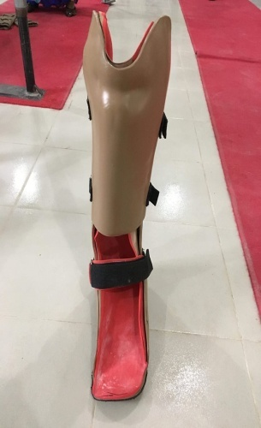
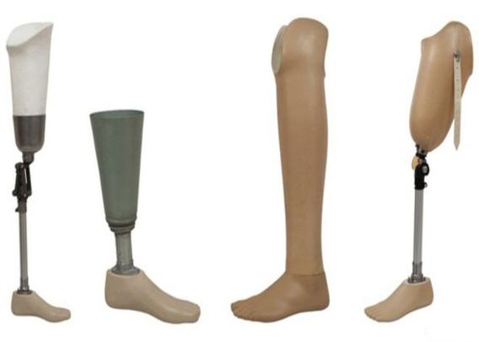

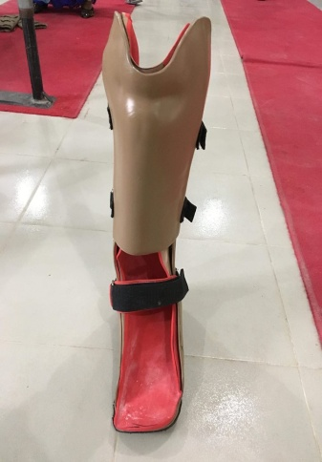
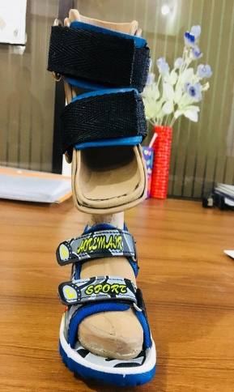
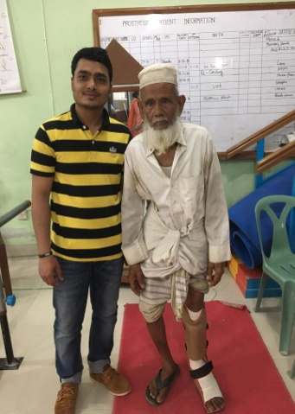
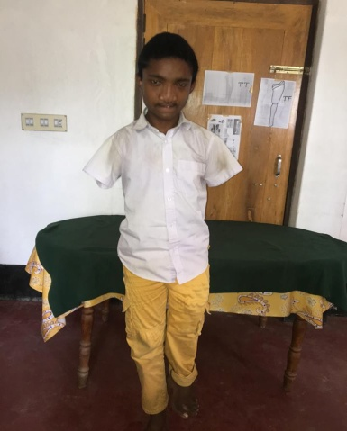
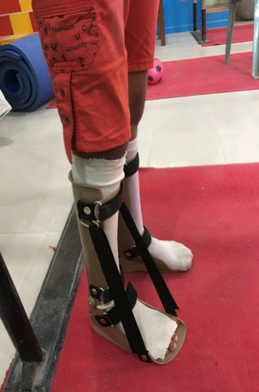

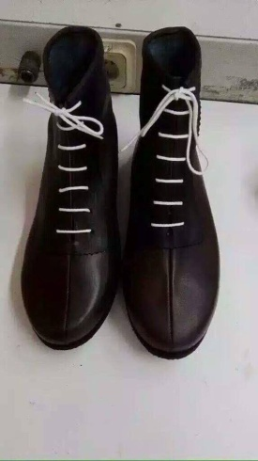
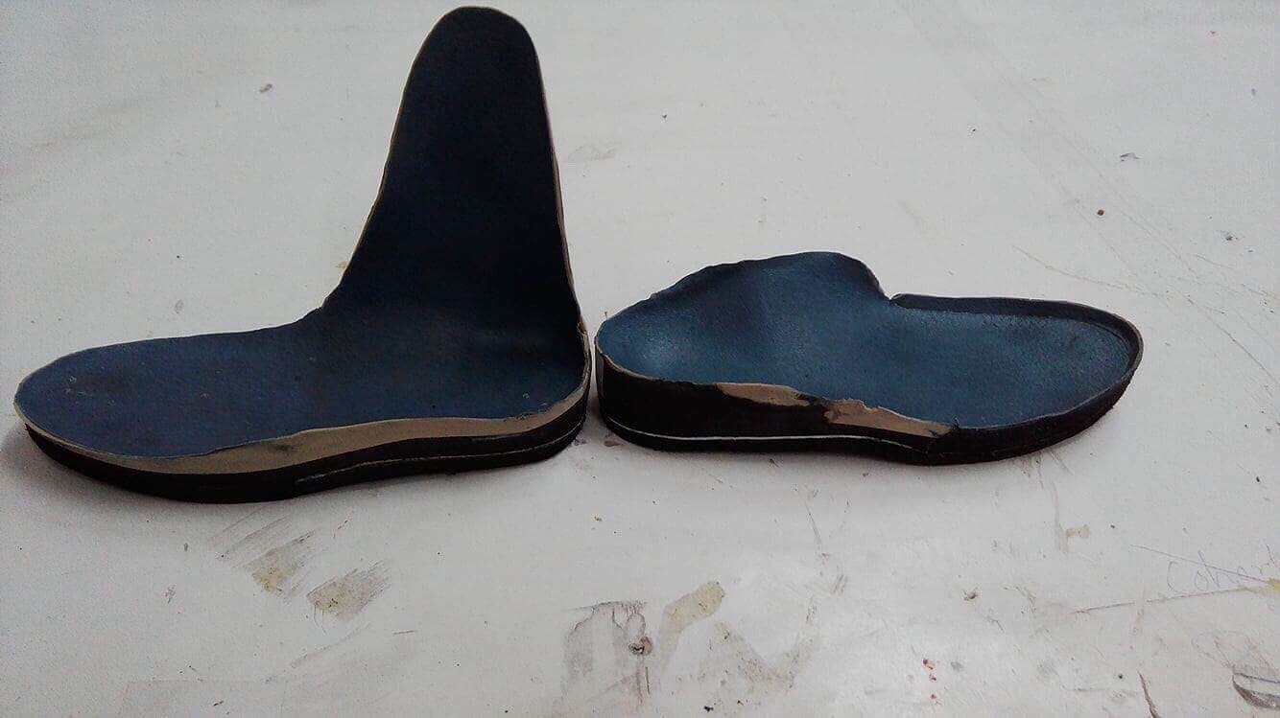
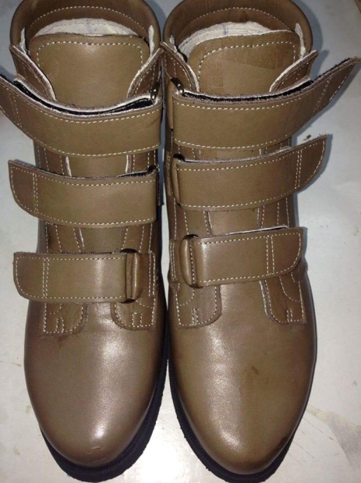
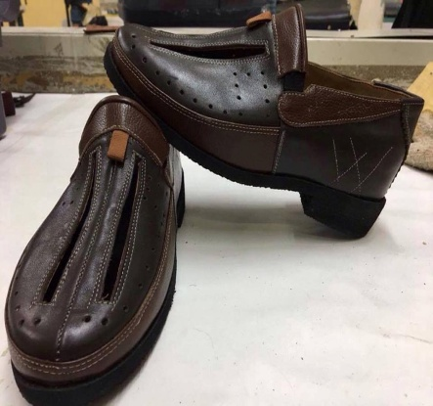

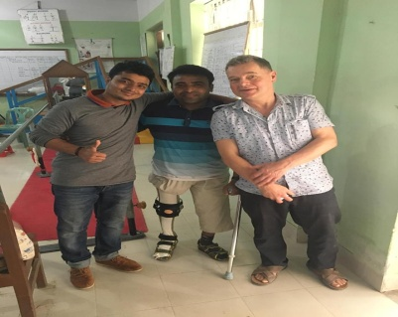
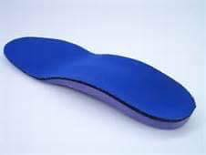

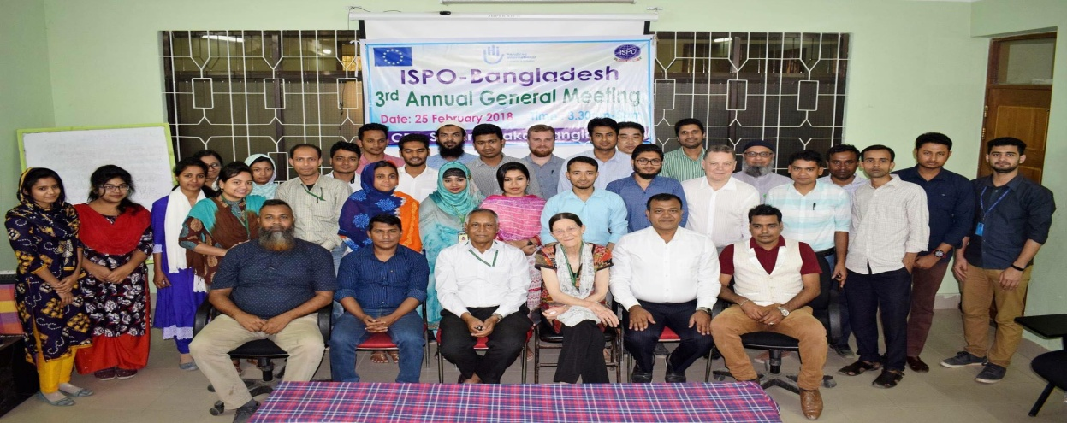

References:
- "How artificial limb is made - material, manufacture, making, used, parts, components, structure, procedure". www.madehow.com. Retrieved 2017-10-24.
- Vanderwerker, Earl E., Jr. (1976). "A Brief Review of the History of Amputations and Prostheses". ICIB. 15 (5): 15–16.
- https://en.wikipedia.org/wiki/Foot
Preventive care practices, foot exam by health professional. CDC website. gis. cdc.gov/grasp/diabetes/DiabetesAtlas.html. Accessed August 21, 2017.
- www.diabetes.org/…foot-complications/foot-care.html
Foot complications. American Diabetes Association website. diabetes.org/ living-with-diabetes/complications/foot-complications/?referrer=https://www. google.com/. Updated February 5, 2016. Accessed August 23, 2017.
- https://www.diabetesaustralia.com
Australian Institute of Health and Welfare (AIHW). Diabetes prevalence in Australia. Detailed estimates for 2007-08. [online] Canberra, ACT: AIHW. June 2011 [Accessed 5 Jul 2011].
- www.diabete.qc.ca/en/understand-diabetes/all
- Redford, John B.; Basmajian, John V.; Trautman, Paul (1995). Orthotics: clinical practice and rehabilitation technology. New York: Churchill Livingstone Inc. pp. 11–12.
- webteam@gcu.ac.uk. "Home - A-Footprint". www.afootprint.eu. Retrieved 20 March 2018.
- Braces and Splints for musculoskeletal conditions American Family Physician. 2010-02-09

Biography :
I has completed Diploma in Orthopedic Shoe Technology(professional) in 2017 (graduated by Fontys University, Netharland). I also completed Orthotic Technology (ISPO,CAT-2) from Mobility India in 2014 and DPT & Higher Secondary School Certificate.

Name: Md. Ashaduzzaman
Orthotist (P&O) and Pedorthist(OST),
CRP,Dhaka-Bangladesh
e-mail: ashadcrp@gmail.com
Mobile: +8801960165117

