Evaluate of 3D-printed model as a training tool

Hamidreza Mosleh ¹, Ronak Shabani ¹, Mohammadreza Minator Sajjadi ² , Mehdi Mehdizadeh ¹

1: Department of Anatomical Sciences, Faculty of Medicine, Iran University of Medical Sciences, Tehran, Iran
2: Department of Orthopedic Surgery, Taleghani Hospital, Shahid Beheshti University of Medical Sciences, Tehran, Iran.

Abstract

Recent developments in 3D printing have gave orthopedic surgeons among a novel technology that has the ability to revolutionize preoperative planning. The appearance of 3D printing technology enables the digital preoperative plan and simulation to move from the virtual phase to the reality phase. Varum disorders are recurrent lower limb malformations associated with many anatomical changes in the knee joint and adjacent segment. High Tibial osteotomy is one of the best treatment options in genuvarus deformity. In this randomized clinical trial study, 16 patients with genuvarum were selected. A standing alignment radiograph and CT scan were taken. Mimics software was used to build the 3D model. Then, we had to prepare the model made for printing by a 3D printer. Finally, the printed 3D model was provided to the orthopeadic’s residents. Residents performed an osteotomy on the printed model that was exactly the same as the actual surgery. 3D printed bone models were very helpful for training residents, in terms of improving their understanding of unique anatomical aspects and performing simulated surgery.

12 residents were included in this evaluation. Satisfaction with the 3D printed model for learning, compared to medical images, was evaluated on a 5-point Likert scale as follows: 1) Not at all useful, 2) Not very useful, 3) useful, 4) Very useful, and 5) Extremely useful.

The distribution of level of satisfaction across the 12 trainees was as follows: useful, 1; very useful, 2; and extremely useful, all other 9 trainees.

We believe that simulation using 3D printed models prior to performing technically difficult procedures may be very helpful, especially for inexperienced surgeons. Instead of performing risky procedures directly on the patient, practicing such procedures ahead of time with 3D printed bone models should have a positive effect on patient safety and training aspects.
Image

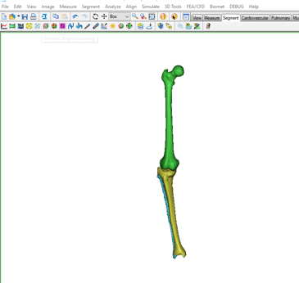
Fig 1: modeling in mimics.

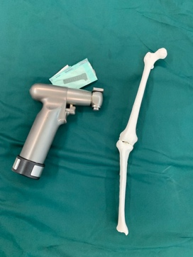
Fig 2: Residents performed an osteotomy on the printed model

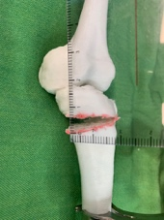
Fig 3: 3D model after simulation osteotomy on it.

 Biography
Hamidreza Mosleh has 24 years old and he is a MSc student of Anatomical sciences at Iran university of medical sciences. His research interests include anthropology and radiology in anatomy.
Email: mosleh.h@iums.ac.ir

