REUNITING UNUNITED POST NAILING ASEPTIC DIAPHYSEAL FRACTURE FEMUR/TIBIA BY DYNAMISATION/AUGMENTATION PLATING

The failure is either mechanical, biological or both. Mechanical failure – undersized nail, improper locking, distal spacious medullary canal, distal small fragment. Biological failure- comminuted fractures, internal degloving. Controlled dynamization by removing static screw in stable construct in delayed healing fracture promotes osteogenesis by micromotion and compression at fracture site obtained by axial cyclic loading. Treatment options for non-unions are exchange nailing/conversion to plate/augmentation plating with bone graft/bone grafting alone. Method: All surgeries done under spinal anaesthesia. Appropriate surgical approach depending on site. Decortication proximal and distal to fracture site, retaining existing nail. 6-8 cortices purchased either side. Autogenous bone graft in every patient. Discussion Popular method is exchange nailing with large size nail , the success rate varies from 53-100% in different studies. Rotational stress is chief cause of failure after exchange nailing. We used combi-hole plates for augmentation. Fixing plate over nail in situ is possible with little maneuvering. Augmentation plate eliminates rotational stress completely. It’s a myth that during reaming endosteal blood supply damages and putting a plate after few months jeopardises the periosteal vascularity also. It is proved beyond doubt that endosteal blood supply is restored within two to six weeks after reaming. Augmentation plate with autogenous bone graft combines the advantage of nail providing stable alignment with rigid fixation by plate. Augmentation plate increases bending stiffness 2.5 times and torsional stiffness 3.3 times, concomitant bone graft stimulates osteogenesis. This procedure is simple, lesser associated risks and not requiring blood transfusion. Conclusion: Augmentation plating with bone grafting will be the treatment of choice for nonunion of diaphyseal fractures. Medlock concluded mean union-rate in exchange nailing 74% in augmentation plating is 99.8%. Controlled early dynamization can abort impending non-union in large percentage of post-nailing delayed healing fracture.

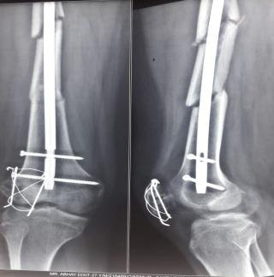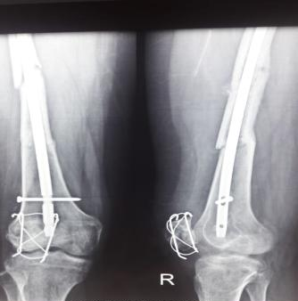
BEFORE DYNAMISATION AFTER THREE MONTHS

AFTER 2 YEARS
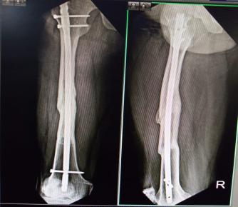

60 MONTHS AFTER INDEX SURGERY
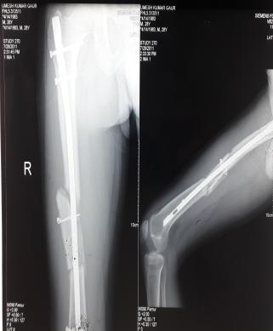

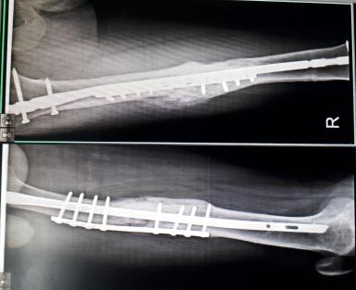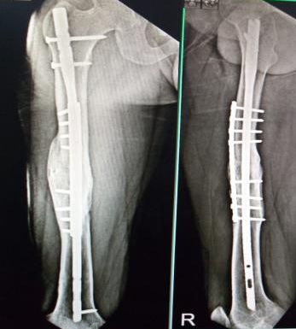

AFTER 4 MONTHS AFTER 2 YEARS
BIBLOGRAPHY
- Raju Vaishya et al (2016) Plate Augmentation with retention of intramedullary nail is effective for resistant femoral shaft non-union ; Journal of Orthopaedics 13 (2016):242-245.
- Gareth Medlock et al (2018) Uniting the ununited : should established non-unions of femoral shaft fractures initially treated with IM nails be treated by plate augmentation instead if exchange IM nailing? A systematic review ; Strategies in Trauma and Limb reconstruction 13:119-128.
- Chin-Jung Lin et al (2012) Effectiveness of plate augmentation for femoral shaft non unions after nailing ; Journal of Chinese Medical Association 75 : 396-401.
- Jiang Liangjun et al (2014) Augmentation plating in hypertrophic non-union after nail fixation of femoral shaft fracture compared with exchange plating :Chinese Medical Journal 127(16):2900-2905.
- J Park et al (2013) Indications and outcomes of augmentation plating with decortication and autogenous bone grafting for femoral shaft non unions: Injury Dec 201344(12):1820-1825.

BIOGRAPHY:
Dr.K.K.Mittal is a senior orthopedic and trauma surgeon working for last 40 years in a busy trauma centre near capital city of India. His patient centric approach paves way for innovative methods for treatment benefitting a large number of patients over his career span of four decades and also inspiring new surgeons. He is actively involved in academic activities and has presented his work at various prestigious state level and national conferences.
E mail: khtcgzb@hotmail.com Whatsapp: +919910058845
