EXTRA MEDULLARY FIXATION IN UNSTABLE TROCHANTERIC/SUBTROCHANTERIC FRACTURE BY PROXIMAL FEMORAL-LOCKING COMPRESSION PLATE (PRE CONTOURED PROXIMAL FEMORAL PLATE)
DR.K.K.MITTAL MS(ORTH.)HOD ORTHOPAEDICS, KRISHNA HOSPITAL AND TRAUMA CENTRE INDIA
Introduction:Fracture geometry, anatomy and bio-mechanics render trochanteric and subtrochanteric region susceptible to instability, reduction loss, implant failure and non union.An implant providing complete angular stability by creating fixed angle dynamic lock, PF-LCP meets all needs of these fracture fixation minimizing complications. PF-LCP provides advantage of TSP, blade plate and LCP. Method: Supine on fracture table under spinal anaesthesia, lateral vastus splitting approach. Biological/open fixation depending upon indirect/direct reduction respectively. Rotation maintained by keeping patella horizontal. PF-LCP on lateral aspect of proximal femur, 3 guide wires passed through wire guide mounted on plate in desired position under C Arm control, three screws in neck and minimum 3 distal to fracture.49 cases done in last 3 years. Discussion: Posterio-Medial column reconstruction is of paramount importance. PF-LCP acts as tension band plate, provides lateral shield, angular screws in neck provide torsional, bending stiffness, combi hole plate provides compression at Metaphyseal-diaphyseal junction, kick stand screw prevents varus collapse. Result: All patients followed till union. No revision or additional surgery done. Subtrochanteric fractures took longer to heal. Two patients had screw back-out but not enblock screw backout from neck. Three elderly patients had loss of initial position due to early weight bearing. No cut-out of hip screws. No patient developed infection, DVT, non-union, implant failure. Conclusion: PF-LCP provides stable, effective extramedullary fixation in unstable trochanteric like revere oblique ,fracture lateral trochanteric wall, four part fractures and sub-trochanteric fractures, fractures with narrow medullary canal, previous deformities, revision for malunion/ non-union.
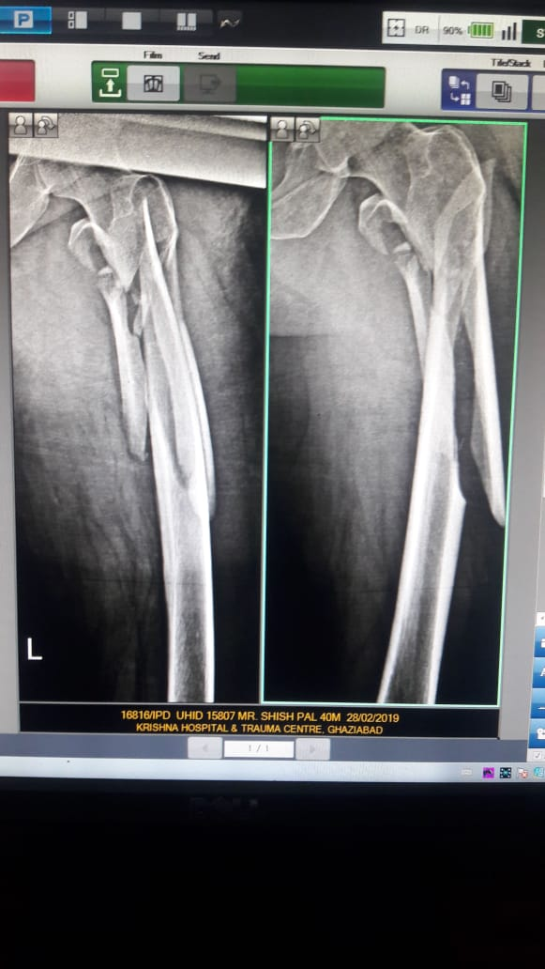
MIPO 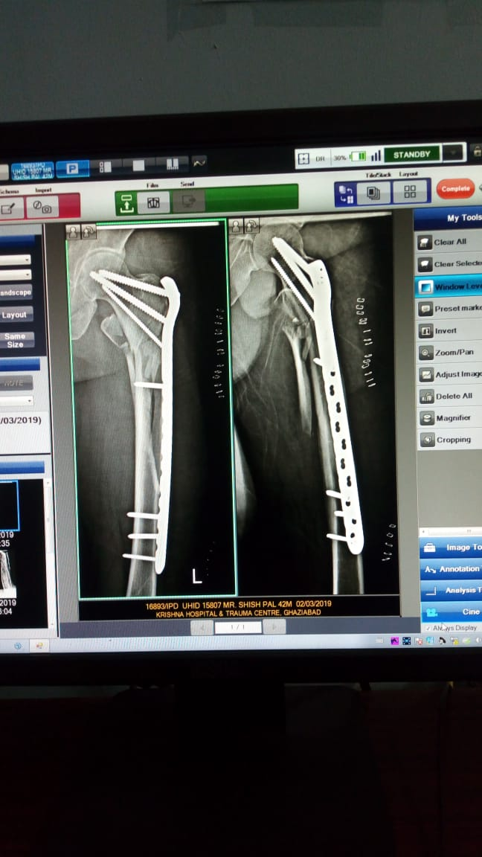
PRE OPERATIVE POST OPERATIVE
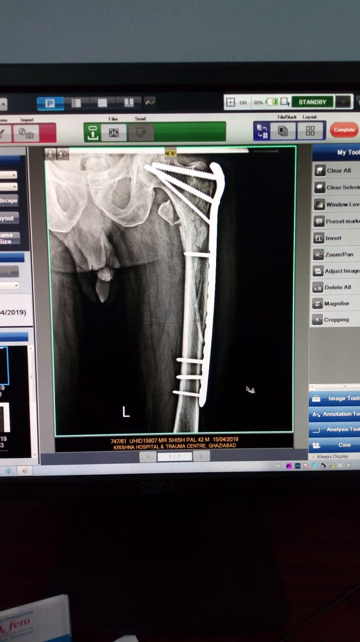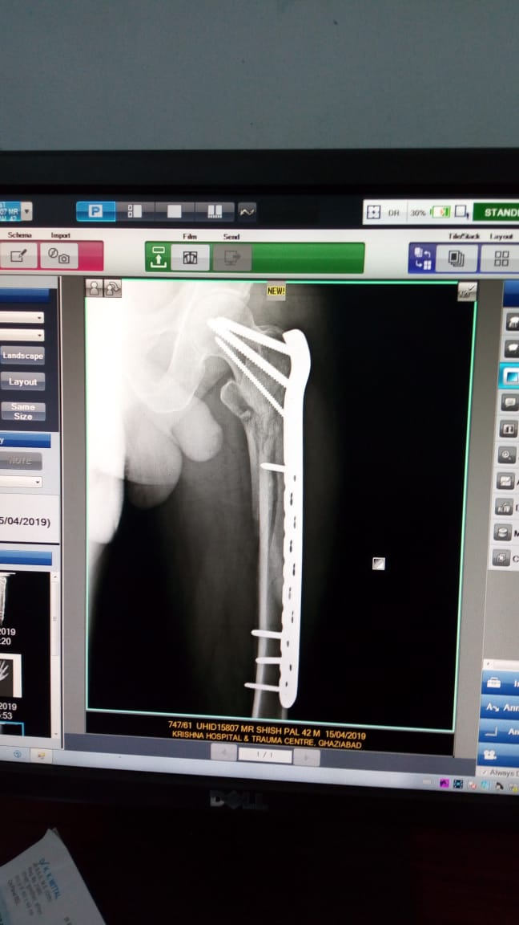
AFTER THREE MONTHS

BIBILOGRAPHY:
- Erik A. Hasenboehler MD et al (2007),Treatment of Complex Proximal Femoral Fractures with the Proximal Femur Locking Compression Plate, ORTHOPEDICS (2007); 30:618.
- Syed Ibrahim et al (2017) , A retrospective analysis of surgically treated complex proximal femur fractures with proximal femoral compression locking plate ,Sociedade Brasileira De Ortopedia E Traumatologia 52(6):644-650
- Ahmedreza Mirbolook et al (2015) Sub Trochanteric Fractures :Comparison of Proximal Femoral Locking plate and Intramedullary Locking nail fixation outcome , Indian J.Surg 77 (Suppl3):S795-S798.
- Saini P et al (2013) Biological Fixation of Comminuted Sub Trochanteric Fractures with proximal femur locking compression plate, Injury 44(2): 226-231.
- Wei Ting Lee et al (2014) Proximal Femoral Locking Compression plate for proximal femoral fractures, Journal of Orthopaedic surgery 2014; 22(3):287-93.

BIOGRAPHY:
Dr.K.K.Mittal is a senior orthopedic and trauma surgeon working for last 40 years in a busy trauma centre near capital city of India. His patient centric approach paves way for innovative methods for treatment benefitting a large number of patients over his career span of four decades and also inspiring new surgeons. He is actively involved in academic activities and has presented his work at various prestigious state level and national conferences.

E mail: khtcgzb@hotmail.com Whatsapp: +919910058845

