Partial-Thickness Rotator Cuff Tears
Watche Kourtian, Orthopedic Surgeon, Beirut-Lebanon

Abstract
Partial-thickness Rotator Cuff tears are a common cause of pain and disability in the adult shoulder. They are roughly twice as common as full-thickness RC tears.
We will discuss the Pathomechanics causing these injuries, their clinical presentation, types, diagnosis, treatment options and outcome.

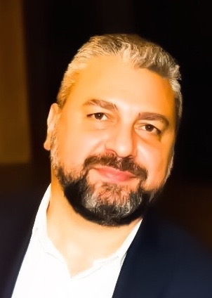
Biography
Watche Kourtian is a retired Army Colonel and former head of the Orthopedic Department in The Central Military Hospital in Beirut. Currently, he is an attending Orthopedic Surgeon at Keserwan Medical Center (KMC affiliated with AUBMC). He is specialized in Arthroscopic Surgery and Sports Injuries.

Email: drvkourt@gmail.com

