6ytgCONDAL INJURY IN KNEE, IS RETURN TO HIGH COMPETITION SPORTS POSSIBLE ?.
Alex se43qwDante Antezana Arzabee43
José Jordán Cuenca
Alex Dante Antezana Arzabe, ¹
Jose Jordan Cuenca, ²
¹ Medical Director Center of Sports Traumatology Cochabamba, Bolivia
² Biological Unit Cell Therapy Center of Sports Traumatology Cochabamba, Bolivia.
Keywords: Platelet Rich Growth Factors, Arthroscopy, Infiltration, Subcondral Bone.

- Abstract body.
In recent years the incidence of chondral knee injuries has increased, due to sports demands, accelerated rehabilitation programs and aggressive surgeries, leading to the abandonment of sports activity.Longitudinal, descriptive, prospective study. Period January 2017 to December 2018The patients were evaluated by means of magnetic resonance (PHILIPS) of 1.5 Teslas, with sequences T1, T2, TSE.Diagnosed the injury, we performed arthroscopy of the knee, arthroscopic cleaning of the joint, associated with micro perforations in the areas of the lesion. Then we proceed to the infiltration of Plasma Rich in Growth Factors in the subchondral bone at the level of the distal femur and proximal tibia, 7 ml in each segment, then we performed the infiltration of Rich Plasma in 7-ml intra-articular Growth Factors.The difficulty of performing a revision arthroscopy is complex; so we rely on the results of post-surgical nuclear magnetic resonance (2 months); it reports the development of articular cartilage in the area of ​​injury, in addition to the resolution of bone edema if it exists.Functional evaluation using the Lysholmm scale prior to surgery gave a score of 54 points and a score of 95 points after surgery.Partial support of weight in the affected limb was permitted 21 days after surgery and return to sporting activity was in a period of 60.6 days. A 16-week follow-up was done to each athlete.
- Image:
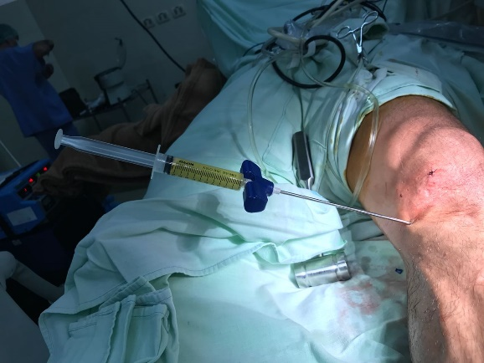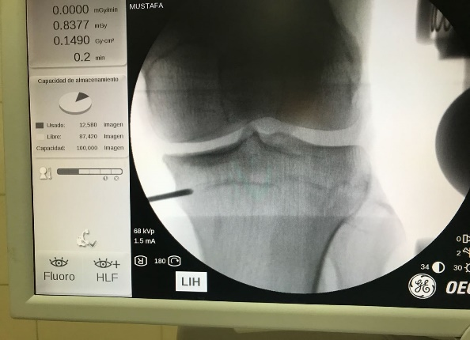

III. Reference:
1. Kruger JP, Hondke S, Endres M, Pruss A, Siclari A, Kaps C. Human platelet-rich plasma stimulates migration and chondrogenic differentiation of human subcondral progenitor cells. J Orthopaed Res 2012; 30(6): 845- 852
2. Sanchez M, Fiz N, Guadilla J, Padilla S, Anitua E, Sánchez P. Intraosseous infiltration of platelet-rich-plasma for severe knee osteoarthritis. Arthrosc Tech 2014 Dec 15; 3(6): e713-717.
- Biography:
Alex Antezana Arzabe, orthopedic surgeon, with specialization studies at the School of Medicine of the University Mayor de San Simon Cochabamba Bolivia. Currently Director of the Center for Sports Traumatology, dedicated to the investigation of sports injuries and biological therapies for more than 10 years.
- Presenting autor details

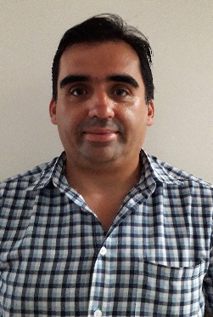
Name : Alex Dante Antezana Arzabe
Contact number: 0059172256351
Linked In Account: CTD Antezana
Category : Oral Presentation
Passport Number: 3608485

