Functional outcome of operated case of pelvic fractures from level I trauma center: a prospective observational study
Saurabh S(1), Trikha V(2)
- Senior Resident, Department of orthopaedics, AIIMS, New Delhi
- Professor, Department of orthopaedics, JPN Apex Trauma Centre, AIIMS, New Delhi
ABSTRACT
Objective: This study aims towards evaluating patients who sustained pelvic fracture and to evaluate their functional, radiological and quality of life outcome.
Material and methods: This was a prospective observational study done from March 2015 to April 2016. Total 30 patients were operated during this period. Approach was decided as per fracture pattern. Post-operatively, they were followed with radiographs and clinical examination at 6 weeks, 3 months and 6 months. Functional scoring was done using Majeed functional score and radiological grading was done using Matta’s criteria. WHOQOL-BREF score was used to assess quality of life. Statistical analysis was done by using Stata 11.0 software.
Results: Functional outcome were excellent in 20 patients, good in 9 and poor in 1 patient. Quality of life score was more than 70 in all domain. Radiological healing was present by 4.5 months.
Conclusion: Multi-disciplinary approach is required for management of pelvic fractures. Good functional, quality of life and radiological outcome can be achieved with operative treatment of unstable pelvic fractures.

Image:
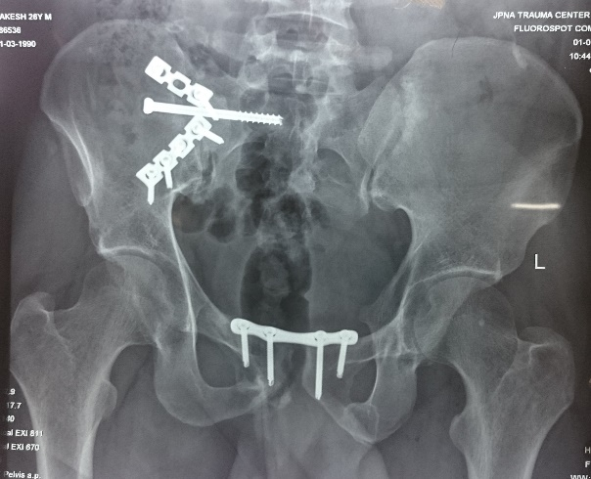

References:
- Young JW, Burgess AR, Brumback RJ, Poka A. Pelvic fractures: value of plain radiography in early assessment and management. Radiology. 1986 Aug;160(2):445–51.
- Moon DH, Kim NK, Won JS, Choi JS, Kim DH. Outcome of Surgical Treatment of AO Type C Pelvic Ring Injury. Hip Pelvis. 2014 Dec;26(4):269–74.
- Mardanpour K, Rahbar M. The outcome of surgically treated traumatic unstable pelvic fractures by open reduction and internal fixation. J Inj Violence Res. 2013 Jun;5(2):77–83.

Biography:
Dr. Suman Saurabh has completed his MBBS from premier All India Institute of Medical Sciences, New Delhi. He has done his post-graduation ie MS in Orthopaedics from same institute. Currently, he is working as a senior resident at same place.

Presenting author details

Full Name: Dr. Suman Saurabh
Contact Number: +91-9711218455
Twitter account: NA
LinkedIn account: NA
Category: Oral presentation
Passport number: N978013

