Effect of oxidant 1, 3-dichloro-5-5-dimethylhydantoin and 5, 5-dimethylhydantoin with different substrates: The kinetic measurements

Arvind Prasad Dwivedi¹ and Shweta Neeraj²
¹Department of Chemistry, Govt. Sanjay Gandhi Smrati Auto., P.G., College Sidhi M.P
²Department of Chemistry, Govt. Girls P.G. College (NAAC) Rewa-486001 (M.P.) India

Abstract: The kinetic measurement with different concentration of oxidant 1,3-dichloro-5,5-dimethylhydantoin and 5,5-dimethylhydantoin with ℓ–alanine, ℓ-glycine and ℓ–valine. The catalytic effect of acid in the reaction rate reveal an interaction between oxidants species H₂O⁺Cl and substrates. The observed order of reactivity of ℓ-amino acids (ℓ-glycine > ℓ–alanine > ℓ-valine) was explained on the basis of hydrolysis of reacting species.
Key words: Kinetic measurement, concentration, catalytic effect, hydrolysis, reveal.
1. Introduction
N-chlorinated hydantoin are important and versatile chlorinating agents. That have found use in a range of synthetic operations. The prototypical example, 1,3-dichloro-5, 5-dimethylhydatoin (DCDMH) has been employed as a chlorine source for the ɑ–chlorination of acetophenones¹ and 1-aryl-2-pyrazolin-5-ones,² for the preparation chlorohydrin derivatives of corticosterioids^{,3} for the benzylic chlorination of 2-methylpyrazine,⁴ and for the selective chlorination of a heavily functionalized quinoline derivative in route to the antibiotic ABT-492.⁵ In the latter DCDMH⁶⁻⁸ was employed to trap an enolate resulting from the attack of dimethyl zinc on to an ɑ,β-unsaturated ketone, DCDMH has been employed as a number of transformation including the halodeboration of aryl boronic acids,⁹ the oxidation to triazolinediones,¹⁰ the microwave-assisted cleavage of oximes¹¹, the preparation of dialykyl chlorophosphatges,¹² and as a terminal oxidant in the sharpless asymmetric aminohydroxylation reaction.^{13,14} DCDMH has emerged as leading of silyl linkers for solid-phase organic syntheris.¹⁵⁻¹⁸
- EXPERIMENTAL
All the reagents and solvents used were of analytical grade (B.D.H., C.D.H. and Acros). The solution of DCDMH is standardized iodometrically. The solution of sodium thiosulphate was prepared by taking a B.D.H. grade simple in a doubly distilled water and was standardized against copper sulphate solution using KI and starch as an indicator iodometrically. Other solutions of NaCl, KCl, DMH were prepared by dissolving. Their requisite amount of AnalaR sample in distilled water. The reaction kinetics was studied by using thermostat maintained at constant temperature.
- RESULTS AND DISCUSSION
The kinetic data have been collected for five-fold concentrations of the oxidant [DCDMH] (1.25 – 5.0 × 10⁻³ mol dm⁻³) and at fixed concentration of ℓ–alanine at 303 K temperature (Table: 1 and Fig. 1). The unit slope of plot of log [DCDMH] vs. time was found to be linear indicating first-order dependency on the reaction rate. The effect of [5,5-dimethylhydantoin] (DMH) on the rate of oxidation of was investigated by taking its varying five-fold concentration of (0.50 – 5.00 × 10⁻² mol dm⁻³) maintaining. The concentration of ℓ–glycine and ℓ–valine constant at fixed temperature (Table: 2 and Fig. 2). The inverse plot of k⁻¹ vs. [DMH] was obtained linear in each substrate.

Mechanism
1,3-dihloro-5,5-dimethylhydantoin (DCDMH) on hydrolysis yields finally dimethylhydantoin (DMH) in aqueous solution. The following equilibrium exists.
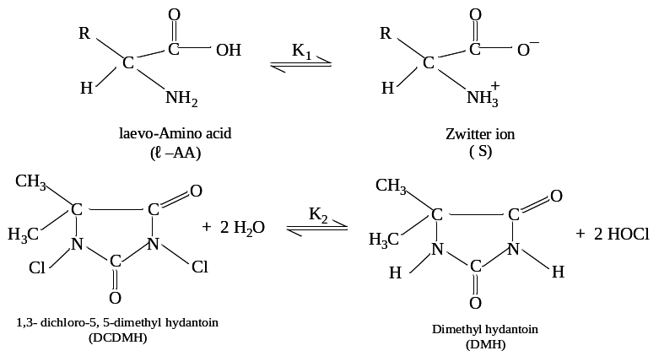
………. (1)

………. (2)

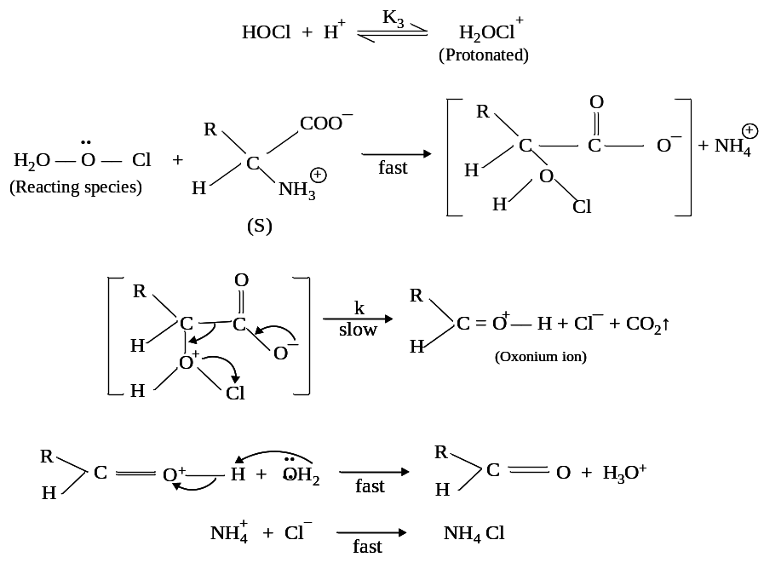
………. (3))

………. (4)

………. (5)

………. (6)
………. (7)

where, R = CH₃, -CH-(CH₃)₂ for corresponding aldehydes.
The final rate law derived based on mechanism using steady state approximation is represented by equation (8).
………. (8)
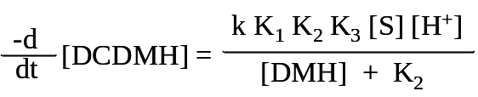

The observed order of reactivity was found in sequence
ℓ-glycine > ℓ-alanine > ℓ-valine

The similar mechanism has also been earlier reported by authors¹⁹⁻²² for the study of ℓ-AA-DCDMH system. The reaction yielded acetaldehyde, formaldehyde and butyraldehyde end-products which is characterized by the spot test and other modern physical methods.
4. Conclusion
1,3-dichloro-5,5-dimethylhydantoin has been in route to the antibiotic ABT-492. DCDMH was employed to trap an enolate resulting from the attack of dimethylzinc on to an ɑ-β-unsaturated ketone thus generating an ɑ-chloro-β-methyl ketone functionally in route to a building block of Amphotericin B.

Table 1 : Effect of concentration of DCDMH on rate of reaction
[Substrate] = 2.00 × 10⁻³ (mol dm⁻³) ;
[H⁺] = 0.66 × 10⁻³ (mol dm⁻³) ;
CH₃COOH- H₂O = 30 % (v/v) ;
Temp. = 303 K

S. No. | [DCDMH] ×10³  (mol dm⁻³) | k₁ ×10⁴ (s⁻¹)
S. No. | [DCDMH] ×10³  (mol dm⁻³) | ℓ-alanine  (CH₃CHNH₂COOH)
1. | 1.25 | 4.56
2. | 2.00 | 4.65
3. | 2.50 | 4.63
4. | 3.33 | 4.58
5. | 4.00 | 4.66
6. | 5.00 | 4.64

Table 2 : Effect of variation of [5,5-dimethylhydantoin] (DMH) on reaction rate
10³ × [DCDMH] (mol dm⁻³) = 2.50 (1, 2) ;
[H⁺] (mol dm⁻³) = 0.50 (1), 0.80 (2) ;
CH₃COOH- H₂O % (v/v) = 20 (1), 50 (2) ;
Temp. K = 308 (1), 303 (2)

S. No. | [5,5-dimethylhydaotoin]×10³  (mol dm⁻³) | k₁ ×10⁴ (s⁻¹)
S. No. | [5,5-dimethylhydaotoin]×10³  (mol dm⁻³) | ℓ-glycine  (NH₂CH₂COOH)  (1) | ℓ-valine  (CH₃)₂CHCHNH₂COOH)  (2)
1. | 0.00 | 4.75 | 3.82
2. | 0.50 | 4.56 | 3.63
3. | 1.00 | 4.49 | 3.34
4. | 1.25 | 4.10 | 3.03
5. | 2.00 | 3.77 | 2.75
6. | 2.50 | 3.42 | 2.39
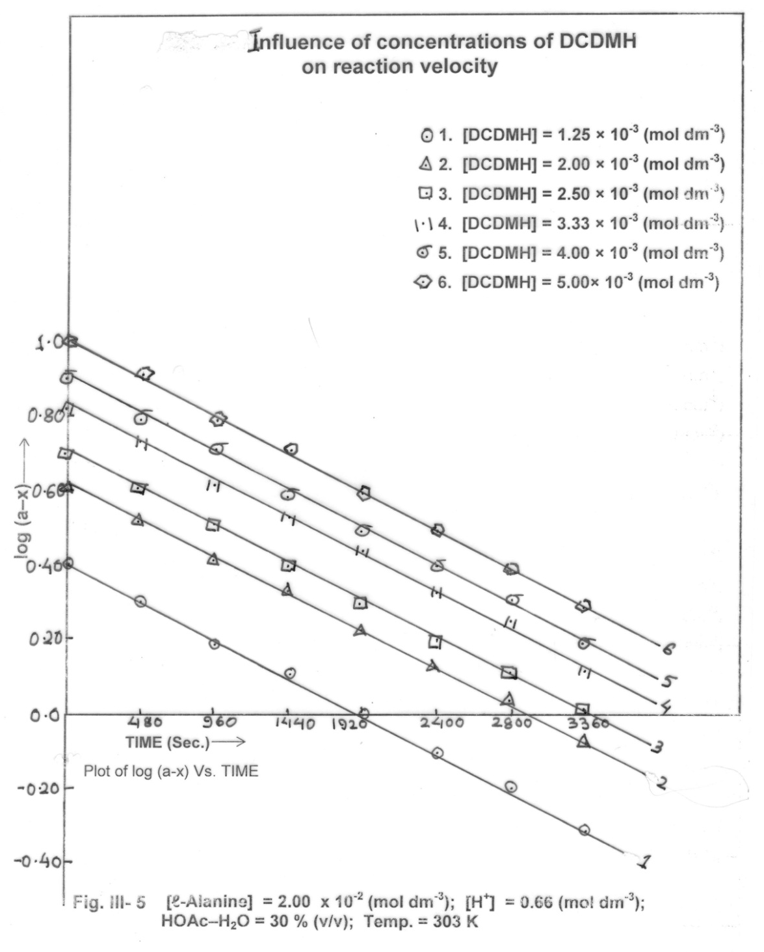
Fig.1
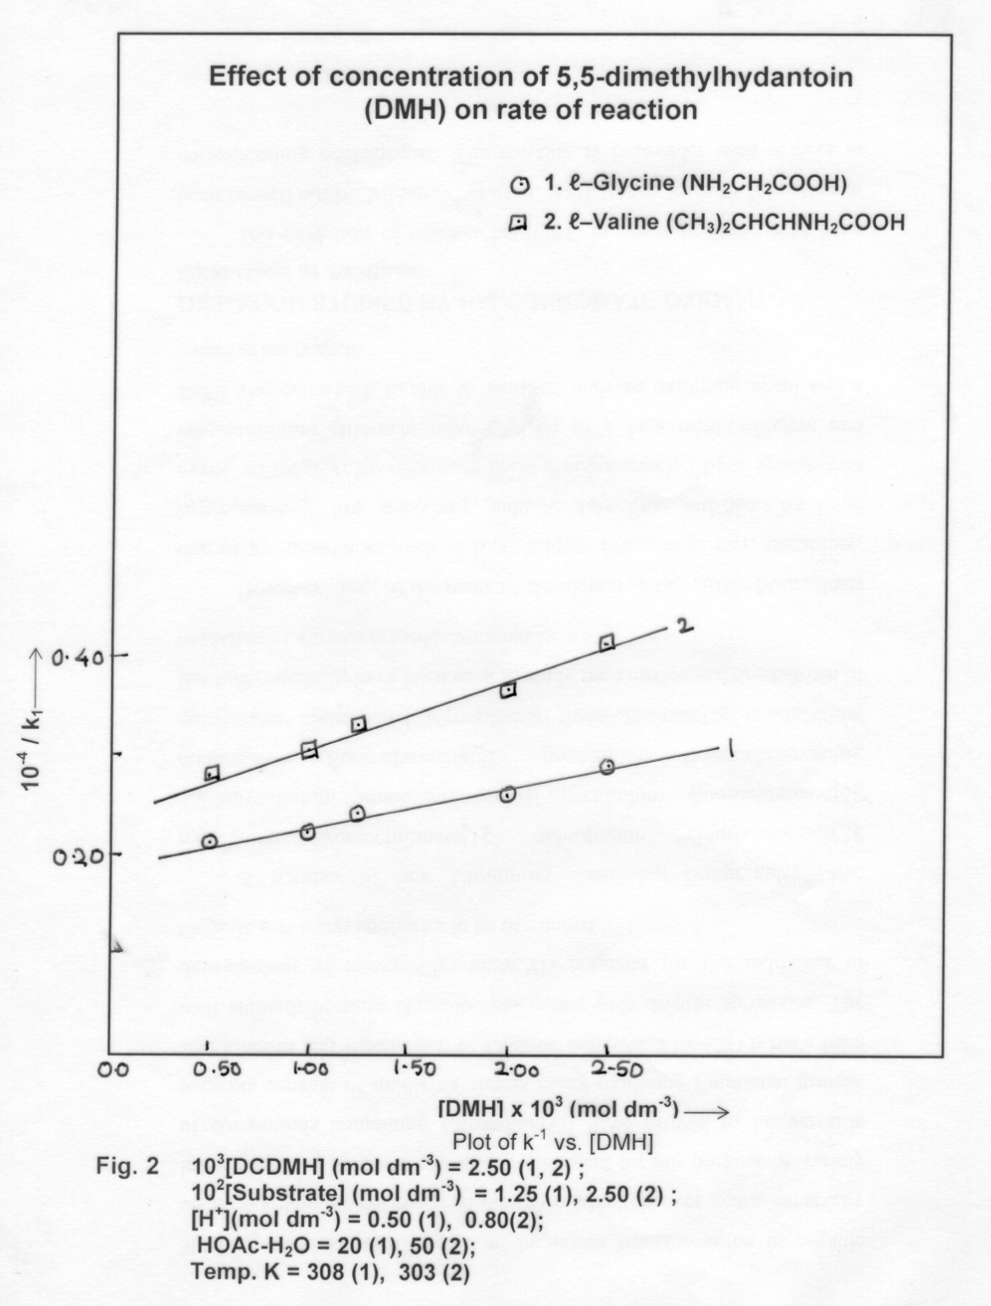
5. REFERENCES
[1] | Xu ZJ, Zhang Dy, Zou XZ, Synth commu 2006, 36, 255-258.
[2] | Spitulnik MJ. : Synthesis 1985, 299-300.
[3] | Shapiro EL, Centles MJ, Tiberi RL, Popper TL, Berkenkopf J, Lutsky B, Watnick AS. : J Med Chem 1987, 30, 1581-1588.
[4] | Karmazin L, Mazzanti M, Bezombes JP, Gateau C, Pecaut J, Inorg Chem 2004, 43, 5147-5158.
[5] | Barnes DM, Christesen AC, Engstrom KM, Haight AR, Stoner EJ, Wagaw S, Org process Res Dev 2006, 10, 803-807.
[6] | Chen BC, Murphy CK, Kumar A, Clark C, Zhou P, Lewis BM, Buckley J. : Organic synthesis 1996, 73, 159-173.
[7] | Mergelsberg I, Gala D, Scherer D, Dibenedetto D, Tanner M. : Tetrahedron Lett 1992, 33, 161-164.
[8] | Miesch L, Gateau C, Morin F, Franck-Neumaann M, Tetrahedron Lett. 2002, 43, 7635-7638.
[9] | Szumigala RH, Devine PN, Gautheir DR, Volante RP, J Org Chem 2004, 69, 566-569.
[10] | Zolifigol MA, Nasr-Isfahani H, Mallakpour S, Safaiee M, Synlett 2005, 761-764.
[11] | Khazaei A, Manesh AA, Synthesis 2005, 1929-1931.
[12] | Shakya PD, Dubey DK, Pardasani D, Palit M, Gupta AK, Org Prep Proced Int 2005, 37, 569-574.
[13] | Barta NS, Sidler DR, Somerville KB, Weissman SA, Larsen RD, Reider PJ. : Org Lett 2000, 2, 2821-2824.
[14] | Harding M, BGodkin JA, Hutton CA, Synlett 2005, 2829-2831.
[15] | Zolfigol MA, Ghaemi E, Madrakian E, Choghamarani AG, Mendeleev commun 2006, 41-42.
[16] | Nikman K, Zolfigol MA. L J Iran Chem Soc 2006, 3, 59-63.
[17] | DiBlasi CM, Macks DE, Tan DS,Org Lett 2005, 7, 1777-1780.
[18] | Grela K, Tryznowski M, Bieniek M., Tetrahedra Lett 2002, 43, 9055-9059.
[19] | Neeraj Shweta, Parihar SS, Dwivedi AP, Int J Adv Research in Chemical Science (IJARCS) 2018, 4, 9-14.
[20] | Neeraj Shweta, Parihar SS, Dwivedi AP, Int J Adv Research in Chemical Science (IJARCS) 2018, 5, 25-30.
[21] | Neeraj Shweta, Parihar SS, Dwivedi AP, Int J Adv Research in Chemical Science (IJARCS) 2018, 5, 1-5.
[22] | Neeraj Shweta, Parihar SS, Dwivedi AP, Int J Engineering and Information Systems (IJEAIS) 2018, 2, 27-31.

