Effect of Ozonated Gel on Management of Denture Stomatitis Cases

WHAT IS OZONE?
- Ozone is a naturally occurring compound consisting of three oxygen atoms. ( tri-atomic oxygen O3).
. It is found in the form of a gas in the Earth's atmosphere, where it is formed through a photo chemical process.
- Medical Grade Ozone Therapy
Ozone therapy has successfully being used in the medical field for treatment of various diseases for more than 100 years. ‘’Medical grade Ozone’’ is prepared from pure oxygen using different types of “Ozone Generators”. ‘’Medical grade Ozone’’ can produce different effects according to the chosen concentration and the way of its administration.
- Ozone Therapy in Dentistry
. Ozone Applications in Fixed Prosthodontics
Use of ozone gas before temporization and cementation of the final fixed prosthesis.
.Ozone Applications in Surgery:
Alveolar socket after extraction / ozonated water being used for irrigation
.Ozone Applications in Endodontics:
Ozone gas used in root canals Disinfection
.Ozone Applications in Dental Caries:
The ozone penetrates through the decayed tissue, eliminating any bacteria, fungi and viral contamination. It also denatures the acid metabolites of the bacteria.
.Ozone Applications in Pedodontics:
Treatment and prevention of “bottle” caries.
Remineralization of pit and fissure caries.
Remineralization of smooth surface caries.
.Ozone Applications in Periodontics:
The effect of ozonized olive oil after scaling
.Ozone Applications in Periodontics:
the application of ozone therapy in chronic gingival and periodontal diseases.
.Ozone Applications in Implant Dentistry:
The effect on perimplantitis
.Ozone Applications in Orthodontics:
Application of ozone gas around orthodontic brackets to avoid demineralization and white spots.
. Ozone Applications in Oral Medicine:
application of ozone gas for treatment of Herpetic oral lesions.
Ozone gas application with oral ulcers as in diabetic patients.
Ozone Applications in Teeth Bleaching:
.Ozone Applications in Temporomandibular Disorders (TMD):
Ozone Applications in Removable Prosthodontics:
Denture Stomatitis
Etiology of Denture Stomatitis
Exfoliative Cytology?
Aim of the work
The aim of this study was to evaluate the effect of ozonated gel application on management of Denture Stomatitis in completely edentulous patients.
Materials
The Longevity Ext 120 ozone generator was used to produce ”Ultra pure ozone” from oxygen with concentration ranging from 3 to 120 µg/ml.*
*Preparation of Ozonized Gel
Bubbling of 25µg /ml ozone gas through pure olive oil for two days until it solidifies.
Patients Selection:
Ten completely edentulous patients were selected from those attended to the Prosthodontic Department, Faculty of Dentistry, Pharos University. Wearing complete dentures with signs of denture stomatitis. Free from uncontrolled systemic diseases
Oral Cytological Smear Procedures: Exfoliative cytology were performed on smear samples from oral mucosa collected from the patients affected with Denture Stomatitis under their complete denture. “Exfoliative Cytological Smears”
were performed for each patient : before ozonated gel application and after ozonated gel application.
Ozonized gel application: The patients were instructed to do the following -
- Washing their denture thoroughly with brush under running tap water.
- . Suitable amount of ozonized gel ( 2.5ml= 2.5cm3) was applied one time daily for 15 days
- The denture was reinserted in the patient mouth.
. Cytological Smear Procedure After ozonated gel application
Exfoliative cytology of mucosal smears showing epithelial cells. Inflammatory cells are much reduced (H&EX200).
RESULTS:
Exfoliative cytology of mucosal smears demonstrated increase in number of inflammatory cell in Denture Stomatitis patients before ozone gel application as compared with those smears taken from the patients after ozone gel application.
Conclusions:
Ozonated gel therapy is an effective therapeutic treatment modality for relieving the inflammatory signs of Denture Stomatitis under complete dentures.
Oral exfoliative cytology is a minimally invasive procedure and therefore it is ideal for the repeated examination and follow up of certain treatment.
Images
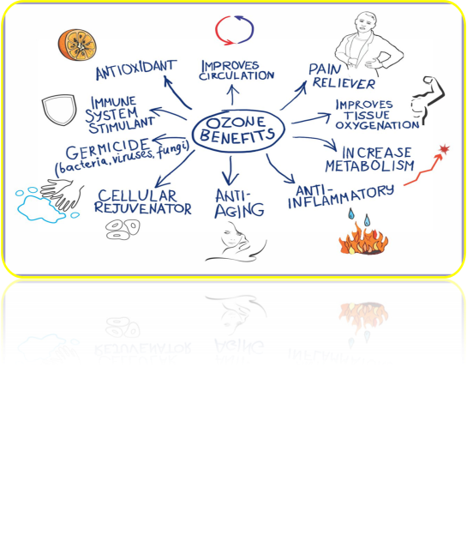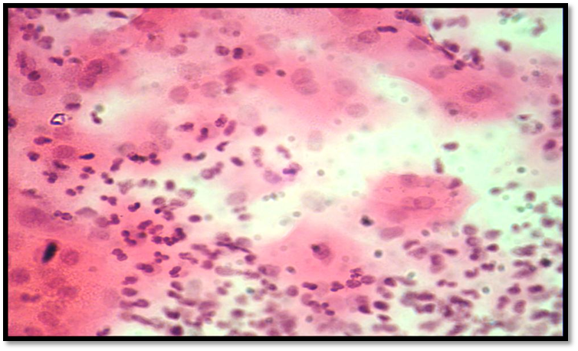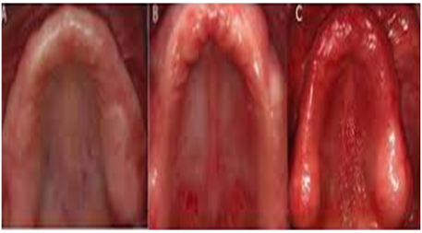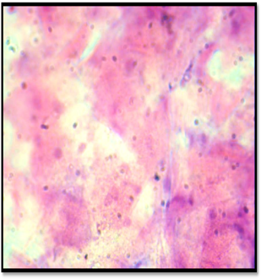
Recent publications :
Guanche D, Zamora Z, Hernandez F, Mena K, Alonso Y, Roda M. Effect of ozone/oxygen mixture on systemic oxidative stress and organic damage. Toxicol Mech Methods. 2010; 20: 25-30.
Nogales CG, Ferrari PA, Kantorovich EO, Lage-Marques JL. Ozone therapy in medicine and dentistry. J Contemp Dent Pract 2008; 1:75-84.
Wang RR, Shang GW, Hu LF, Wang XP, Huang W, Li MY. The disinfecting effect of ozone on four kinds of bacteria. Shanghai Kou Qiang Yi Xue. 2008; 17: 92-95.
Bocci V. The case for oxygen-ozone therapy.Br J Biomed Sci. 2007; 64:44-9.
Geweely NS. Antifungual activity of ozonized olive oil (Oleozon). Int J Agri Biol .2006; 8: 670-675.
Bocci V. Ozone: A New Medical Drug. Springer, Netherlands 2005 pp31-35
Editorial Review: Ozone Therapy. The International Journal of Artificial Organs. 2004; 27: 168- 175.
Saini R. Ozone therapy in dentistry: A strategic review. J Nat Sci Biol Med. 2011 Jul-Dec; 2(2): 151–153.
Biography: Effect of Ozonated Gel on Management of Denture Stomatitis Cases 
*Mohamed Hamdi Mohamed Ali .
*Class 2016 pharous university-Alexandria –Egypt .
*mobile number :00201101234423
*Email:zahnarztismail@gmail.com
*this research has been made in the clinics of prosthesis department of pharous university due to the huge number of the patients coming everyday asking for treatment of denture stomatitis.so we start to use the ozonated gel as a treatment on a large number of the patients and actually I have found that it has magical effect as a treatment of denture stomatitis .

