An insight into a promising cutting-edge laser drilling/trepanning technology assisted by water-based ultrasonic vibrations and magnetic field
Houxiao Wang, Jiangsu University, China
Naifei Ren, Jiangsu University, China
Xudong Ren, Jiangsu University, China
Lin Li, The University of Manchester, UK
Wei Zhou, Nanyang Technological University, Singapore
Dao Hua Zhang, Nanyang Technological University, Singapore

Abstract (300 word limit)
Pulsed laser drilling and trepanning assisted by ultrasonic vibrations and/or external magnetic assistance is a recently emerging/growing technology, and it has gained more and more attentions/interests from the researchers in the area. However, the plasma cloud induced during laser drilling/trepanning can move down laser defocus distance and reduce laser energy absorption for workpiece. For transducer-based ultrasonic assistance, normally, there are some issues encountered, such as serious energy loss during ultrasonic wave propagation in the air, piercing noise caused by direct ultrasonic impact onto some locations of the workpiece, and limited operation life span of the ultrasonic system. Besides, there are also two critical technical problems encountered during underwater laser drilling or machining, one is the underwater-induced interaction between water and laser beam owing to water-induced refraction and absorption, the other is the serious water surface instability when using assist gas flow, leading to random alteration of the angle of incidence for the laser beam. In this talk, as shown in Figure 1, a promising cutting-edge laser drilling/trepanning technology assisted by water-based ultrasonic vibrations coupled with an external magnetic field, which is not underwater laser drilling/trepanning (only the bottom half of the workpiece is immersed in the water), is proposed and reported with examples and demonstrations. It is shown that the laser drilling/trepanning quality, efficiency and performance can be effectively improved with high precision, greatly relieving residual stress for laser drilled/trepanned workpieces. Except for laser drilling and trepanning, this water-based ultrasonic-assisted technology with magnetic assistance also has foreseeable promising and wide prospects for future research works and manufacturing applications in some other related fields due to its unique merits of science and technology, especially in the areas of laser machining, processing and manufacturing such as laser welding/brazing, laser additive manufacturing, laser cladding/coating, and laser cutting, etc.

Image
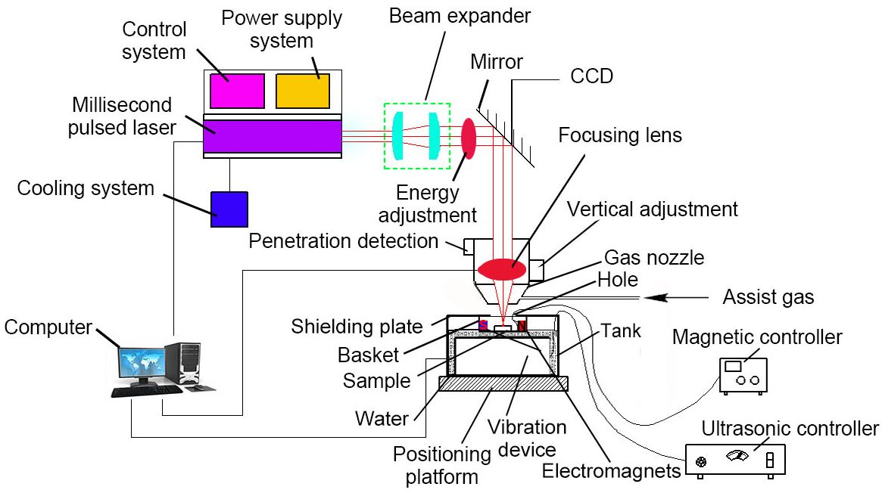
Figure 1. Schematic of water-based ultrasonic-assisted laser drilling and trepanning system using magnetic assistance.
Recent Publications (minimum 5)
- Wang H, Zhu S, Xu G, Zhou W, Li L, Zhang DH, Ren N, Xia K, Shi C (2018) Influence of ultrasonic vibration on percussion drilling performance for millisecond pulsed Nd:YAG laser. Optics and Laser Technology 104: 133-139.
- Wang H, Zhu S, Asundi A, Xu Y (2019) Experimental characterization of laser trepanning performance enhanced by water-based ultrasonic assistance. Optics and Laser Technology 109: 547-560.
- Xia K, Ren N, Wang H, Shi C (2018) Analysis for effects of ultrasonic power on ultrasonic-assisted single-pulse laser percussion drilling. Optics and Lasers in Engineering 110: 279-287.
- Wang H, Xu G, Zhu S, Zhou W, Ren N, Xia K (2018) Comparison of percussion laser drilling quality with and without water-based ultrasonic assistance. Journal of Manufacturing Processes 36: 175-180.
- Wang H, Zhu S, Xu Y, Ren N (2019) Experimental investigation on eﬀects of water-based ultrasonic vibrations, transverse magnetic field and water temperatures on percussion laser drilling performance. Optics and Laser Technology 112: 395-408.


Biography (150 word limit)
Dr. Houxiao Wang received his PhD degree from the Nanyang Technological University (NTU) in 2013. He conducted the collaboration work attached with the Institute of High Performance Computing (IHPC) in Singapore from 2009 to 2011. He got the NTU Research Scholarship (Singapore) in 2008. He is currently an associate professor at the School of Mechanical Engineering, Jiangsu University. His current research interests mainly focus on advanced laser drilling/trepanning, machining, processing and manufacturing assisted by water-based ultrasonic vibrations and/or magnetic field, materials processing, and focused ion beam (FIB) nanofabrication and nanometrology for optical applications. He is an invited editorial board member of American Journal of Physics and Applications (AJPA). Dr. Wang is currently the member of several professional organizations such as The Optical Society of America (OSA), the Optics and Photonics Society of Singapore (OPSS), and the Materials Research Society of Singapore (MRSS). He has published more than 30 peer-reviewed journal papers. He has been invited as or served as the (honorable) plenary/keynote/invited speaker, the honorable guest/speaker, the (honorable) session chair/co-chair, the honorary/invited organizing committee member, the invited scientific committee member and/or the technical program committee member for more than 20 important international conferences in the area. He has been invited for organizing more than 20 important international conferences held in 2019.
Email: wanghx@ujs.edu.cn

Notes/Comments:
Prof./Dr. Houxiao Wang is a leading scientist in the field of advanced laser drilling/trepanning, machining, processing and manufacturing assisted by water-based ultrasonic vibrations and/or external magnetic field. He has firstly proposed and successfully developed a unique promising water-based ultrasonic-assisted laser drilling and trepanning technique with/without using magnetic assistance. Dr. Wang’s recent publications and cutting-edge research works with novel/promising science and technology in this area have gained more and more attentions/interests from the researchers/readers, impressing them with a great impact.

