High Accuracy Optoelectronic Jaw Motion Dynamic Tracking System
Liang-Yuan Cheng¹, Chih-Yu Hsu^{1,2}, Tzung-Han Lin³, Shyh-Yuan Lee^{1,2} and Yuan-Min Lin^{1,2}

Abstract (300 word limit)

There are numerous methods to trace the mandibular motion nowadays, such as graphical method, electromagnetic fields, ultrasonic devices and optoelectronic devices. In this study, we presented a novel high-accuracy marked optoelectronic jaw motion tracking system and related algorithms. Comparing to the popular ultrasonic-based JMA devices and other developed optoelectronic devices, which are heavy and can cause occlusal interference during tracking, our lightweight devices are optical-based detection system including a mandibular tracer, an eyewear facebow device, and stereo-vision cameras. Eyewear facebow and mandibular tracer provided information regarding the locations and relative movement of upper and lower jaws. Using OpenCV-based self-developed algorithm and post-iterative compensator, we were able to record the dynamic jaw movement in virtual environments with a high accuracy of mean error is 65.6 μm in x, y, and z directions, and our RMS errors are less than 101.2 μm at working distance. The lightweight devices had minimal occlusal disturbance and provides smooth motion-tracking experiences. The accuracy of our system is at least a quarter order better than other techniques, and it is relatively low-cost.

Image
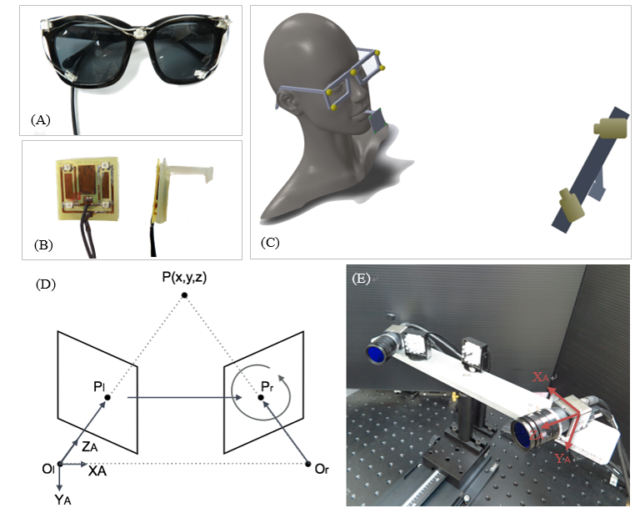
Recent Publications (minimum 5)
- Shyh-Yuan Lee, Sheng-Chien Wu, Hsuan Chen, Lo-Lin Tsai, Jy-Jiunn Tzeng, Chih-Hsin Lin, and Yuan-Min Lin*, Synthesis and characterization of polycaprolactone-based polyurethanes for the fabrication of elastic guided bone regeneration membrane. Biomed Research International (Accepted)
- Jy-Jiunn Tzeng, Yi-Ting Hsiao, Yun-Ching Wu, Hsuan Chen, Shyh-Yuan Lee, and Yuan-Min Lin*, Synthesis, Characterization, and Visible Light Curing Capacity of Polycaprolactone Acrylate. Biomed Research International (Accepted)
- Chang, Wei-Ting; Hsu, Huang Jan; Jiang, Cho-Pei; Lee, Shyh-Yuan; Lin, Yuan-Min＊ (2017, Apr). Effects of Titanium dioxide and tartrazine lake dye on Z-axis resolution and physical properties of light-cured resin printed by a visible-light 3D printer . Rapid prototyping journal, 24(4). (Accepted)
- Chih-Hsin Lin, Ming-Chau Chang, Shih-Chieh Hung, Shyh-Yuan Lee, Yuan-Min Lin*, Bioactive surface modification of polycaprolactone using MG63-conditioned medium can induce osteogenic differentiation of mesenchymal stem cells , Journal of Materials Science, 2017. 52(7):p3967-3978 (IF=2.302, R/C= 82/271 in Materials science, Multidisciplinary)
- Yung‐Chang Cheng*, Deng‐Huei Lin, Cho‐Pei Jiang, Yuan‐Min Lin*, Dental implant customization using numerical optimization design and 3‐dimensional printing fabrication of zirconia ceramic, International Journal for Numerical Methods in Biomedical Engineering, doi: 10.1002/cnm.2820.

Biography (150 word limit)
Dr. Yuan-Min Lin, DDS, MSc, PhD, is an Associate Professor at the Department of Dentistry, National Yang-Ming University, Taiwan. He is the head of the Laboratory of Digital Dentistry and Dental Materials. Dr. Lin is also the founder of the Enlighten Materials company, a company focusing on the 3D printing and bioprinting materials..
Email: ymlin@ym.edu.tw

