Multi-spectrum laser-excited phosphor light engine for endoscopic fiber illumination applications
Tsung-Xian Lee, National Taiwan University of Science and Technology, Taiwan
Jian-Yu Shen, National Taiwan University of Science and Technology, Taiwan

Abstract
We develop a novel endoscopic illumination with laser-based light source, which contains two functions of multi-spectrum and dynamic light fields. How to meet the requirements of multi-spectrum, high efficiency, miniaturization, and even dynamic light field of endoscopic illumination, it is full of innovation and challenges. In this paper, we focus on the development of multi-spectral laser illumination module. We destroy the existing thinking and use innovative optical design in order to improve the system efficiency and reduce system size under Étendue constraints. We further focus on the fiber design, and evaluate the coupling efficiency, laser speckle, illumination distribution, dispersion, shading and other light qualities, to optimize the light source module. Following the above results, we also incorporate another innovative idea that we called dynamic light field for endoscopic illumination, including uniform illumination that can be enlarged/reduced and controlled spot contrast, and even the two types can be arbitrarily switch. Our design is desirable to provide a highly efficient, high-quality light and compact endoscopic illumination, can provide accurate endoscopic images, and to drive more medical and industrial endoscopy applications.

Image
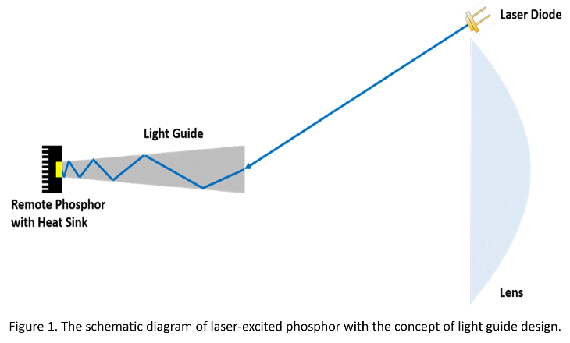
Recent Publications
- T. X. Lee, C. C. Chou (2017) Scale-Dependent Light Scattering Analysis of Textured Structures on LED Light Extraction Enhancement Using Hybrid Full-Wave Finite-Difference Time-Domain and Ray-Tracing Methods. Energies 10:424.
- T. X. Lee, T. L. Lu, B. S. Chen, (2016) Combining near-field hyperspectral imaging and far-field spectral-angular distribution to develop mid-field white LED optical models with spatial color deviation. Opt. Express 24:A1094-A1106.
- T. X. Lee, B. S. Chen (2016) High uniformity and tolerance design for direct-lit LED backlight illumination using Lagrange interpolation. J. Display Technol. 12:1403-1410.
- T. X. Lee, C. F. Chou (2016) Ideal luminous efficacy and color spatial uniformity of package-free LED based on packaging phosphor-coated geometry. Appl. Opt. 55:7688-7693.
- S. Y. Tu, H. Y. Lin, T. X. Lee (2015) Efficient speckle-suppressed white light source by micro-vibrated and color-mixing techniques for lighting applications. Opt. Express 23:26754-26768.

Biography
Tsung-Xian Lee received his Ph. D. in Optical Science from National Central University in Jan. 2008. Then he served as senior technical staff at Epistar Corporation in 2008-2011. In Aug. 2011, he joined the National Taiwan University of Science and Technology and served as assistant professor at the Graduate Institute of Color and Illumination Technology. His research interests are LED illumination optics, imaging and non-imaging design, lighting engineering, human factor in lighting and lighting testing and evaluation method.
Email: txlee@mail.ntust.edu.tw

Notes/Comments

