Mechanical vibration characteristics of hetero-core fiber optic sensor built in at both clamped ends with bending
Michiko Nishiyama, PhD, Soka university, Japan
Kazuhiro Watanabe, Prof., Dr. Eng., Soka university, Japan

Abstract (300 word limit)
Vibration monitoring for early detection of failures have been proposed in various industrial fields. Conventional vibration monitoring techniques have been widely used based on capacitive or piezoelectric accelerometers. However, the vibration sensors for the industrial applications are preferred to be unaffected from the electro-magnetic interference (EMI) noise.
On the other hands, a fiber optic sensor is superior to the conventional electric sensors for the vibration monitoring. This is because that it is not necessary to supply the power at the sensor itself, and they are resistant to corrosion and fatigue and immune to electromagnetic interference. We have been developing hetero-core fiber optic sensors, which are made of a stable single-mode (SM) fiber and can detect bending curvature changes in optical loss change. It is also insensitive to temperature changes of the sensor portion because the length of the sensing region is as long as a few millimeters so as not to be affected from the silica thermal expansion. In previous study, we presented characteristics of a newly-developed hetero-core fiber mechanical vibration sensor for simple fault diagnosis of the machine. The proposed technique with high robustness under the harsh environment has possibility in achieving a simple and real-time fault diagnosis system.
In this paper, since the hetero-core fiber optic sensor sharply induces the optical loss change to curvature change of the fiber, we arranged the construction of the hetero-core fiber to be more strongly bended fixed at the two ends by a tip arranged at the bending direction as shown in Fig. 1(a). The uniform cylindrical fiber plays a role as a beam due to its rigidity from a silica glass and acrylate coating. As shown in Fig. 1(b), vibration characteristics of the proposed configuration indicate harmonic mode of vibration for the two rigid ends and the tip as a single support. The natural frequency of the fiber is tunable with the length between two fixed ends.

Image

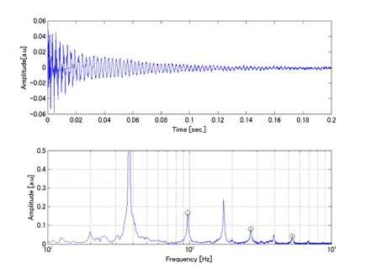
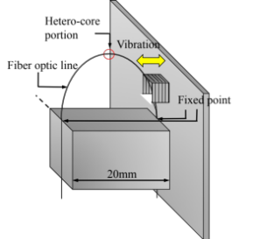
- (b)
Fig. 1 Free vibration test result of the hetero-core fiber sensor as bending settings; (a) the sensor configuration, (b) raw signal after impact and its FFT spectrum.
Recent Publications (minimum 5)
- Michiko Nishiyama and Kazuhiro Watanabe, Frequency characteristics of hetero-core fiber optics sensor for mechanical vibration, Sensors and Actuators: A Physical, vol. 209, 1 March 2014, pp.154-160.
- Michiko Nishiyama, Hirotaka Igawa, Tokio Kasai, Naoyuki Watanabe, Distributed strain measurement based on long-gauge FBG and delayed transmission/reflection ratiometric reflectometry for dynamic structural deformation monitoring, Applied Optics, Vol. 54 Issue 5, pp.1191-1197 Feb. 2015.
- Michiko Nishiyama, Masako Sonobe, and Kazuhiro Watanabe, "Unconstrained pulse pressure monitoring for health management using hetero-core fiber optic sensor," Biomed. Opt. Express 7, 3675-3685 (2016).
- Hiroshi Yamazaki, Michiko Nishiyama, Kazuhiro Watanabe, and Mikhail Sokolov, “Tactile sensing for object identification based on hetero-core fiber optics”, Sensors and Actuators A, Vol.247, pp.98-104, Aug. 2016.
5. Yuya KOYAMA, Michiko NISHIYAMA, and Kazuhiro WATANABE, “Behavior monitoring based on intensity matrix distribution in output plane of single-mode ﬁber bundle,” IEEE Transactions on Instrumentation and Measurement (accepted).

Biography (150 word limit)
Michiko Nishiyama received B.S. degree from Ochanomizu University, Tokyo, Japan, in physics in 2000. She worked in Nikon as designing an optical lens system from 2000 to 2003. She received M.E. and Ph.D degrees from Soka University in information systems science in 2005 and 2008. She worked on development of optical fiber sensors, as an assistant professor of Soka University from 2008 to 2011. She was a research associate at JAXA from 2011 to 2014 and currently a lecturer at Soka University since she re-joined in April 2014.
Email: mnishiya@soka.ac.jp

Notes/Comments:

