High-throughput screening of Euglena gracilis with optofluidic time-stretch quantitative phase microscopy
Baoshan Guo, PhD, Beijing Institute of Technology, China
Cheng Lei, PhD, University of Tokyo, Japan
Lan Jiang, Prof., Beijing Institute of Technology, China

Abstract (300 word limit)
The development of reliable, sustainable, and economical sources of alternative fuels is an important, but challenging goal for the world. As an alternative to liquid fossil fuels, algal biofuel is expected to play a key role in alleviating global warming since algae absorb atmospheric CO₂ via photosynthesis. Among various algae for fuel production, Euglena gracilis is an attractive microalgal species as it is known to produce wax esters (good for biodiesel and aviation fuel) within lipid droplets. To date, while there exist many techniques for inducing microalgal cells to produce and accumulate lipid with high efficiency, few analytical methods are available for characterizing a population of such lipid-accumulated microalgae including E. gracilis with high throughout, high accuracy, and single-cell resolution simultaneously. Here we demonstrate high-throughput, label-free, single-cell screening of E. gracilis with optofluidic time-stretch quantitative phase microscopy that can simultaneously provide both amplitude and phase images of E. gracilis cells at a high throughput of 10,000 cells/s. The phase information of E. gracilis is useful for identifying intracellular compounds such as lipids based on their refractive index contrast. Specifically, based on the amplitude and phase map of each cell, we classify nitrogen-sufficient (ordinary) and nitrogen-deficient (lipid-accumulated) E. gracilis cells in a non-invasive manner. This method holds promise for evaluating cultivation techniques and selective breeding for microalgae-based biofuel production. The microscope is also potentially applicable for identifying other cell types such as blood cells and cancer cells.

Image
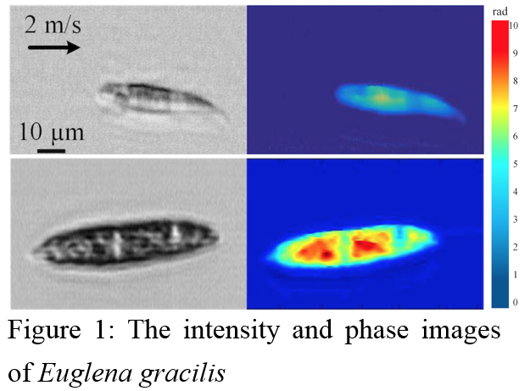
Recent Publications (minimum 5)
- Baoshan Guo, Cheng Lei, et al (2017) Optofluidic time-stretch quantitative phase microscopy. Methods 1007402.
- Baoshan Guo, Cheng Lei, et al (2017) High-throughput, label-free, single-cell, microalgal lipid screening by machine-learning-equipped optofluidic time-stretch quantitative phase microscopy. Cytometry Part A 91(5): 494-502.
- Baoshan Guo, Cheng Lei, et al (2016) High-throughput Accurate Single-cell Screening of Euglena gracilis with Fluorescence-assisted Optofluidic Time-stretch Microscopy. Plos One 11(11): e0166216.
- Cheng Lei, Baoshan Guo, et al (2016) Optical time-stretch imaging: Principles and applications. Applied Physics Reviews 3: 011102 (2016).
- Ming Li, Hector Muñoz, Alexander Schmidt, Baoshan Guo, et al (2016) Inertial focusing of ellipsoid Euglena gracilis cells in a stepped microchannel. Lab On a Chip 16: 4458.

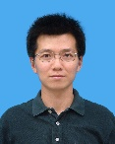Biography (150 word limit)
Baoshan Guo received a bachelor's degree at the Fudan University and received a PhD in the Institute of Semiconductors from the Chinese Academy of Sciences, specializing in optoelectronics. He did postdoctoral research at University of Toronto, University of Hong Kong and University of Tokyo. He is now an associate professor at the Beijing Institute of Technology and is mainly engaged in the research of plasmonics, ultrafast laser processing and ultrafast imaging.
Email: gbs_semi@hotmail.com

Notes/Comments:

