Surface Micro-Patterning of Oriented Polyethylene Films using Interference Holography
Sarah S. D. Lafleur, Lihua Shen, PhD, University of Eindhoven, The Netherlands
Cees W. M. Bastiaansen, Associate professor, University of Eindhoven, The Netherlands
John R. Severn, Industrial fellow, DSM , The Netherlands

Abstract

The ability to micro-pattern polymeric materials with pre-designed surface structures is of great significance in a wide range of applications including sensors, tissue engineering and biofouling. A new procedure is presented for generation of relief gratings on oriented and chain-extended polyethylene (PE) films using interference holography with a nanosecond pulsed laser. An ultraviolet absorber, 2-(2H-benzotriazol-2-yl)-4,6-ditertpentylphenol (BZT) is incorporated into PE prior to drawing to generate absorption at the wavelength of the laser. Illumination with an interference pattern in the absorption band of BZT leads to an obvious height change in the exposed regions and consequently relief gratings are generated (Fig.1 ).

The height change in the exposed regions is dependent on the energy dose of the laser but also on the angle between the grating direction and the film orientation direction. The latest observation is attributed to a competition between thermal contraction and local melting/recrystallization of the chain-extended polyethylene, and thermal evaporation of BZT. The formation of surface relief gratings on high performance oriented PE is of high interest to obtain a strain sensor that can detect optically small deformations during tensile deformations.

Finally, the gratings patterned on the PE films can be used as strain sensors in tensile deformation. A red laser beam (633nm) is diffracted by the grating and produces a diffraction pattern. The distance between the diffracted orders (m0-m1) enables us to know the grating period on the material, thus to determine accurately the strain applied on the film.

Image
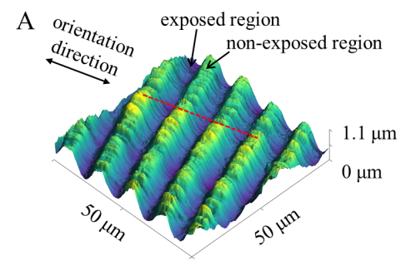
Figure 1. AFM picture of a relief grating on oriented PE obtained by interference holography
Recent Publications

1. Tan, J. L.; Tien, J.; (2003) Cells Lying on a Bed of Microneedles: An Approach to Isolate Mechanical Force. Proc. Natl. Acad. Sci. U. S. A, 100, 1484−1489.
2. Kuwabara, K.; Ogino, M.; (2004) Fluorescence Measurements of Nanopillars Fabricated by High- Aspect-Ratio Nanoprint Technology. Microelectron. Eng. , 73− 74, 752−7563.
3. Prenen, A. M.; van der Werf, J. C. A.; Bastiaansen, C. W. M.; Broer, D. J. (2009) Monodisperse, Polymeric Nano- and Microsieves Produced with Interference Holography. Adv. Mater. , 21, 1751−1755.
4. Xia, D.; Ku, Z.; (2011). Nanostructures and Functional Materials fabricated by Interferometric Lithography. Adv. Mater., 23, 147−179.
5. Niggemann, M.;Blaesi, B.; (2001). Periodic Microstructures for Large Area Applications Generated by Holography. Proc. SPIE, 4438, 108−115


Biography

In 2014, Sarah obtained a master in Formulation of colloidal systems and polymers. Between 2010 and 2014, Sarah has worked on various projects in companies and universities. In 2012 Sarah did a one year internship at SABIC-Innovative plastics in Bergen op Zoom, The Netherlands where she worked on the development of new polycarbonate materials for UK/India and European rail, airplane and hospital claddings applications, improving the flammability and the anti-graffiti properties. Finally, her graduation project was at AGFA Gevaert in Mortsel, Belgium where she worked on the formulation of a primer to improve the adhesion of UV-curable inks on glass and on the formulation of spot colors to increase the color gamut of an existing set of inks.
In October 2014, Sarah joined the Functional Organic Materials and Devices group for a Ph.D. in collaboration with DSM, under the supervision of C. Bastiaansen and J. Severn. She is currently working on functional devices based on chain-extended polyethylenes.
Email: s.lafleur@tue.nl

