Biocide films elaborated by plasma enhanced chemical vapor deposition from ZnO nanoparticles and HMDSO

F. E Teniou¹, M. Kihel¹, Sahli¹
¹Université Frères Mentouri Constantine 1, Laboratoire de Microsystèmes et Instrumentation (LMI), Algérie

Keywords: Biocide films, plasma deposition, ZnO nanoparticles,

- Abstract Body
For long time, organosilicon thin films has a great interest in many applications that are based on the surface modification. Recently more attention has been focused to the use of organosilicon thin films with embedded metallic nano-sized particles as biocide films [1]. In this study, ZnO Nanoparticles have been deposited with organic films by plasma discharge in order to elaborate biocide thin films. Tow deposited methods have been combined in order to elaborate biocide films. Dielectric barrier discharge (DBD) and plasma enhanced chemical vapor deposition (PECVD). The plasma discharge used is generated by a AC power source with frequency of about 19 kHz using HMDSO as plasma gas and ZnO powder. Bacillus bacteria in Muller Hinton environment has been used in order to exhibit the biocide properties of deposited films. It has been observed that almost all species are eliminated.

- Image:

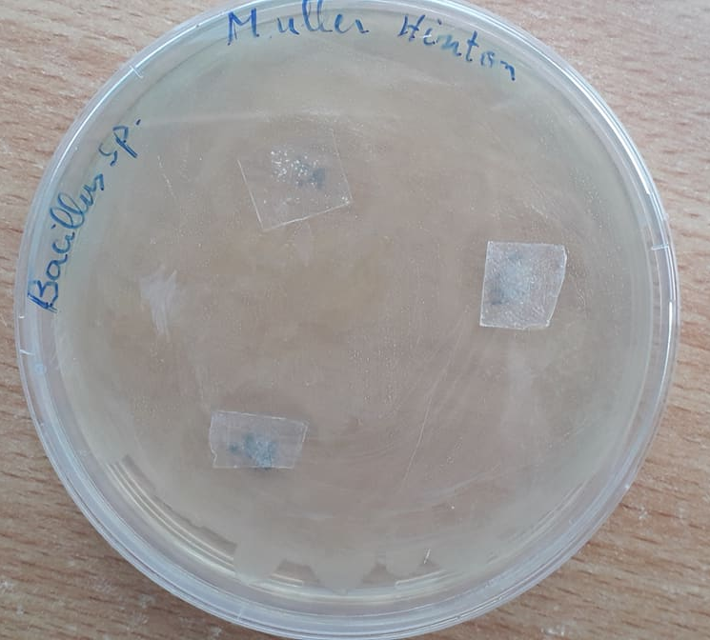

- Reference:
- S. Zanna, C. Saulou, M. Mercier-Bonin, B. Despaxe, P. Raynaude, A. Seyeux, P. Marcus2010. Ageing of plasma-mediated coatings with embedded silver nanoparticles on stainless steel: An XPS and ToF-SIMS investigation. Applied Surface Science 256 () 6499–6505.
- Biography:
Fella Esma Teniou received his MS in Microelectronic from Electronics Department, Constantine 1 University, Constantine, Algeria, in 2016. Currently, he is a PhD student working on polymer biocide thin films deposition by cold plasma.

Mouloud Kihel received his PhD in Microelectronic Systems and Materials from Constantine 1 University (Algeria) in 2010. His current research interests include nanopowder, plasma and electrical properties of hydrocarbons thin films.

Salah Sahli received his BS in Engineering Physics from the University of Constantine (Algeria) in 1982. He received his PhD in Microelectronic from Paul Sabatier University, Toulouse (France), in 1986. From 1987 to 1998, he worked as an Assistant Professor with the Electronic Institute of Constantine University. Currently and since 1999, he is a Professor at the Faculty of Technology Sciences of Constantine 1 University (called before ‘Mentouri University’). His research interests are focused on the applications of cold plasmas for thin films deposition and polymer surface treatment and for life sciences and biomedical applications.

- Presenting author details

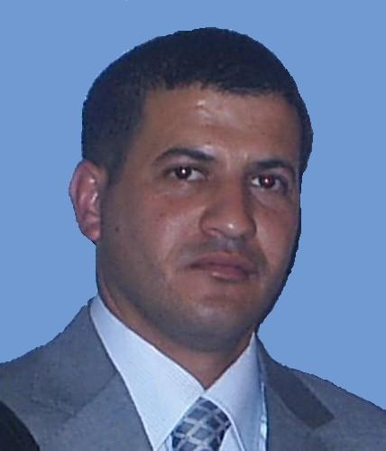
Full Name: Kihel Mouloud
Contact number:00213555545191
Twitter account:
Linked In account:
Session name/ number:
Category: Poster presentation
Passport Number: 169760104

