3D motion of photon and its new energy equation
Gh. Saleh, Prof., Saleh research centre, Shiraz, Fars, Iran
M. Parsi, Dr., Saleh research centre, Shiraz, Fars, Iran
M. Akafzadeh Sarvari, Dr., Saleh research centre, Shiraz, Fars, Iran

Abstract (300 word limit)
Light and its nature have caused a lot of ink to flow during these last decades. Its dual behavior is partly explained by Double-slit experiment of Thomas Young - who represents the photon’s motion as a wave - and also by the Photoelectric effect in which the photon is considered as a particle. However, Einstein himself writes: "It seems as though we must use sometimes the one theory and sometimes the other, while at times we may use either. We are faced with a new kind of difficulty." SALEH THEORY solves this ambiguity and this difficulty presenting a three-dimensional trajectory for the photon's motion and a new formula to calculate its energy.
The emission of the photon, following the change in energy level of electron, causes a motion, which rotates along and around a straight axis at light speed (c): a three-dimensional trajectory combining the both of rectilinear and orbital trajectories. However, the side view of the movement shows still a sine wave. One turn of photon's rotation around the assumed axis is equal to the wavelength of a sinusoidal wave. Thus, the number of turns of the photon in a second has to be considering the Frequency similar to the Planck Formula ().
In fact, the emitted photon has an initial energy from which must be subtracted the Rotational kinetic energy to have the sum of the Translational kinetic energy:
Initial energy - Rotational kinetic energy = Translational kinetic energy
Saleh Theory knows the Translational kinetic energy as the same energy that Thomas Planck had presented with his famous formula: E=hϑ measured empirically in the laboratory.
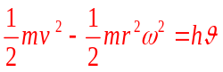
Where, m is the photon mass, v its straight velocity, r its gyroradius, h Planck constant, ϑ its frequency and ω its angular velocity.

Image
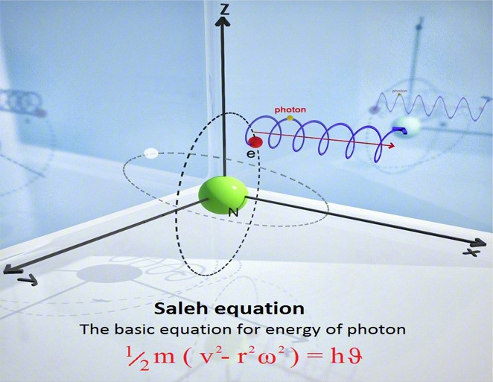
Recent Publications
- Gh. Saleh, M. J. Faraji, R. Alizadeh, A. Dalili (2018) THE SUPERSTRING THEORY AND THE SHAPE OF PROTONS AND ELECTRONS. MATTER: International Journal of Science and Technology, Vol 4, No 2 .
- Gh. Saleh, M. J. Faraji, R. Alizadeh, A. Dalili (2018) A New Explanation for the Color Variety of Photons. MATEC Web of Conferences 186, 01003
- Gh. Saleh, M. J. Faraji, R. Alizadeh, A. Dalili (2018) The discovery of the nature of superstring theory. J Phys Chem Biophys 2018, Volume 8.
- Gh. Saleh, M. J. Faraji, R. Alizadeh, A. Dalili (2018 Structure of Electron, Proton and Neutron. J Laser Opt Photonics 2018, Volume:5
- Gh. Saleh, M. J. Faraji, R. Alizadeh, A. Dalili (2018) Ultimate structure of the proton J Astrophys Aerospace Technol 2018, Volume 6.

Biography
Dr. M. Akafzadeh Sarvari is a researcher, translator and presenter in Saleh Research centre.
Email: assis.j.faraji@saleh-theory.com

