The effectiveness of surgical treatment of Terson syndrome.
Rusanovskaya A.V., Klimova A.N.
City budget health care institution
City Clinical Hospital No. 52 of the Moscow City Health Department, Moscow, Russia.
Terson syndrome (hemorrhagic oculocerebral syndrome) - vitreal, preretinal, subhialoid or subretinal hemorrhage associated with acute subarachnoid, intracerebral hemorrhage or traumatic brain damage. For the first time Terson's syndrome is described in 1881 by the German ophthalmologist Moritz Litten. However, the syndrome was named after the French ophthalmologist Albert Therson, who re-described this symptom complex in 1900. According to statistics, Terson syndrome occurs in 8-19.3% of subarachnoid hemorrhages, 9.1% of intracerebral hemorrhages and 3.1% of traumatic brain damage [1]. Subarachnoid hemorrhage, which is associated with Terson syndrome, has a higher Hunt-Hess score, which indicates a severe course and a high risk of death [2].
There are several probable mechanisms of intraocular hemorrhage in Terson syndrome. According to one of the hypotheses, intraocular hemorrhage is associated with a sharp increase in pressure in the veins of the retina, due to an increase in pressure in the cavernous sinus, and the subsequent rupture of the retinal vessels. In addition, there is an opinion about the penetration of blood from the cranial cavity into the vitreous cavity along the intershell neuropathy [2]. A sharp mono or bilateral loss of vision on the background of intracranial hemorrhage is characteristic of the clinical picture. The main method of treatment is timely vitrectomy [2]. According to the literature, this type of surgical treatment is effective in 81% of cases [3].
Case reporte. Patient S. .. born in 1974, in April 2016, she entered the neuro-resuscitation department in a coma. The diagnosis was established: subarachnoid hemorrhage, rupture of the giant aneurysm of the right carotid artery (Fig. 1).
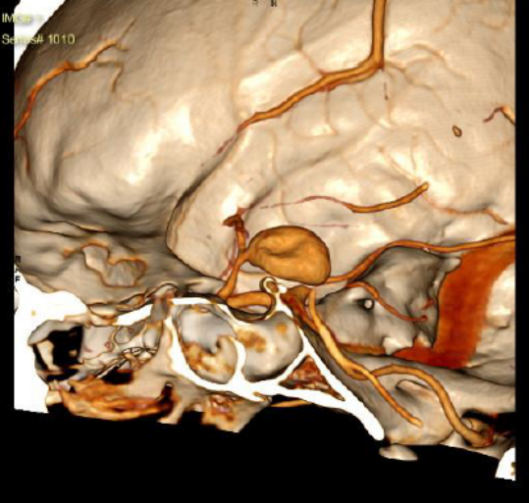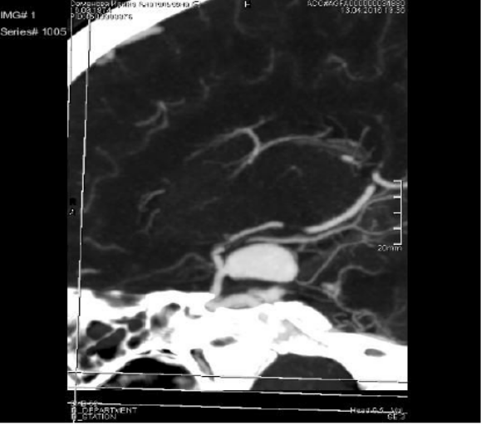
Fig.1. Multispiral computed tomography of the brain: saccular aneurysm of the right carotid artery with signs of damage to the medial wall.
Surgical treatment was performed: osteoplastic craniotomy in the right fronto-temporal-parietal region, clipping of the aneurysm of the right carotid artery. On return of consciousness, the patient was diagnosed with a lack of objective vision in both eyes, and Terson's bilateral syndrome. On echobiometry of the eyeballs: pronounced mobile hyperechoic inclusions in the vitreal cavity (Fig. 2).
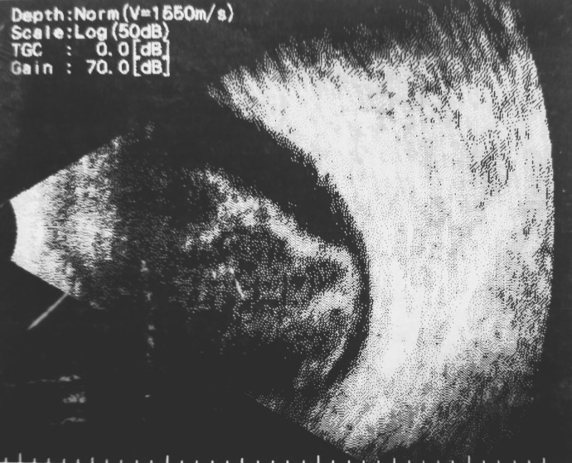
Fig.2. Ultrasound of the eyeball: hyperechoic inclusions in the vitreal cavity.
After stabilization of the physical condition, 25G microinvasive vitrectomy was performed on both eyes. During vitrectomy, a dense adhesion of the posterior hyaloid membrane to the retina, vitreal and subhaloid hemorrhage (at the stage of fibrosis) were detected (Fig. 3).
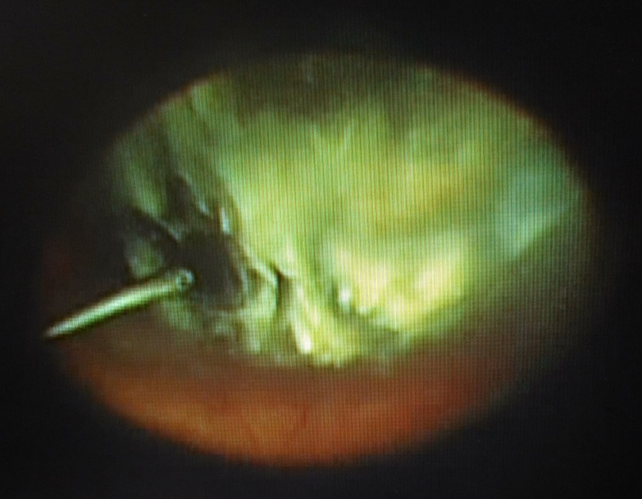

Fig.3. Vitreous hemorrhage in the stage of fibrosis.
Visual acuity on the first day after surgery 0.7. 1 year after surgical treatment, the visual acuity in both eyes is 1.0. Fields of vision in the normal range. OCT of the macular region and optic nerves within normal limits. There are no signs of optic atrophy (Fig.4).
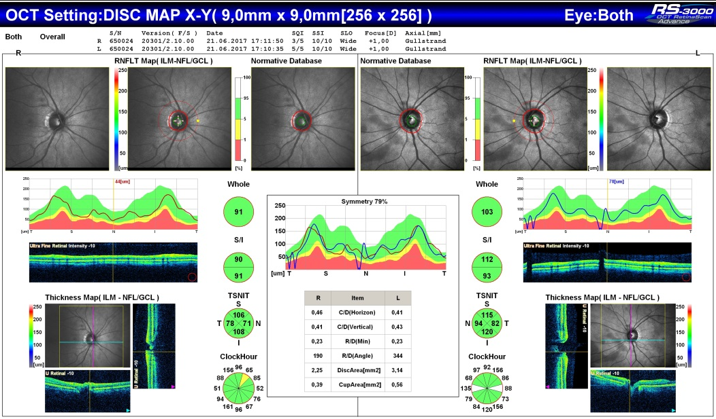
Fig.4. OCT optic nerves
Conclusion: Terson syndrome is a serious complication of intracranial hemorrhage, leading to a significant reduction in vision and disability of patients. However, with timely and reasonable surgical treatment, a complete restoration of visual functions is possible, because Terson's syndrome is rarely accompanied by ischemic angioretinopathy.
List of references.
- Czorlich P, Skevas C, Knospe V, et al. Terson syndrome in subarachnoid hemorrhage, intracerebral hemorrhage, and traumatic brain injury (2014). Neurosurg Rev. Epub.
- McCarron MO, Alberts MJ, McCarron P (2004). A systematic review of Terson's syndrome: frequency and prognosis after subarachnoid haemorrhage. J. Neurol. Neurosurg. Psychiatr. 75 (3): 491–3.
- Kuhn F¹, Morris R, Witherspoon CD, Mester V (1998) Terson syndrome. Results of vitrectomy and the significance of vitreous hemorrhage in patients with subarachnoid hemorrhage. Ophthalmology. Mar;105(3):472-7.
Abstract. Terson's syndrome (hemorrhagic oculocerebral syndrome) is a vitreal, preretinal, subgialoid or subretinal hemorrhage associated with acute subarachnoid, intracerebral hemorrhage, or traumatic brain injury. The clinical picture is characterized by a sharp mono or bilateral loss of vision in the background of intracranial hemorrhage. The main method of treatment is timely vitrectomy. With timely and justified surgical treatment, complete restoration of visual functions is possible, as Turson's syndrome is rarely accompanied by ischemic angioretinopathy.

