Title:
A pilot phase I trial of IL-21 expanded ideal-donor natural killer (NK) cells in combination with mogamulizumab in patients with Cutaneous T-cell Lymphomas (CTCL) or Adult T-cell Leukemia/Lymphomas (ATLL)

Authors:
Basem M. William¹, John Reneau², Amanda R. Campbell³, Anna Vilgelm², Michelle Watts³, Lynn O'Donnell², Ying Huang², Catherine Chung², Marcos deLima², Steven Devine⁴, Sumithira Vasu², Dean A. Lee³

¹OhioHealth Blood and Marrow Transplant Program, Columbus, OH, USA
²Nationwide Children’s Hospital, Columbus, OH, USA
³Ohio State University, Columbus, OH, USA
⁴NMDP/Be The Match, Minneapolis, MN, USA

Background:
IL-21 expanded NK cells have high expression of CD16 and have demonstrated antibody-dependent cell-mediated cytotoxicity (ADCC) activity in combination with monoclonal antitumor antibodies (mAb). Mogamulizumab (moga) is a mAb targeting CCR4 that is defucosylated to enhance its binding to CD16, thereby enhancing ADCC of NK cells against targets expressing CCR4. We designed a pilot phase I clinical trial studying this combination in patients with relapsed/refractory (r/r) CTCL and ATLL. The study is soon opening to accrual at the OSU James Cancer Center (NCT04848064). Study is conduced under IND 26888.

Preclinical data:
Allogeneic NK cells obtained from buffy coat (Red Cross Blood Bank), were expanded for 14 days on CSTX002 feeder cells, cryopreserved, and then thawed and recovered for 48 hours prior to testing. Malignant T-cells were incubated with moga (at 10ng/µl) for 30 minutes prior to co-culture with NK cells and cytotoxicity was determined by the calcein release assay (Somanchi et al, J Vis Exp 2011). Malignant T-cells were obtained from peripheral blood from 3 patients with multiply relapsed CTCL and all have circulating Sezary cells and from CCRF-CEM cell line (T-ALL cell line that expresses CCR4). No significant cytotoxicity was observed with moga alone and significant synergy in cytotoxicity was observed between and moga and NK cells in all 3 patient samples and also CCRF-CEM cell line (figure 1: A and B). Two-fold increase in ADCC was observed with addition of moga to NK cells (p=0.0272; figure 1C)

Design:
Patients will receive lymphodepleting chemotherapy (Fludarabine/Cyclophosphamide) on days -5 to -3 prior to cell infusion, moga weekly for 4 doses starting on day -7 (prior to the first NK cell infusion) and then every 2 weeks until toxicity or progression. Patients will receive third-party ideal-donor mbIL-21 expanded NK cells once every 2 weeks for 6 total doses (Figure 1D). Donors meeting ideal-donor characteristics from National Marrow Donor Program were identified in collaboration with Be The Match Biotherapies. PBMNC were collected by apheresis, CD3-depleted, expanded for 14 days as previously described, and cryopreserved in ready-to-infuse aliquots. NK cells will be thawed and infused in 2 dosing cohorts; 3x10⁷ and 1x10⁸ cells/kg in a standard dose-escalation design. Primary endpoint is the maximum tolerated dose of NK cells given in combination with standard-dose moga. Dose-limiting toxicity (DLT) is defined as any steroid refractory graft vs host disease (GVHD), severe NK cell-related toxicities, or other unusual events occurring from D-7 until D+84 post last dose of NK cells. Dose-escalation will proceed in the standard 3+3 fashion. Secondary endpoints include overall response rate (ORR) per ISCL/USCLC/EORTC consensus panel, for CTCL, and international consensus panel, for ATLL and progression-free and overall survival. Correlative endpoints include quality of life impact as captured by Skindex-16 score, serum cytokine levels in blood, persistence of NK cells by chimerism studies, correlation between CCR4 staining of tumor cells in skin and trafficking of NK cells to skin by immunohistochemistry or immunofluorescence in serial skin biopsies and ORR (Figure 1D).

Abbreviated eligibility:
Eligible patients will be 18 years, or older, with biopsy-proven, measurable, stage IB-IVB relapsed or refractory CTCL or ATLL, progressing on at least one standard chemotherapy. Other eligibility criteria include: ECOG performance status of ≤ 1, no systemic anti-neoplastic therapy within a week or 3 half-lives, adequate laboratory parameters including: absolute neutrophil count ≥1000/mm³, platelet count ≥50,000/mm³, total bilirubin ≤ 2 x upper limit of normal (ULN), AST/ALT ≤ 3 x ULN or ≤ 5 x ULN in patients with documented hepatic involvement by lymphoma, and calculated creatinine clearance ≥ 50 ml/min., disease free of prior malignancies for ≥ 2 years with exception of treated basal cell, squamous cell carcinoma of the skin, or carcinoma in situ of the cervix or breast and life expectancy ≥ 90 days. Patients who were pre-treated with moga, pregnant, HIV positive, with active hepatitis B and C, active CNS involvement, active grade II-IV acute or extensive chronic GVHD or other serious medical comorbid conditions are excluded.

A

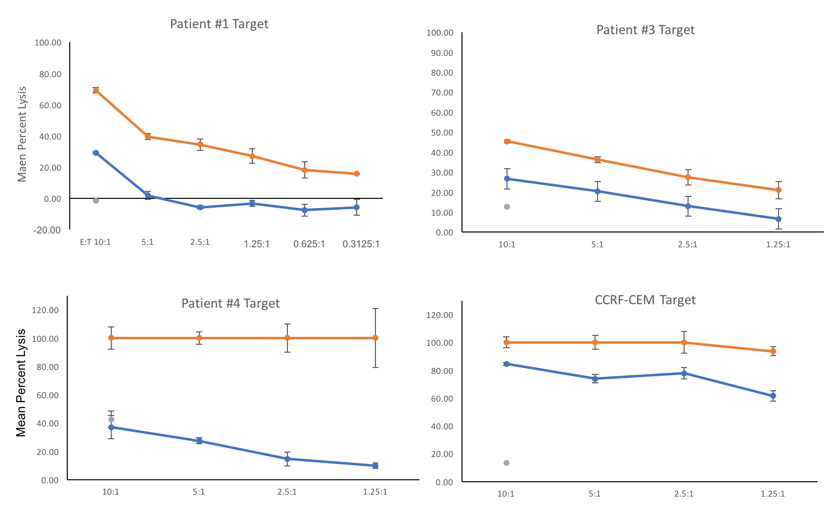
B
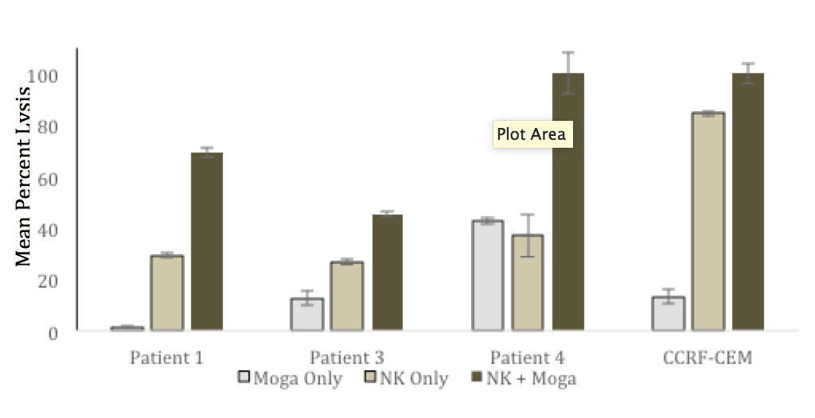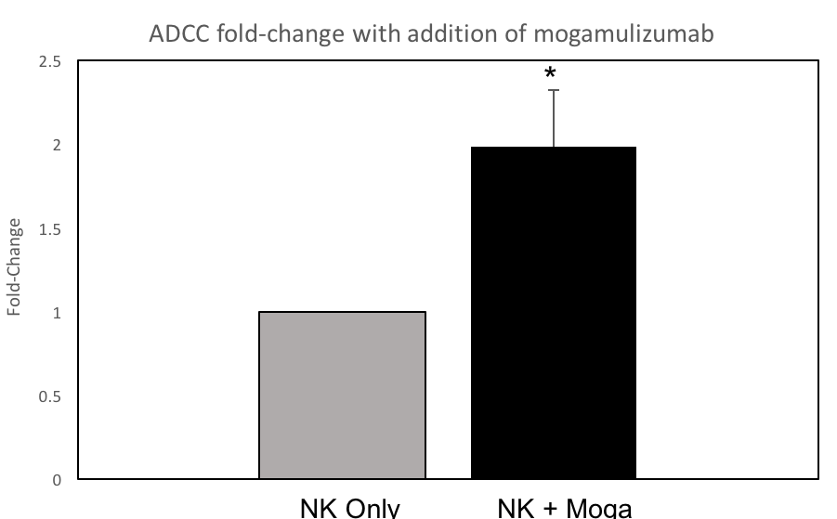
C
E
D
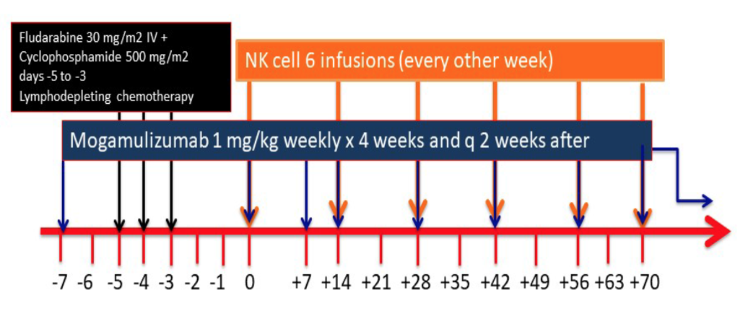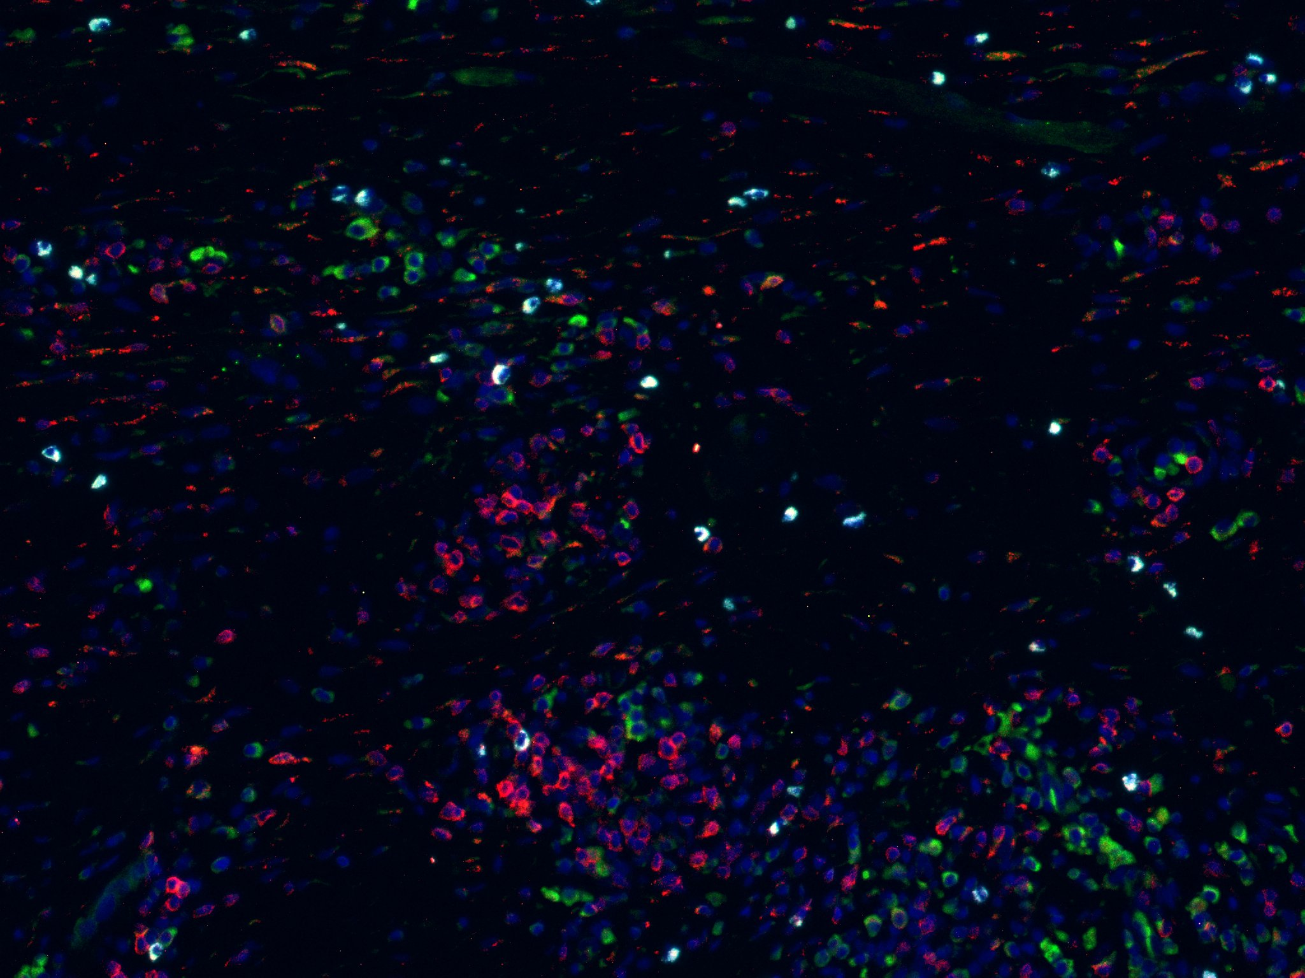

Figure-1
- Cytotoxicity curves across all E:T ratios for each target cell. Orange = NK cells plus mogamulizumab-coated target cells; Blue line = NK cells plus tumor targets alone (without antibody); Gray = mogamulizumab-coated tumor cells alone.
- Summary data for all 4 cell lines at the 10:1 E:T ratio.
- Fold-change in ADCC, comparing NK cells plus tumor cells (control, normalized to 1) and NK cells plus antibody-coated tumor cells across 3 patient samples and 1 cell line. P=0.0272.
- Treatment scheme; day 0 refers to the first day of NK cell infusion
- Immunofluorescence assay for anti-CCR4, Anti-CD3, Ani-NKp46 (NK cell marker)

Basem M. William, MD, MRCP(UK), FACP
Lymphoma Program Leader
Clinical Director, Blood and Marrow Transplant and Cell Therapy Program
Medical Director, Cell Therapy Laboratory
Institutional Principal Investigator, Alliance of Clinical Trials in Oncology
OhioHealth Riverside Methodist Hospital
Columbus, Ohio, USA

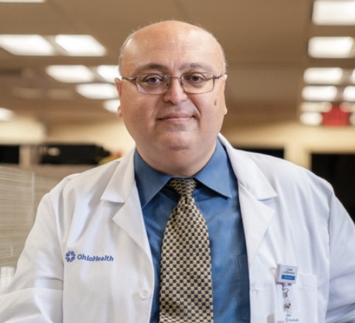

Brief Biography
Dr Basem William is a hematologist with an internationally-recognized expertise in hematological malignancies, lymphoma, T-cell lymphomas (cutaneous and systemic), drug development, hematopoietic stem cell transplantation and cellular therapy. He has been a PI/co-investigator/site PI on over 100 clinical trials in hematological malignancies and cell therapy. He published over 75 peer reviewed articles, over 120 peer-reviewed abstracts, and 4 books chapters and has previously served on the NCCN Guidelines expert panel in T-cell Lymphomas. He is certified by the American Board of Internal Medicine in Hematology, Oncology, Internal Medicine, and Hospice/Palliative Medicine and is a member of the Royal Colleges of Physicians of the United Kingdom. After leading the T-cell lymphoma program at the Ohio State University Comprehensive Cancer Center, where he was an Associate Professor of Internal Medicine, for 4 years, he recently joined OhioHealth Health system to help build a new comprehensive hematological malignancies, transplant, and cell therapy program.

