Influence of measured thermophysical parameters of drilling fluids on downhole temperature models
Muhammad Suleman, Masters Petroleum Engineering, University of Stavanger , Norway

Abstract (300 word limit)
Predicting downhole circulating temperature is essential for successful drilling operations as bottom hole temperature variations are a major cause of changing effective mud density. So, the effort is needed for the development of dynamic modeling capability to simulate the complex downhole temperature environment. Thermal conductivity and specific heat capacity of drilling fluid are an important component in temperature modeling and change with temperature along the wellbore. Despite their importance, very limited data in the literature is available on these parameters and mostly values of thermal conductivity and specific heat are estimated using generic models and only at room temperature.
An experimental study is performed to measure the thermal conductivity and specific heat capacity of the samples of oil-based mud and water-based mud in the laboratory using the C-Therm TCi thermal conductivity analyzer over a temperature range of 20 °C to 60 °C. Based on the measured values models are generated for thermal conductivity and specific heat capacity of OBM and WBM which are then implemented in a simulator on two different wells.
The results from these models show the difference of 2.5°C to 5°C to in the bottom hole temperature during circulation and drilling from the generic model for shallow horizontal well and vertical well respectively. The difference in temperature depends upon the wellbore profile, the total vertical depth of the well and the duration of circulation or drilling process.
Previously thermal conductivity and specific heat capacity of drilling fluid is estimated through generic models and are used in the heat transfer calculation only at room temperature. In this paper, models are presented based on measured values of thermal conductivity and specific heat capacity over a temperature range of 20 °C to 60 °C to have a more precise bottom hole temperature which will ensure safe and efficient drilling operation.

Image
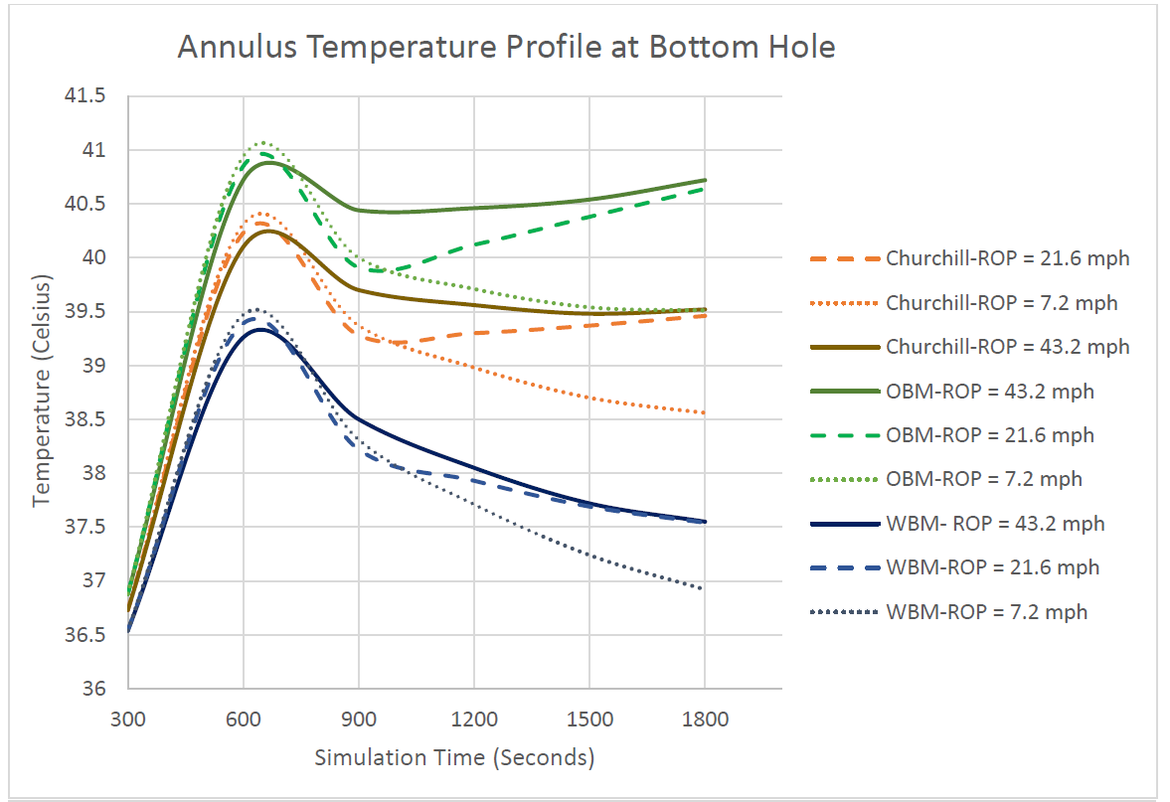
Recent Publications (minimum 5)
- Holmes C.S , Swift S.C “Calculation of Circulationg Mud Temperatures, JPT, Vol 22, No. 6,670-674, 1970.
- Raymond L.R , Swift S.C “Temperature Distribution in a Circulationg Drilling Fluid, JPT, Vol 21. No 3,333-341, 1969.
- Marshall D.W , Bentsen R.G “A Computer Model to Determine the Temperature Distribution in a Wellbore”.
- Naziev Ya.M , Gasanov V.G “Determination of Effect of Variability of Thermal Properties of Materials when Measuring Thermal Conductivity Using Steady-State Thermal Methods”.
5. Naziev Ya.M , Gasanov V.G “A Review of Models for Effective Thermal Conductivity of Composite Materials”.

 Biography (150 word limit)
Muhammad Suleman is currently in the final semester of Master’s in Drilling Engineering at University of Stavanger, Norway where he is working on the measurement of thermophysical properties of drilling mud and their influence on the downhole temperature profile. He also has an exchange semester at University of Houston, USA. He is proficient in drilling operations and modelling part also in programming with python and data analysis with R..
Email: m.suleman.fazal@gmail.com

