Opportunities and challenges for biofuel production from vegetable oils using novel composites based on Egyptian raw materials
Eslam A. Mohammed, Abdelrahman M. Rabie, Nabel A. Negm

Egyptian Petroleum Research Institute, 1-Ahmed El Zommer Street, Nasr city, Cairo, Egypt
1-Abstract
Currently, the most commonly used fossil fuels account for more than 95% of the world’s major energy consumption. However, because of their increasing price all over the world which decreased the progress of development in the developing countries. As a result, the researches were directed to decrease the dependence on the fossil fuel by available, cheap and economic alternative energy sources. In addition, the global warming and the increase of the earth temperature is considered a worldwide problem. That is due to the increase of carbon dioxide, carbon monoxide, and corrosive gases emission from industrial activities and vehicle engines. The two objectives of the present study are replacement of petroleum fuel as a source of energy with alternative environmentally friendly, renewable and low price energy sources for industrial activities and vehicle engines.The targeted liquid fuels are biodiesel, bio-gasoline and biojet using economic, conventional and simple methods. Two main conventional methods will be established which are transesterification and catalytic cracking processes using novel and efficient heterogeneous catalysts. The catalysts are basic and acidic heterogeneous in nature. The targeted heterogeneous catalysts in the study are modified activated carbon, layered double hydroxide (LDH), modified diatomite and acidified mica clays. The synthetic role of the catalysts depend on the economically and low-cost raw materials from the Egyptian resources. In addition, the different types of the produced biofuels will be characterized, analyzed and evaluated for their fuel properties in engines and their economic blends by the petroleum fuel.The expected outcomes of the study are the following: firstly, producing different biofuel grades for different types of engines and power stations; secondly, replacement the petroleum fuel by 25% of the biofuel to decrease the cost and GHG to about 50%.
Keywords: Renewable energy sources; biofuel; Egyptian raw materials; vegetable oils; heterogeneous catalysts.

2-Image
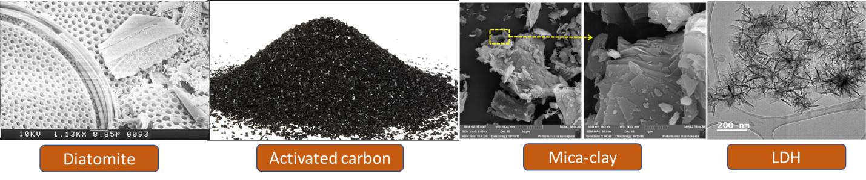

3-References
[1] Amigun B, Sigamney R, Blotnitz HV, 2008. Renew. Sustain. Energy Rev. 12, 690-711.
[2] Freedman B, Pryde EH, 1984. J. Am. Oil Chem. Soc. 61, 1638–1643.
[3] Meher LC, Sagar DV, Naik SN, 2006. Renew. Sustain. Energy Rev. 10, 248–268.
[4] Zhang Y, Dube MA, McLean DD, Kates M, 2003. Bioresour. Technol. 89, 1–16.
[5] Negm NA, Sayed GH, Yehia FZ, Mohamed EA, 2017, J. Mol. Liquids 234, 157–163
[6] Negm NA, Sayed GH, Yehia FZ, Mohamed EA, 2017, J. Mol. Liquids 237, 38–45
[7] Kouzu M, Kasuno T, Tajik M, Sugimoto Y, Hidaka J, 2008. Fuel 87, 2798–06.
[8] Demirbas A, 2007. Energy Convers. Manage 48, 937–941.
[9] Liu R, Wang X, Zhao X, Feng P, 2008. Carbon 46, 1664–1669.
[10] Karagoz S, Bhaskar T, Muto A, Oshiki T, Kishimoto T, 2005. Chem Eng J 108, 127-37.
4-Biography:
Eslam azmy has completed his PhD at the age of 31 years from Ain Shams University and nom in Postdoctoral Studies stage in Egyptian petroleum research institute.

