In-silico analysis of FIGLA transcription factor in the germline
Shouhartha Choudhury¹ and, Supriyo Chakraborty^{2*}

¹Department of Biotechnology, Assam University, Silchar-788011
²School of Life Sciences, Assam University, Silchar-788011

Keywords: FIGLA, bHLH transcription factor, Gene expression; Spermatogenesis; and Oogenesis

Abstract:
The present study investigated FIGLA (factor in the germline alpha) important for ovary formation, folliculogenesis, oocyte development, and somatic cell function. FIGLA encodes a germ cell-specific transcription factor identified as an activator of oocyte gene. The oocyte-specific transcription factors are essential for oogenesis, pluripotency and, embryonic development. FIGLA mutation preferentially expresses in oocytes and plays a role in germ cell development found in chromosome 2. FIGLA gene regulates reproductive life span and represents a candidate for reproductive disorders, such as hypergonadotropic ovarian failure and infertility. The premature ovarian failure of humans causes FIGLA haploinsufficiency, which disrupts the formation of primordial follicles. Those oocyte-specific transcription factors regulate attractive targets of human fertility. In this study, we curated literature-derived information of FIGLA transcription factor in genomic data. We accumulate mammalian organism genome i.e. Homo sapiens, Bos tarsus, Sus scrofa, Pan troglodytes and Mus musculus for comparative and functional analysis. The complete bHLH transcription factor data analysis suggested FIGLA mutation and their bHLH domain, motifs, phylogeny, chromosome location, and gene expression. Therefore, we identified cell-specific transcription factors using in-silico subtraction. These genes discovered for spermatogenesis and oogenesis specific transcription factor expressed in germ cells.

Image:

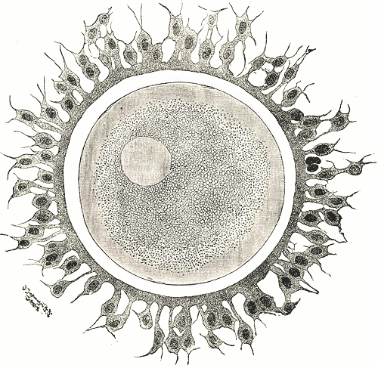
Reference:
- Pangas, Stephanie A., and Aleksandar Rajkovic. "Transcriptional regulation of early oogenesis: in search of masters." Human Reproduction Update 12.1 (2005): 65-76.
- Zhao, Han, et al. "Transcription factor FIGLA is mutated in patients with premature ovarian failure." The American Journal of Human Genetics 82.6 (2008): 1342-1348.
- Hu, Wei, et al. "FIGLA, a basic helix-loop-helix transcription factor, balances sexually dimorphic gene expression in postnatal oocytes." Molecular and cellular biology 30.14 (2010): 3661-3671.

Biography:
Shouhartha Choudhury has completed his B.Tech, M.Tech in Bioinformatics, and M.Phil in Life Science and Bioinformatics from India, and now pursuing Ph.D. from School of Life Sciences, Department of Biotechnology, Assam University, Silchar-788011 (India)

Author details


Full Name: Shouhartha Choudhury
Contact number: +91-9954411181
Email-id(s): shouharthac@gmail.com
Twitter account: Shouhartha Choudhury
Linked In account: Shouhartha Choudhury
Session name/ number: shouharthac@gmail.com
Category: Oral and poster presentation
Passport Number:

