

FAR EASTERN UNIVERSITY-NICANOR REYES MEDICAL FOUNDATION
DEPARTMENT OF OBSTETRICS AND GYNECOLOGY
Regalado Avenue, West Fairview, Quezon City

Malignant Mixed Mullerian Tumor of the Ovary: A Rare Epithelial Cancer Subtype
Mendoza, L., Dueñas, R.

Key words: Malignant mixed mullerian tumors, Ovarian cancer, Ovarian carcinosarcoma

ABSTRACT:
Malignant mixed mullerian tumor of the ovary, also known as ovarian carcinosarcoma, is a rare and highly aggressive malignancy, which represents only 1% to 4% of ovarian cancers. In the Philippines, little is known about its incidence and occurrence, hence specific treatment is not well established. This paper reports a case of a 73 year old multigravid who presented with short history of increasing abdomen, who was then diagnosed with ovarian carcinosarcoma stage IIB through histologic confirmation. The patient underwent total abdominal hysterectomy with bilateral salpingooophorectomy followed by appendectomy and sigmoidectomy. Published literature regarding, genetic theories, clinical presentation, management (surgical and medical), and prognosis are also reviewed.

III. References:
- Paulsson G, Andersson S, Sobre B: A Population-based Series of Ovarian Carcinosarcomas with Long-term Follow-up, ANTICANCER RESEARCH 2013, 33: 1003-1008
- Kurman RJ, Shih I-M. The Origin and Pathogenesis of Epithelial Ovarian Cancer: A Proposed Unifying Theory. Am J Surg Pathol. 2010;34:433-43
- Howlader N, Noone AM, Krapcho M, Neyman N, Aminon R, Altekruse SF, Kosary CL, Ruhl J, Tatalovich Z, Cho H, Mariotto A, Eisner MP, Lewis DR, Chen HS, Feuer EJ and Cronin KA (eds.): SEER Cancer Statistics Review, 1975-2009 (Vintage 2009 Population), National Cancer Institute, Bethesda, MD, April, 2012.

IV. Author:

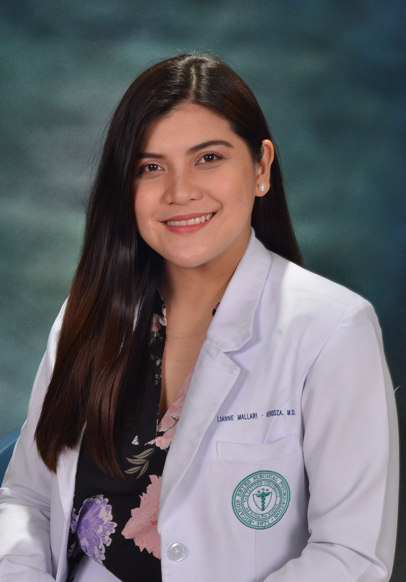
Lianne Mallari-Mendoza is a 2nd year Obstetrics and Gynecology Resident Physician at FEU-NRMF Hospital. She graduated medicine at the age of 25 years old at the same institute. She is also a graduate of clinical laboratory sciences.

Presenting author details
Full name: Lianne Mallari Mendoza
Contact number: 09566320901
Session or Track name/ number:
Category: Oral presentation/Poster Presentation

