Abstract

Title: Social environments influencing obesity in Israel- A qualitative study among health workers focusing on three ethno-religious groups

Mahasweta Mitra¹, Philippa Clarke¹ Arnold Monto¹, Ronit Endevelt², Rivka Goldsmith²
¹University of Michigan-School of Public Health
²Israel Ministry of Health- Nutrition Division

Keywords: Socio-economic status (SES), Ultra-orthodox (Haredi ) Jews
- Abstract
The prevalence of overweight or obesity in Israel is 60% and 30% for adults and children respectively and this burden is higher among ethnic minorities. Cultural beliefs, practices and levels of acculturation contribute to ethnic disparities in obesity. This qualitative study identifies cultural determinants of obesity by studying the social environments among three population groups in Israel: Ultra-orthodox Jews, settled Muslim Arabs and Ethiopian Jews, the latter two being ethnic minorities in the country. The study was conducted at the Israel Ministry of Health in Jerusalem. Nine healthcare experts from varying professional and ethno-religious backgrounds were interviewed using a semi-structured interviewing technique. The data describing different social environments influencing obesity in Israel were divided into six primary themes. This was further broken down to secondary and tertiary themes within each of these three populations. The influence of Westernization on lifestyle practices and eating habits among Ethiopian Jews and Muslim Arabs was identified as one of the primary themes. Haredi Jews on the other hand practice traditionalism. Norms such as “fatness as a sign of affluence” was prevalent in the Ethiopian culture and is seen as an obesogenic health behaviour. Additionally, psychosocial stressors arising from low socio-economic status (SES) in both the minority groups are viewed as a barrier in making healthy life choices. Socio-cultural norms pose an increased burden of obesity among the Ethiopian Jews and the settled Arabs who are both ethnic minorities in Israel This dictates the need for targeted population-based interventions to address obesity in these populations.

- Image:

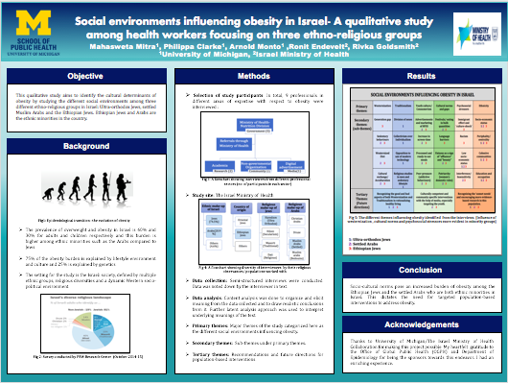
- Reference:

- Keinan-Boker L, Noyman N, Chinich A, Green MS, Nitzan- Kaluski D. Overweight and obesity prevalence in Israel: Findings of the first national health and nutrition survey (MABAT). Israel Medical Association Journal. 2005 Apr; 7(4):219-23.
- Endevelt R, Grotto I, Sheffer R, Goldsmith R, Golan M, Mendlovic J, Siman-Tov MB. Regulatory Measures to improve nutrition policy towards a better food environment for prevention of obesity and associated morbidity in Israel

- Biography:
Mahasweta Mitra is a second year MPH student in the Department of Epidemiology at the University of Michigan School of Public Health. Having worked as a clinical research associate in a focused diabetes care company prior to pursuing her masters, her interest mainly lies in connecting the dots moving from individual patient data to population data in chronic diseases through a thorough understanding of its social determinants.

- Presenting author details

Full Name: Mahasweta Mitra
Contact number: 7343588195
Twitter account: None
Linked In account: https://www.linkedin.com/in/mitra1992
Session name/ number: None
Category: (Poster presentation)
Passport Number: J6819563


