Effect of exercise on obesity adults following bariatric surgery: A meta-analysis of randomized controlled trials
Zi-Qi Ren¹, MM; Guang-Dong Lu², MD; Tian-Zi Zhang¹, MM; Qin Xu¹, MM
¹School of Nursing, Nanjing Medical University, Nanjing, 210029, China. ²Department of Interventional Radiology, the First Affiliated Hospital of Nanjing Medical University, Nanjing, 210029, China.
Keywords: Bariatric surgery; Obesity; Exercise; Weight loss; Physical function

Abstract
Background: A significant proportion of patients do not experience satisfactory weight loss or metabolic improvements, despite successful bariatric surgery. Systematic reviews based on observational studies have described a positive relation of exercise and weight loss before. However, several randomized controlled trials (RCTs) reached inconsistent conclusions, and no meta-analysis of RCTs directly verifying the effect of exercise in patients after bariatric surgery is available.
Objectives: We conducted a meta-analysis of existing randomized controlled trials directly verifying the effect of exercise in patients following bariatric surgery.
Methods: We systematically reviewed all RCTs in multi-databases, including PubMed, Embase, Cochrane Library, OVID and CINAHL from inception to October, 2017. Two independent researchers extracted the data. We took weight loss and physical function as the primary outcomes.
Results: Six trials involving 279 patients were included in our meta-analysis. Compared with those having no special exercise therapy after bariatric surgery, the exercise group had a significant reduction in body weight (mean difference (MD) = -2.02, 95% CI: -3.75 to -0.28), waist circumference (MD= -5.25, 95% CI: -10.48 to -0.03) and systolic blood pressure (MD = -5.25, 95% CI: -10.48 to -0.03), as well as a significant improvement of 6-minute walk distance (MD=29.67, 95% CI: 25.97 to 33.37).
Conclusion: Engaging in exercise after bariatric surgery is feasible and clearly elicits additional improvement in health outcomes. Future trials with at least two years’ postoperative follow-up are required to further find which kind of exercise planning leads to the best clinical outcomes, and thus providing adequate practice guidance.

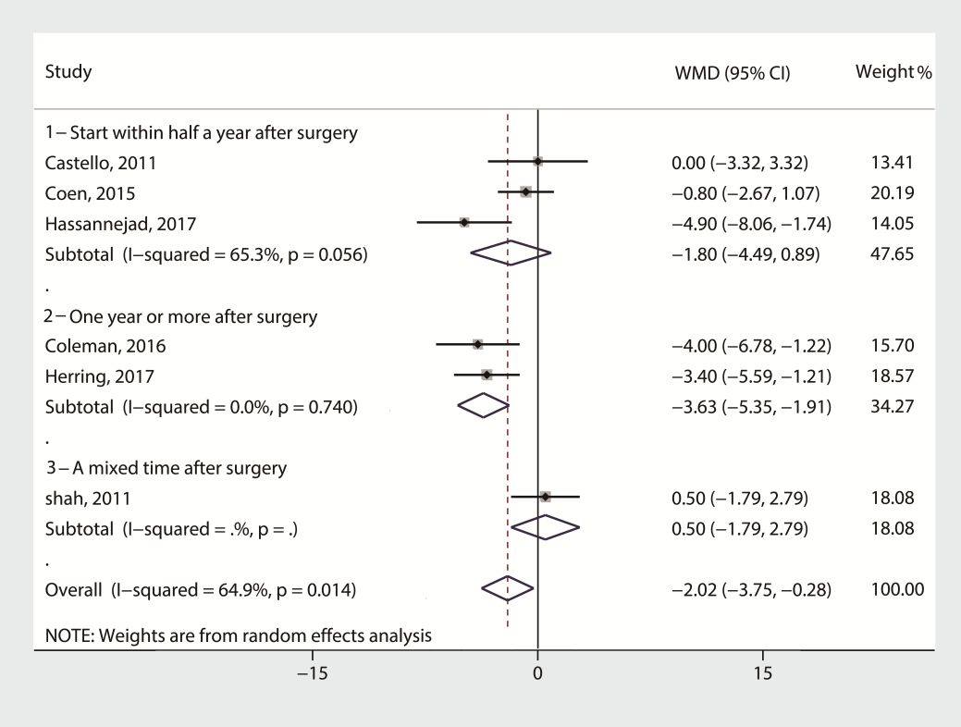
Fig. 1 Mean change in body weight (kg) after exercise intervention versus non-exercise treatment after bariatric surgery. Subgroup analysis was done on the studies that used different starting time of the intervention after surgery, Forest plot.

Fig. 2 Mean change in body weight (kg) after exercise intervention versus non-exercise treatment after bariatric surgery. Subgroup analysis was done on the studies that used different exercise prescriptions after surgery, Forest plot.

