Nutritional genomics: The new landscape of nutrition
Estefanía García Ruiz, PhD in Nutrigenomics and Personalized Nutrition, Chief Executive Officer at GenoVive Spain

Abstract (300 word limit)

Nowadays, scientists still researching the interaction between diet and genes and how certain people have genetic predispositions to developing complex diseases. The knowledge of Human Genome Project found out the integration of genetic and nutrition in health care. This emerging development of nutritional genomics promises to prevent and predict diseases in a therapeutic context.

In the human genome there are about 35,500 genes, among them there are several alleles and millions of different base pairs between individuals and some of these differences can affect the personal response to the nutritional environment. In that sense, the most important challenge for nutritional genomics is to find out the way to personalized nutrition through nutrigenetics and nutrigenomics.

Nutrigenetics is a branch of nutritional genomics that is referred to the effect of genetic variation (also known as polymorphisms) on dietary response. On the other hand, Nutrigenomics study the effects of nutrients, and food components on gene expression.

Nutritional genomics has a special feedback on omics sciences as epigenomics, transcriptomics, proteomics, metabolomics and metagenomics, which plays an important role, integrating human nutrition application. Furthermore, allow us to understand how nutrients and food components interacts with the body.

Image
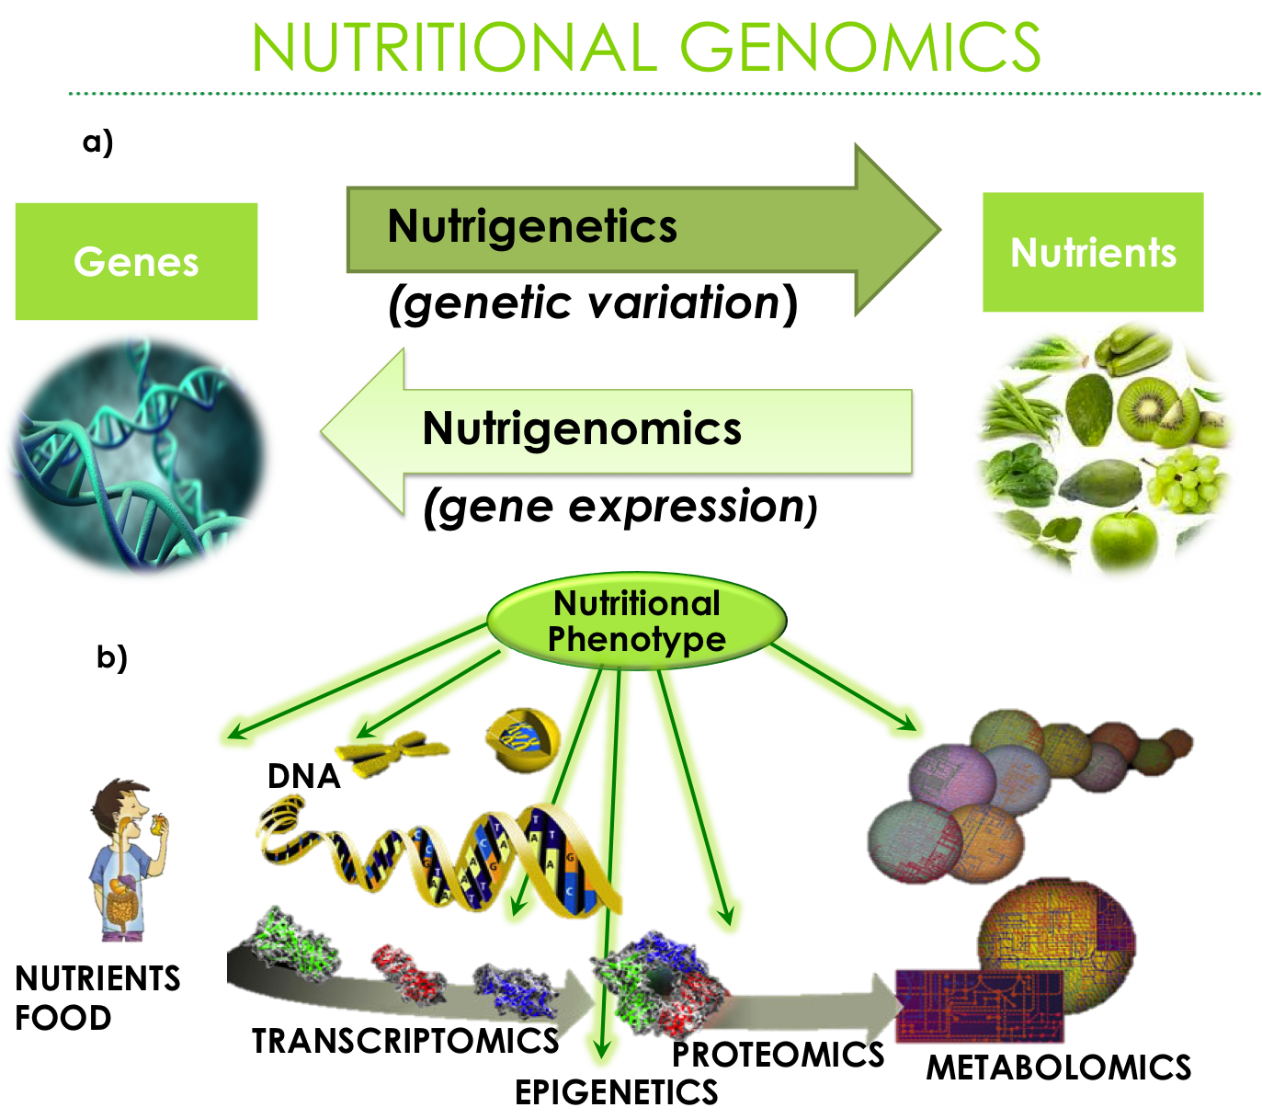

Figure 1. a) Nutritional Genomics: Nutrigenetics and Nutrigenomics
b) Nutritional Genomics and omics sciences


Biography (150 word limit)

Estefanía García Ruiz offers best solutions in personalized nutrition and fitness improving the health and wellbeing. Her passion is to share her knowledge as instructor to nutritionist and healthcare professionals who want to learn how to apply nutrigenetics and nutrigenomics in their private practice. Moreover, she loves to be a genetic advisor (member of Spanish Association of Human Genetics) to help the people to understand their genetics and create a more personalized nutrition experience to: healthy, overweight, cardiovascular diseases, and diabetes patients.
Email: egarcia@genovivelatam.com

Notes/Comments:

