Nutritional Transition, a Risk Factor for Cancer
Madhu Sharma RD, Former Sr Dietician, PGIMER, Chandigarh, India
Looking at the dietary evolution through the past few decades, it is apparent that there has been a paradigm shift in the food consumption pattern of mankind globally. Both urban and rural population is equally affected. ThBarere has been a notable shift, that is, increased incidence of nutritional related chronic disease like diabetes mellitus, Type 2 juvenile diabetes, cardio vascular diseases and cancer. Nutrition transition consequent to industrialization, economic development and dietary modifications both qualitatively and quantitatively, has impacted the lifestyle and health of any population. The concept of nutigenomics in cancer prevention has recently evolved with profound implications in the prevention and therapy of the disease by just altering the dietary behavior of a population. Diet can modify certain common nutritional response elements in gene mutation which can cause or prevent cancer, known as epigenetic modulation influenced by what one eats.
Risk factors for DNA damage are influenced by malnutrition, lack of plant based foods, high meat consumption, low folate diets and high sugar diets. There are many hypothesis listed for risk of cancer. Besides endogenous factors, exogenous factors like oxidative stress due to dietary influence, inflammation, known immune surveillance, smoking, infection, radiation, industrial pollution, chemicals from agriculture sources and medicines also have a role in causing cancer. However, such adverse affects can be mitigated by right nutritional modulation like eating a healthy diet, with emphasis on natural, plant based foods high in vitamins , anti oxidants, and fiber and minimal processed or refined foods, meat, high fat and sugar foods and alcohol.
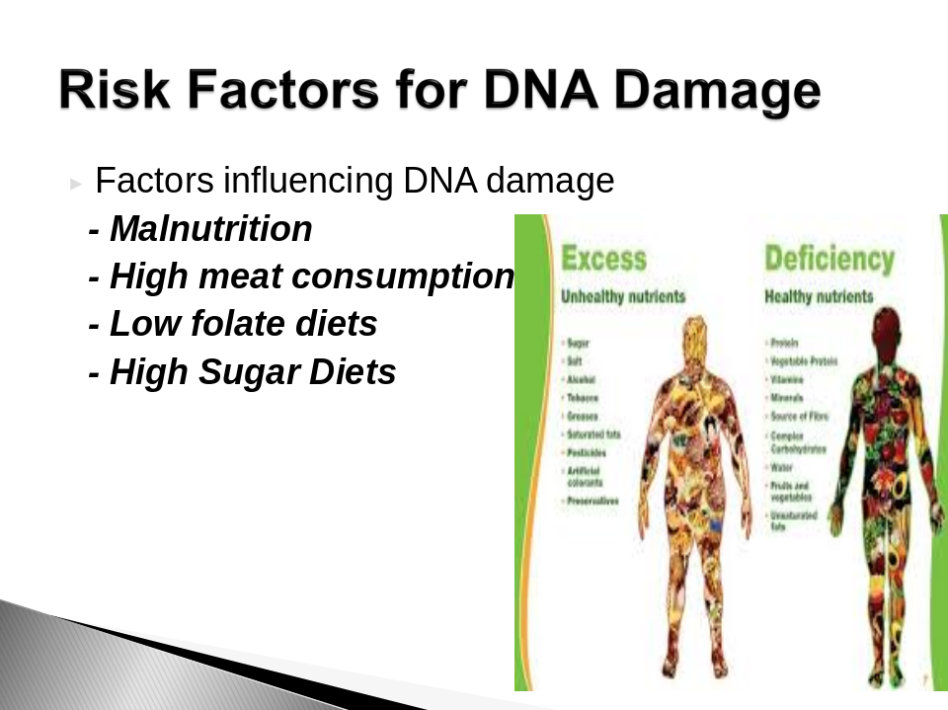

References
- Barry M Popkin, Linda S, Adair and Shu Wen Ng. Now and Then: The global Transition: Nutr Rev.2012 Jan
- Miller, AB. Diet in Cancer Prevention. The Lancet ,2001 Nov.
- ACS Guidelines on nutrition and physical activity of cancer prevention, 2012 Jan/Feb
- Holly L. Nicastro, Elaine B, Trujillo and John A Milner. Nutrigenomics and cancer prevention. Curr Nutr Rep.2012 March
- Kang J X. Nutigenomics and cancer therapy. J Nutrigenet Nutrigenomics, 2013; 6:1-11.

